Unit 5 Lesson 6: Locate Unit Fractions on the Number Line

WU Which One Doesn’t Belong: Fraction Details (Warm up)

Student Task Statement
Which one doesn’t belong?
A
B
C
D

1 Partition Fourths

Student Task Statement
Three students are partitioning a number line into fourths. Their work is shown.
Clare’s number line:
Andre’s number line:
Diego’s number line:
Whose partitioning makes the most sense to you? Explain your reasoning.

2 Unit Fractions on the Number Line

Student Task Statement
Partition each number line. Locate and label each fraction.
- $\frac{1}{4}$
- $\frac{1}{8}$
- $\frac{1}{3}$
- $\frac{1}{6}$
- $\frac{1}{2}$
- $\frac{1}{4}$
- $\frac{1}{8}$
- $\frac{1}{3}$
- $\frac{1}{6}$

Activity Synthesis
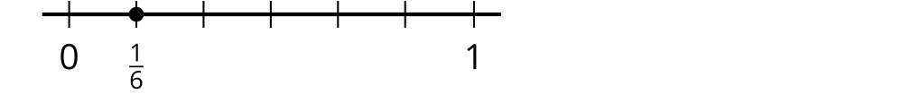
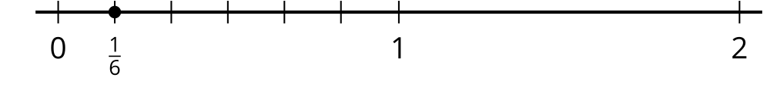

Images for Activity Synthesis
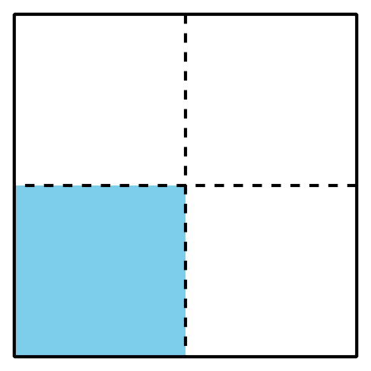
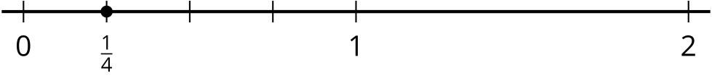
© CC BY 2021 Illustrative Mathematics®

