Unit 2 Lesson 9: Measure to Find the Area

WU Notice and Wonder: Groups and Arrays (Warm up)

Student Task Statement
What do you notice? What do you wonder?

1 Measure to Find Area

Images for Launch

Student Task Statement
Use a ruler to measure the rectangles. Then, calculate the area of the rectangles in square centimeters.
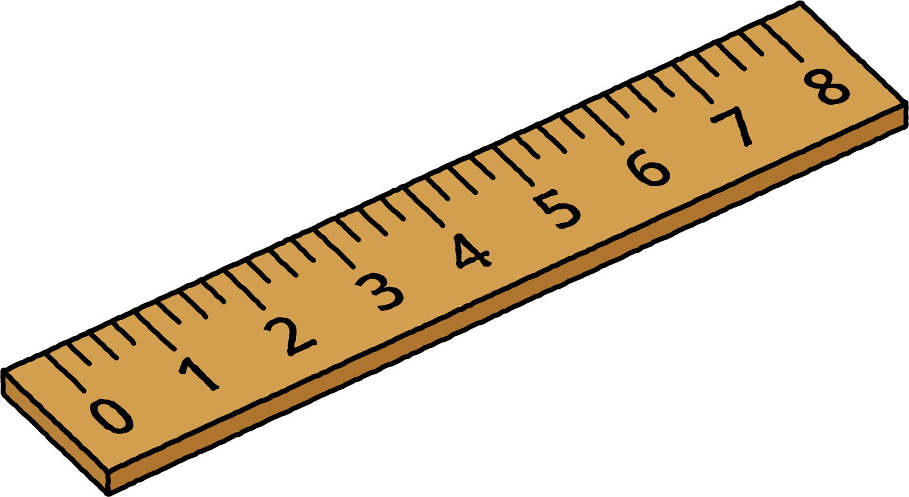
A
B
C

2 Create a Rectangle

Student Task Statement
Your teacher will give you some tape. Use it to create a rectangle with your assigned area.
- Area 1: 4 square feet
- Area 2: 6 square feet
- Area 3: 9 square feet
- Area 4: 10 square feet
- Area 5: 12 square feet
- Area 6: 16 square feet
© CC BY 2021 Illustrative Mathematics®

