Lesson 10: Center Day 2
- Let’s add and subtract.

10.2: Centers: Choice Time
Choose a center.
Five in a Row: Addition and Subtraction
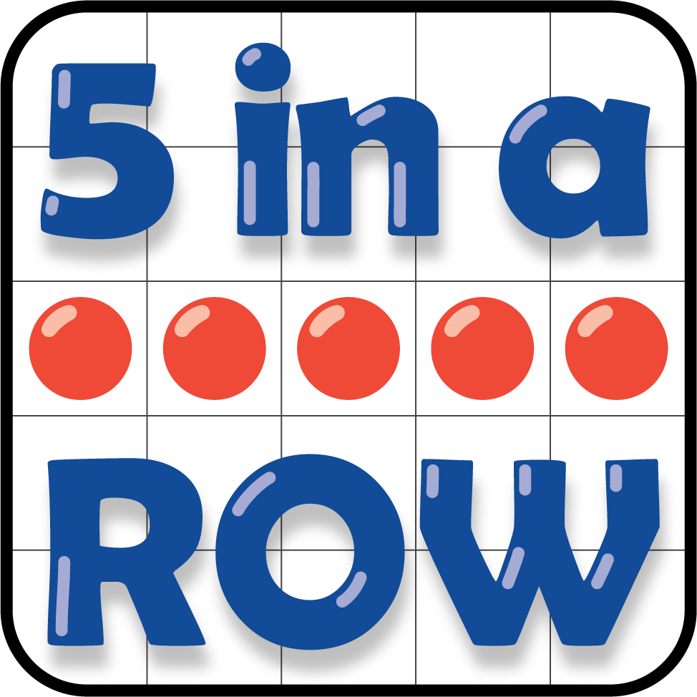
Check it Off
What's Behind My Back
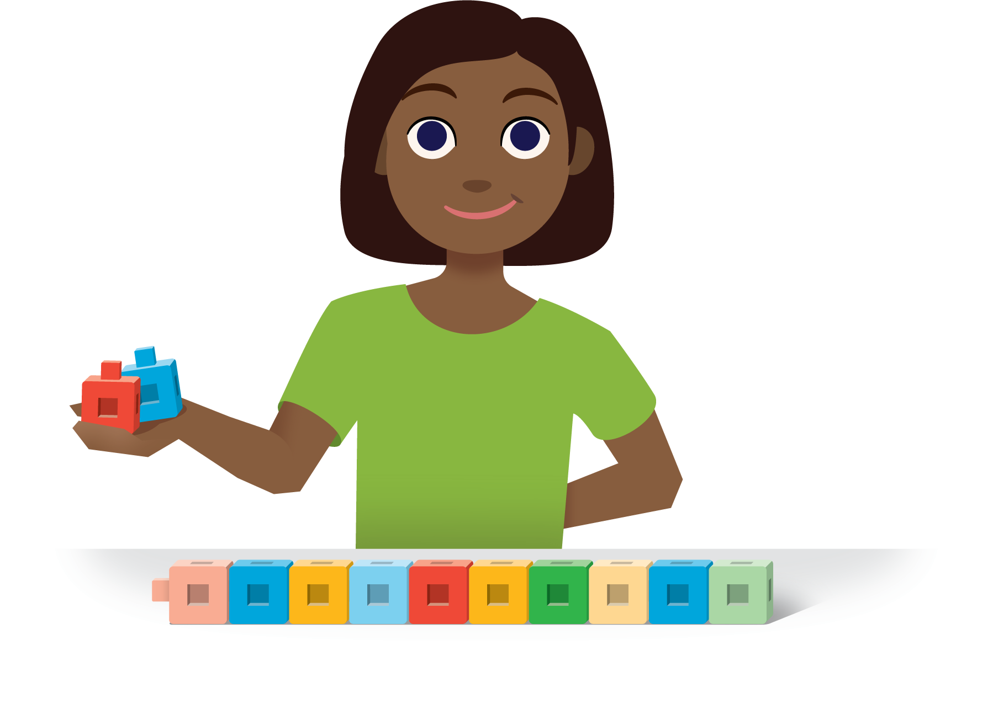
Find the Pair
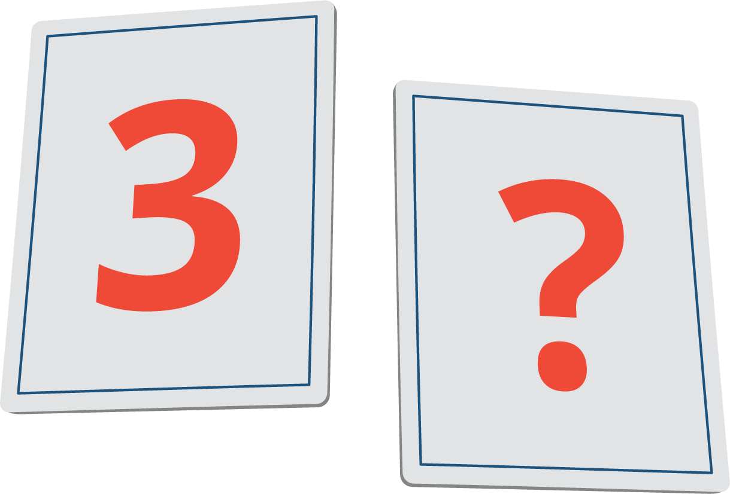
© CC BY 2021 Illustrative Mathematics®

