Unit 2 Lesson 10: Solve Area Problems

WU Number Talk: One More Group (Warm up)

Student Task Statement
Find the value of each expression mentally.
- $5×2$
- $6×2$
- $5×6$
- $6×6$

1 Paint a Wall

Student Task Statement
Noah is painting a wall in a community garden. The wall is shaped like a rectangle. A diagram of the wall is shown here.
Paint is sold in 3 different sizes:
- A small container will cover 3 square meters.
- A medium container will cover 10 square meters.
- A large container will cover 40 square meters.
What should Noah buy? Explain your reasoning.
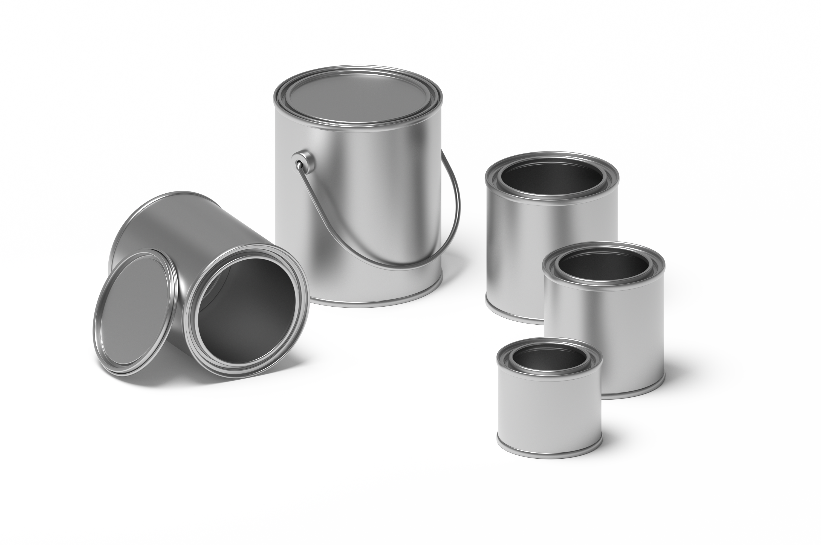

2 Create a Garden

Student Task Statement
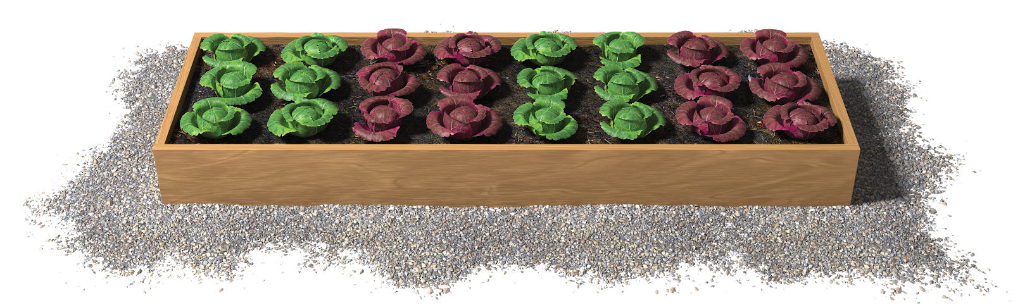
- Elena is planning how to use her rectangular space in the community garden. She needs a space that is at least 20 square feet to fit her plants. She has enough soil for a garden that is 30 square feet. The space she has available has to be 3 feet on one side.
- What are the possible sizes for her garden?
- Create a poster to show your thinking. Organize it so it can be followed by others.
- As you look at the posters with your group:
  - Describe how another group solved the problem in a different way than your group did.
  - Write three things you saw that helped you understand how other students solved the problem.
© CC BY 2021 Illustrative Mathematics®

