Lesson 19: Distinguishing Circumference and Area
Let’s contrast circumference and area.

19.1: Filling the Plate
About how many cheese puffs can fit on the plate in a single layer? Be prepared to explain your reasoning.
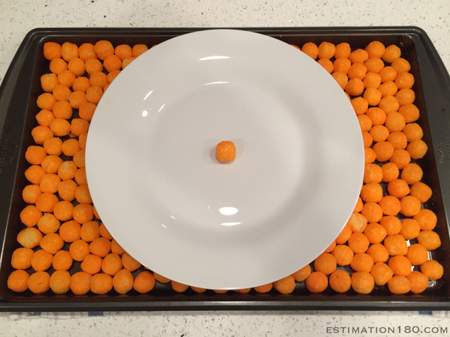

19.2: Card Sort: Circle Problems
Your teacher will give you cards with questions about circles.
- Sort the cards into two groups based on whether you would use the circumference or the area of the circle to answer the question. Pause here so your teacher can review your work.
- Your teacher will assign you a card to examine more closely. What additional information would you need in order to answer the question on your card?
- Estimate measurements for the circle on your card.
- Use your estimates to calculate the answer to the question.

19.3: Visual Display of Circle Problem
In the previous activity you estimated the answer to a question about circles.
Create a visual display that includes:
- The question you were answering
- A diagram of a circle labeled with your estimated measurements
- Your thinking, organized so that others can follow it
- Your answer, expressed in terms of $π$ and also expressed as a decimal approximation

19.4: Analyzing Circle Claims
Here are two students’ answers for each question. Do you agree with either of them? Explain or show your reasoning.
- How many feet are traveled by a person riding once around the merry-go-round?
- 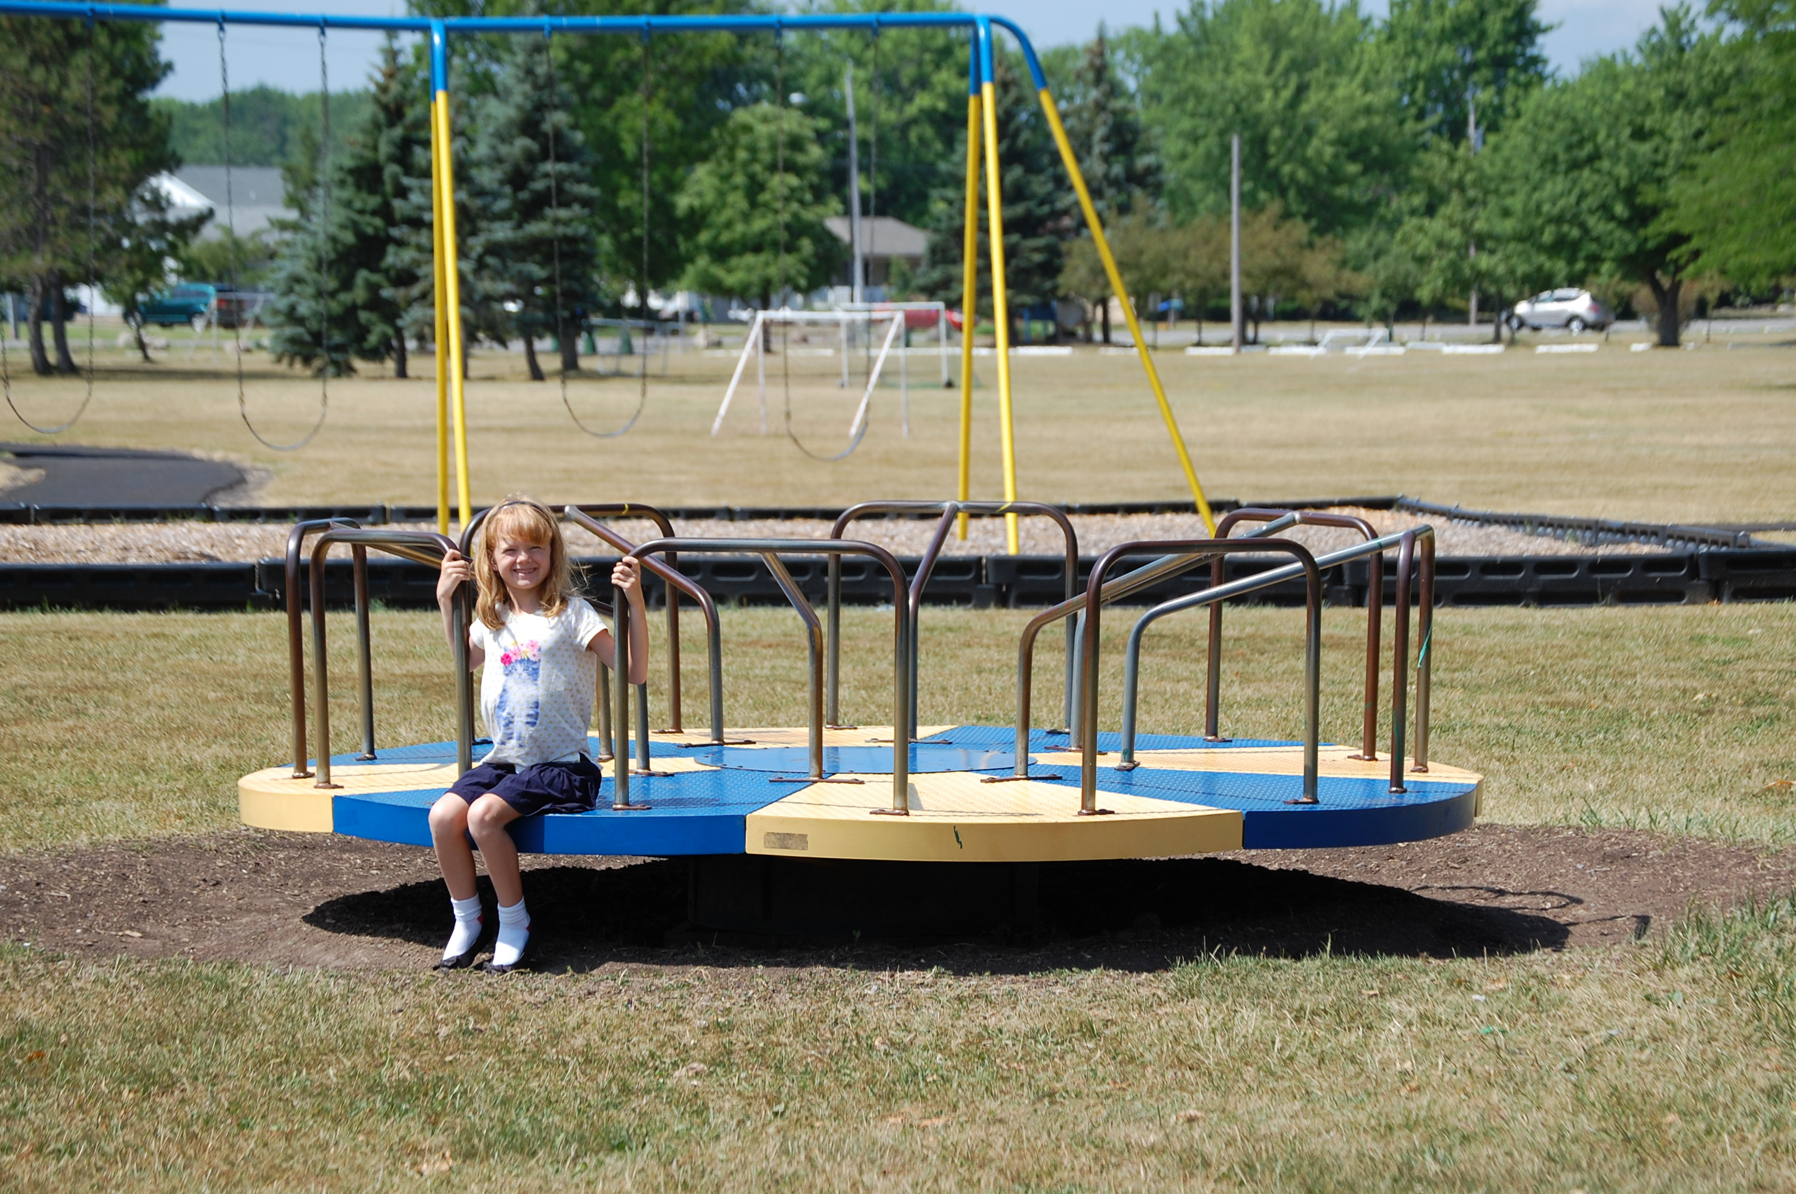
  - Clare says, “The radius of the merry-go-round is about 4 feet, so the distance around the edge is about $8π$ feet.”
  - Andre says, “The diameter of the merry-go-round is about 4 feet, so the distance around the edge is about $4π$ feet.”
- How much room is there to spread frosting on the cookie?
- 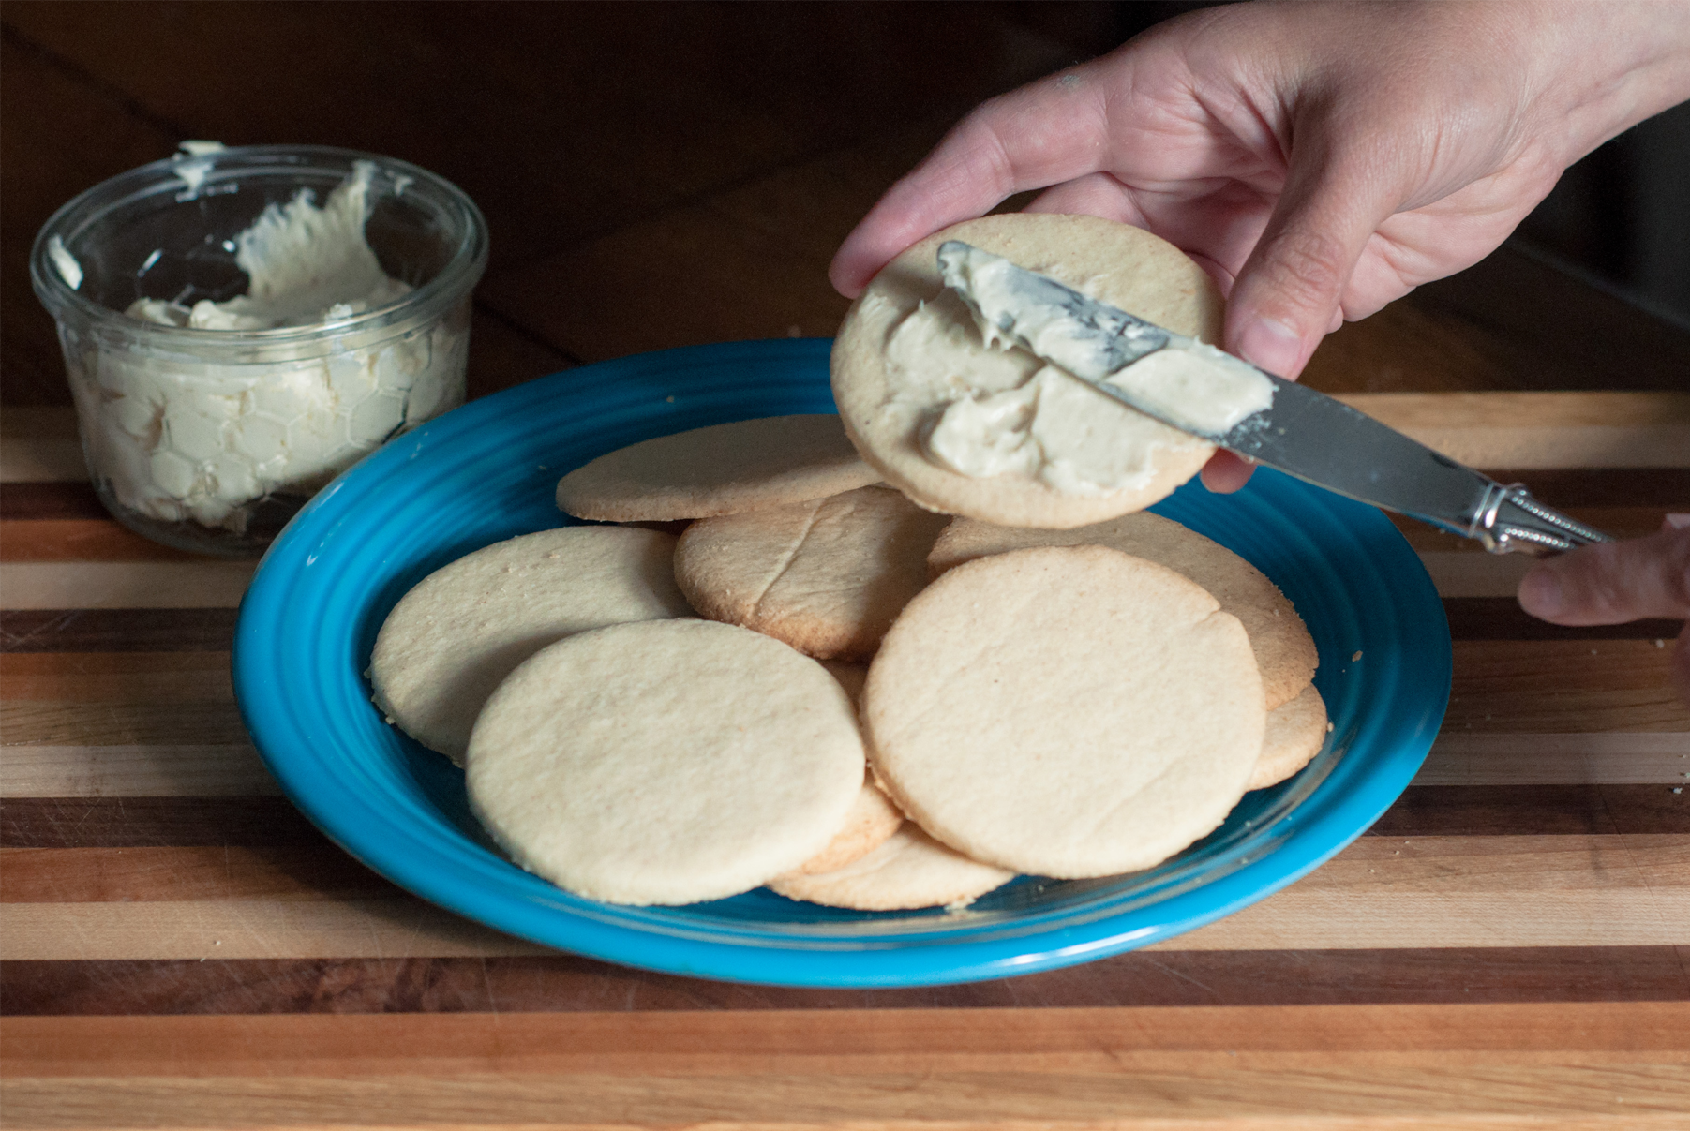
  - Clare says “The radius of the cookie is about 3 centimeters, so the space for frosting is about $6π$ cm².”
  - Andre says “The diameter of the cookie is about 3 inches, so the space for frosting is about $2.25π$ in².”
- How far does the unicycle move when the wheel makes 5 full rotations?
- 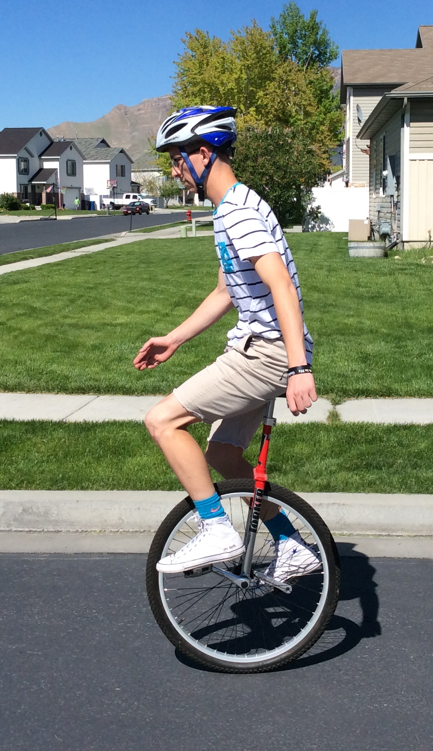
  - Clare says, “The diameter of the unicycle wheel is about 0.5 meters. In 5 complete rotations it will go about $\frac{5}{2}π$ m².”
  - Andre says, “I agree with Clare's estimate of the diameter, but that means the unicycle will go about $\frac{5}{4}π$ m.”

Are you ready for more?
A goat (point $G$) is tied with a 6-foot rope to the corner of a shed. The floor of the shed is a square whose sides are each 3 feet long. The shed is closed and the goat can't go inside. The space all around the shed is flat, grassy, and the goat can't reach any other structures or objects. What is the area over which the goat can roam?
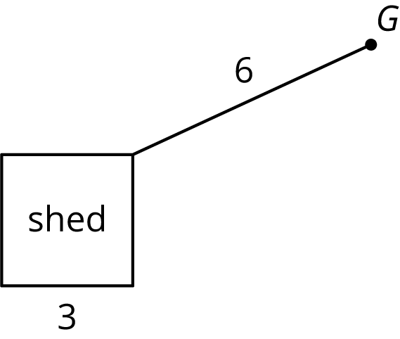

Lesson 19 Summary
Sometimes we need to find the circumference of a circle, and sometimes we need to find the area. Here are some examples of quantities related to the circumference of a circle:
- The length of a circular path.
- The distance a wheel will travel after one complete rotation.
- The length of a piece of rope coiled in a circle.
Here are some examples of quantities related to the area of a circle:
- The amount of land that is cultivated on a circular field.
- The amount of frosting needed to cover the top of a round cake.
- The number of tiles needed to cover a round table.
In both cases, the radius (or diameter) of the circle is all that is needed to make the calculation. The circumference of a circle with radius $r$ is $2πr$ while its area is $πr^{2}$. The circumference is measured in linear units (such as cm, in, km) while the area is measured in square units (such as cm², in², km²).
© CC BY Open Up Resources. Adaptations CC BY IM.

