Lesson 17: Volume and Density
- Let’s use volume and density to solve problems.

17.1: A Kilogram by Any Other Name
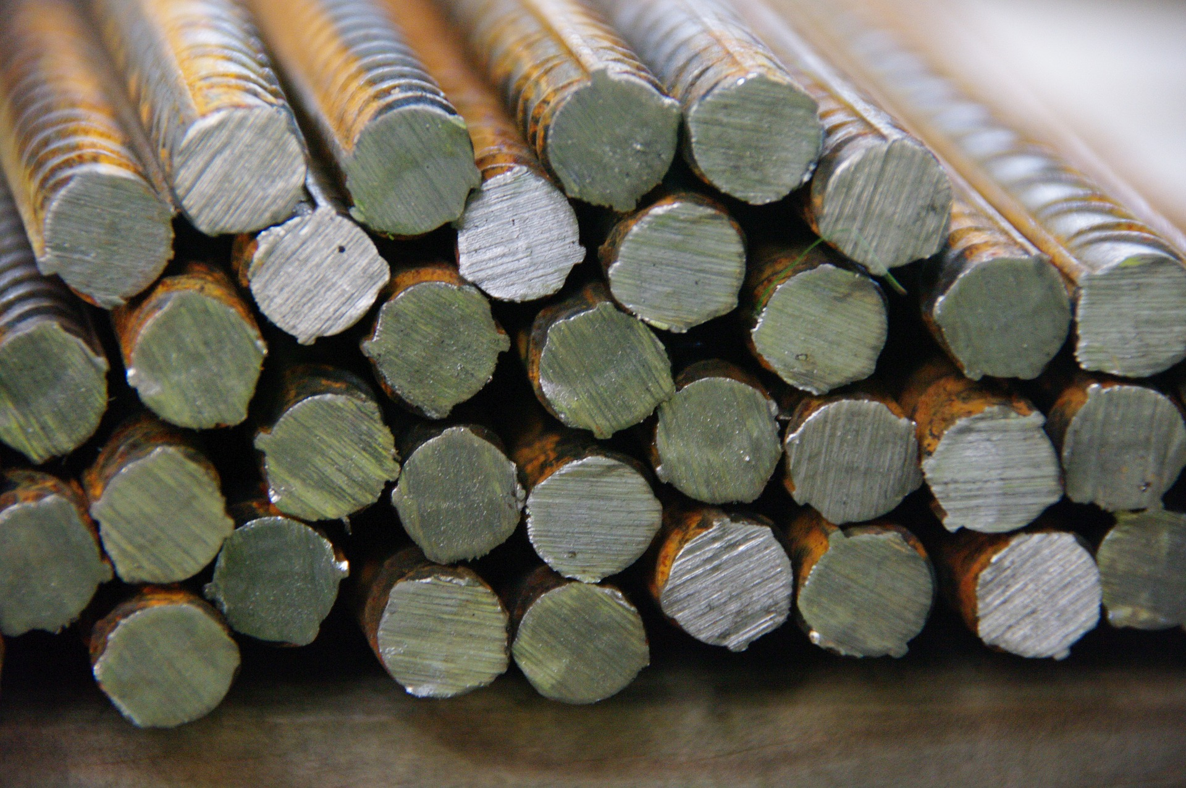
Which has more mass, a thousand kilograms of feathers or a thousand kilograms of steel? Explain your reasoning.

17.2: Light as a Feather
The feathers in a pillow have a total mass of 59 grams. The pillow is in the shape of a rectangular prism measuring 51 cm by 66 cm by 7 cm.
A steel anchor is shaped like a square pyramid. Each side of the base measures 20 cm, and its height is 28 cm. The anchor’s mass is 30 kg.
- What’s the density of feathers in kilograms per cubic meter?
- What’s the density of steel in kilograms per cubic meter?
- What’s the volume of 1,000 kg of feathers in cubic meters?
- What’s the volume of 1,000 kg of steel in cubic meters?

Are you ready for more?
Iridium is one of the densest metals. How many times heavier would a standard pencil be if it were made out of iridium instead of wood?

17.3: A Fishy Situation
An aquarium manager drew a blueprint for a cylindrical fish tank. The tank has a vertical tube in the middle in which visitors can stand and view the fish.
The best average density for the species of fish that will go in the tank is 16 fish per 100 gallons of water. This provides enough room for the fish to swim while making sure that there are plenty of fish for people to see.
The aquarium has 275 fish available to put in the tank. Is this the right number of fish for the tank? If not, how many fish should be added or removed? Explain your reasoning.

Lesson 17 Summary
Imagine you have a baseball and an apple the size of a baseball. If we weigh each, we’ll likely find that even though they’re the same size, the baseball weighs more.
A baseball has volume 200 cubic centimeters and weighs 145 grams, while an apple the same volume might weigh about 100 grams. We say that the baseball is more dense than the apple because it has more mass packed into each unit of volume. The density of the apple in this example is 0.5 grams per cubic centimeter, because $\frac{100\text{ grams}}{200{\text{ cm}}^{3}}=0.5$ grams per cubic centimeter. For the baseball, the density is $\frac{145\text{ grams}}{200{\text{ cm}}^{3}}=0.725$ grams per cubic centimeter.
In general, to find the density of an object, divide its mass by its volume.
© CC BY 2019 by Illustrative Mathematics®

