Lesson 6: Look for Small Groups
- Let’s look for small groups of objects.

Warm-up: Act It Out: Introduction
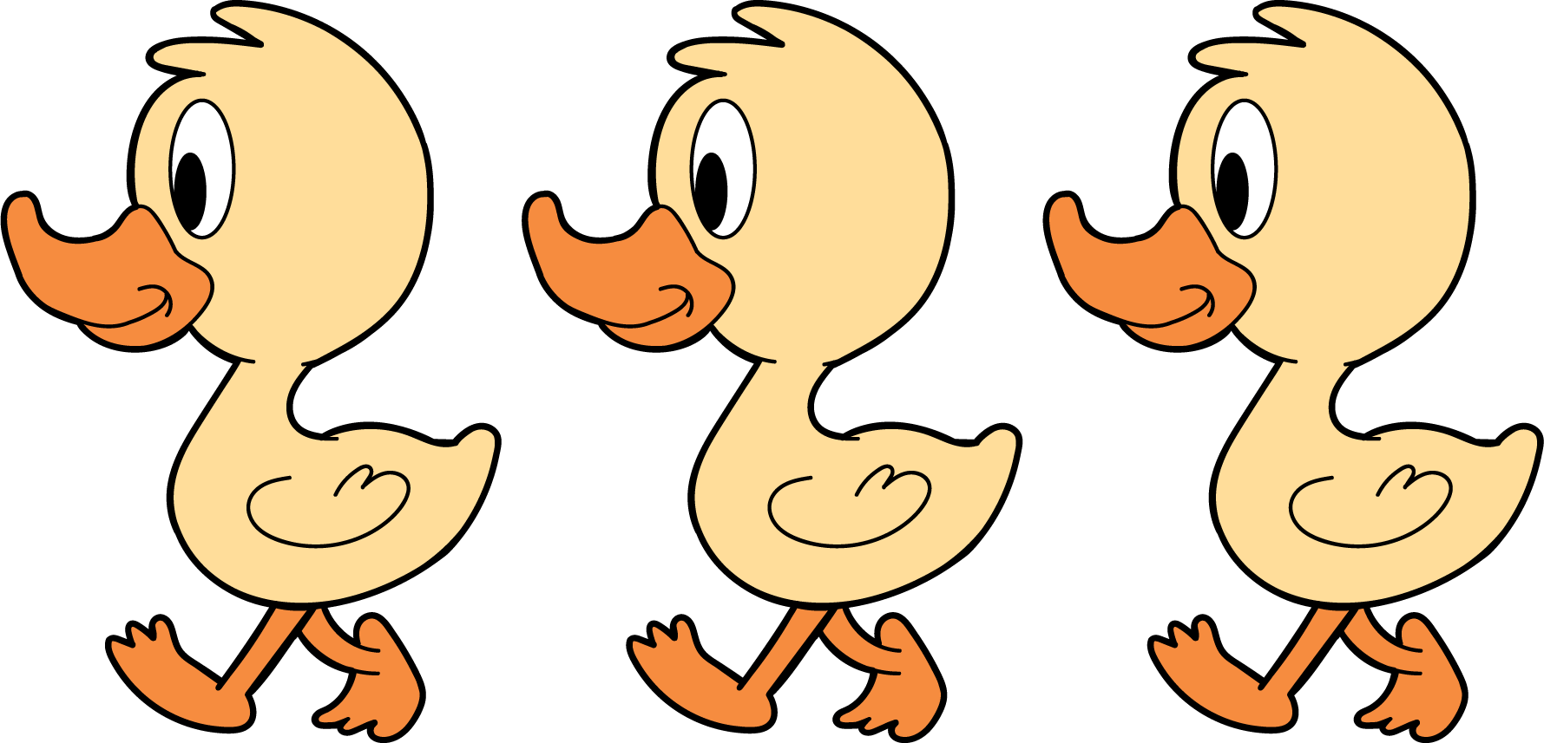
3 little ducks went out one day,
over the hill and far away.
Mother duck said, “Quack, quack, quack.”
Then 3 little ducks came back.

6.1: How Many Do You See: Introduction
How many do you see?
How do you see them?

6.3: Centers: Choice Time
Choose a center.
Geoblocks
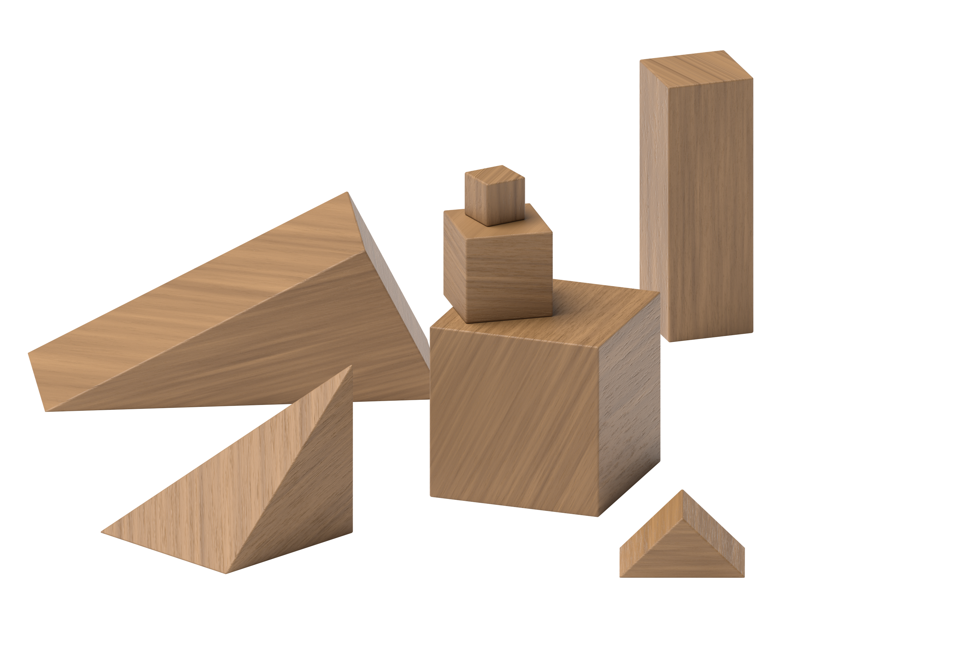
Connecting Cubes
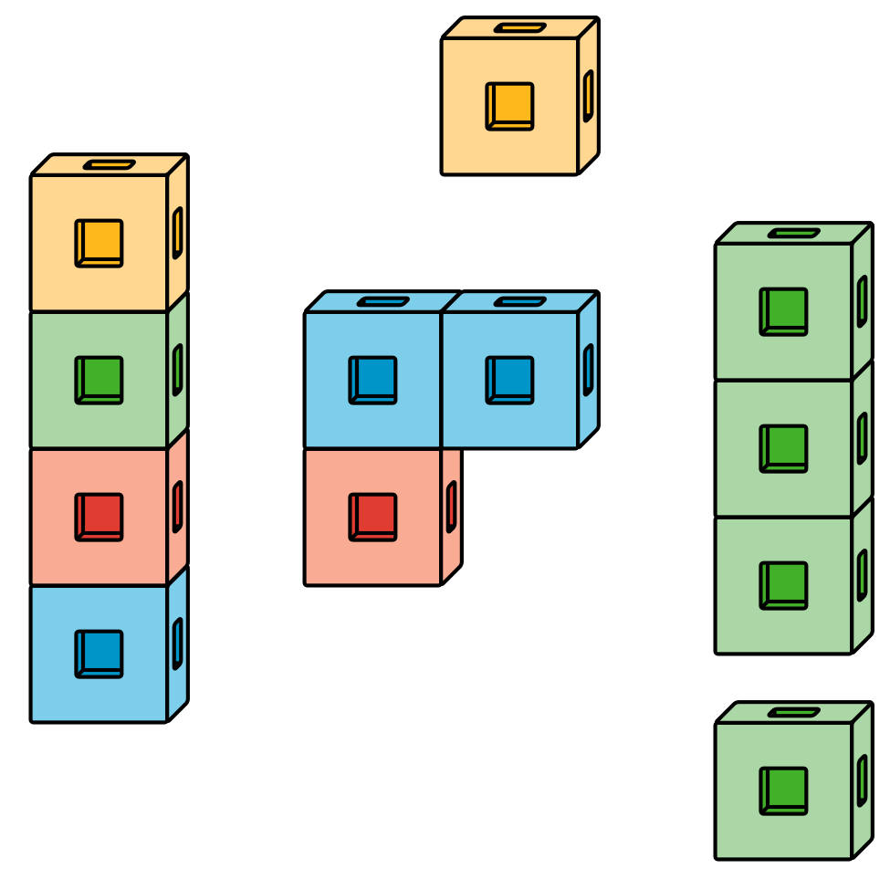
Pattern Blocks
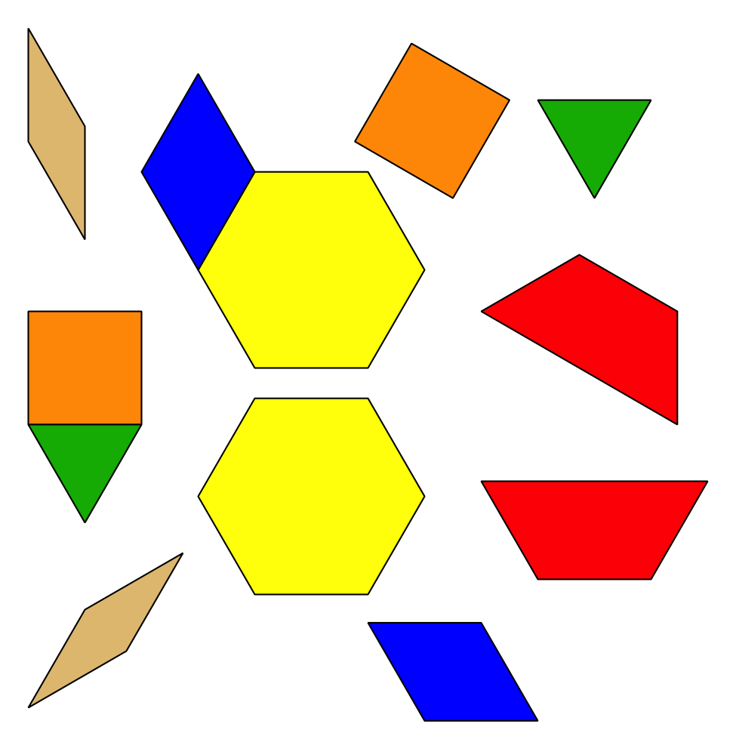
Picture Books
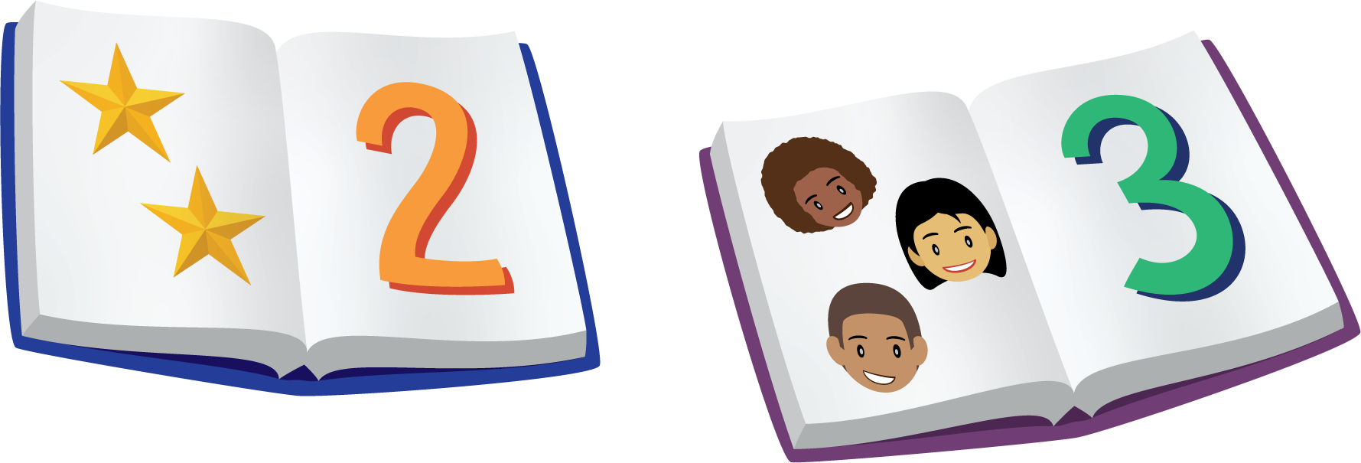
© CC BY 2021 Illustrative Mathematics®

