Unit 3 Lesson 11: Introducing the Number $i$

1 Math Talk: Squared (Warm up)

Student Task Statement
Find the value of each expression mentally.
${\left(2\sqrt{3}\right)}^{2}$
${\left(\frac{1}{2}\sqrt{3}\right)}^{2}$
${\left(2\sqrt{\text{-}1}\right)}^{2}$
${\left(\frac{1}{2}\sqrt{\text{-}1}\right)}^{2}$

2 It is $i$

Images for Launch
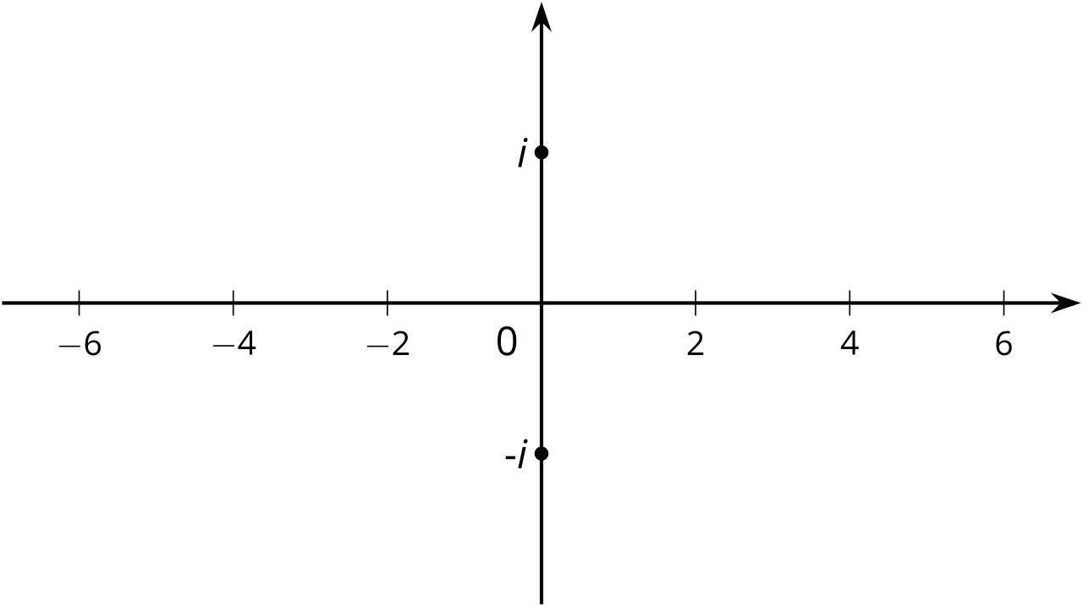

Student Task Statement
Find the solutions to these equations, then plot the solutions to each equation on the imaginary or real number line.
- $a^{2}=16$
- $b^{2}=\text{-}9$
- $c^{2}=\text{-}5$
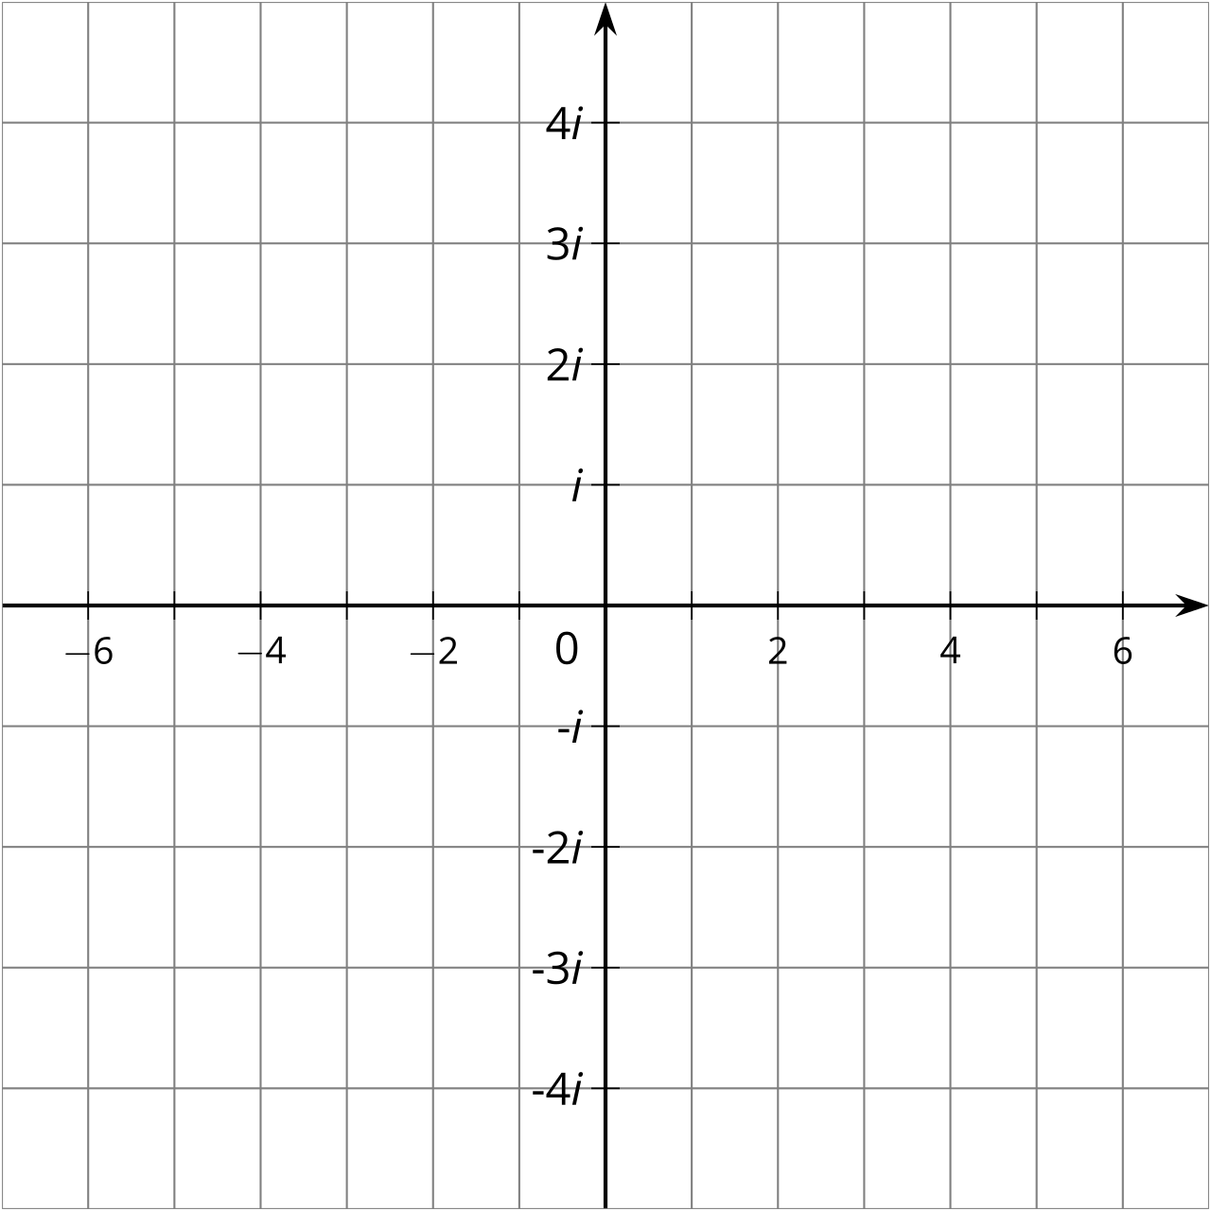

3 The $i$’s Have It

Student Task Statement
Write these imaginary numbers using the number $i$.
- $\sqrt{\text{-}36}$
- $\sqrt{\text{-}10}$
- $\text{-}\sqrt{\text{-}100}$
- $\text{-}\sqrt{\text{-}17}$

4 Complex Numbers

Images for Launch
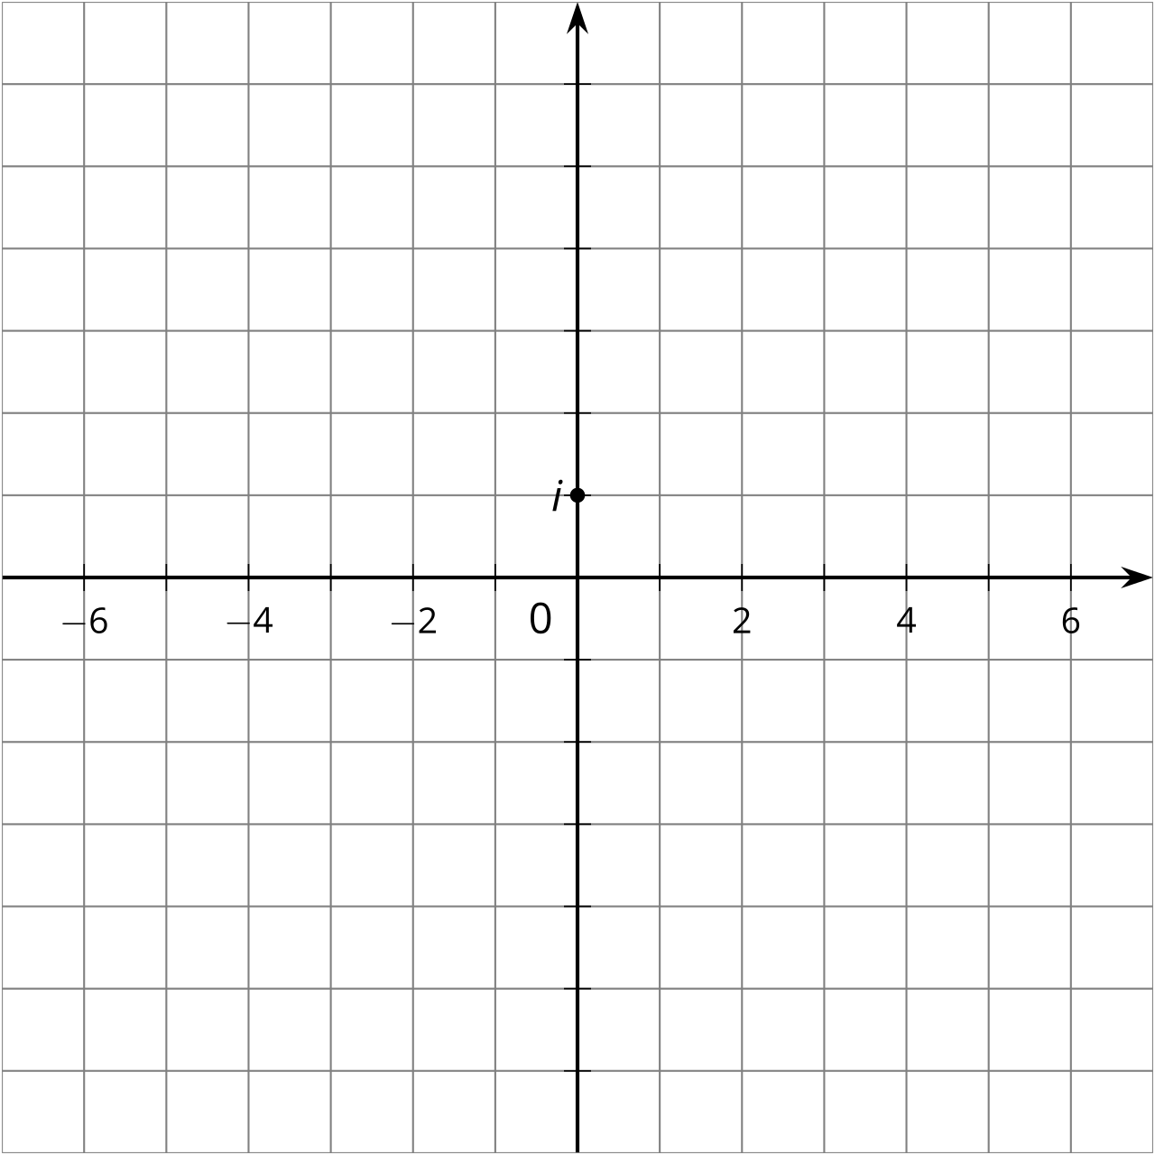

Student Task Statement
- Label at least 8 different imaginary numbers on the imaginary number line.
- When we add a real number and an imaginary number, we get a complex number. The diagram shows where $2+i$ is in the complex number plane. What complex number is represented by point $A$?
- 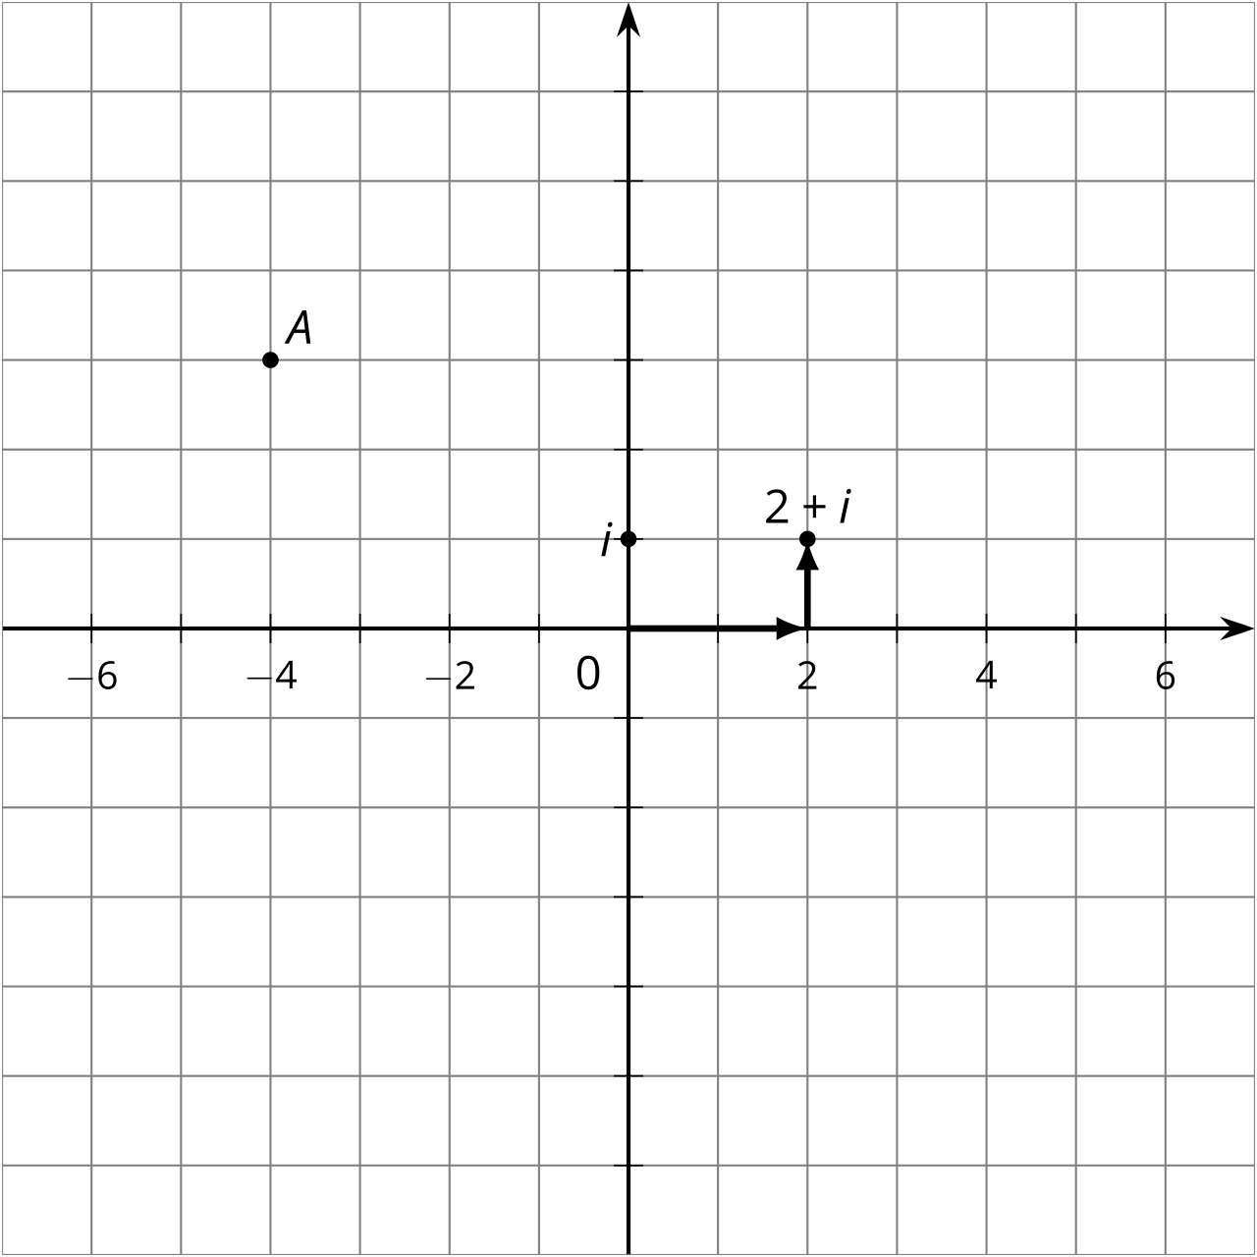
- Plot these complex numbers in the complex number plane and label them.
  - $\text{-}2−i$
  - $\text{-}6+3i$
  - $5+4i$
  - $1−3i$
© CC BY 2019 by Illustrative Mathematics®

