Unit 5 Lesson 2: Make and Break Apart Pattern Block Designs

Which One Doesn’t Belong: Pattern Block Designs (Warm up)

Student Task Statement
Which one doesn’t belong?
A
B
C
D

1 Create Pattern Blocks Designs

Student Task Statement
My Design

2 Han’s Pattern Block Design

Student Task Statement
Han used 8 pattern blocks.

- Expression: ___________________________

- 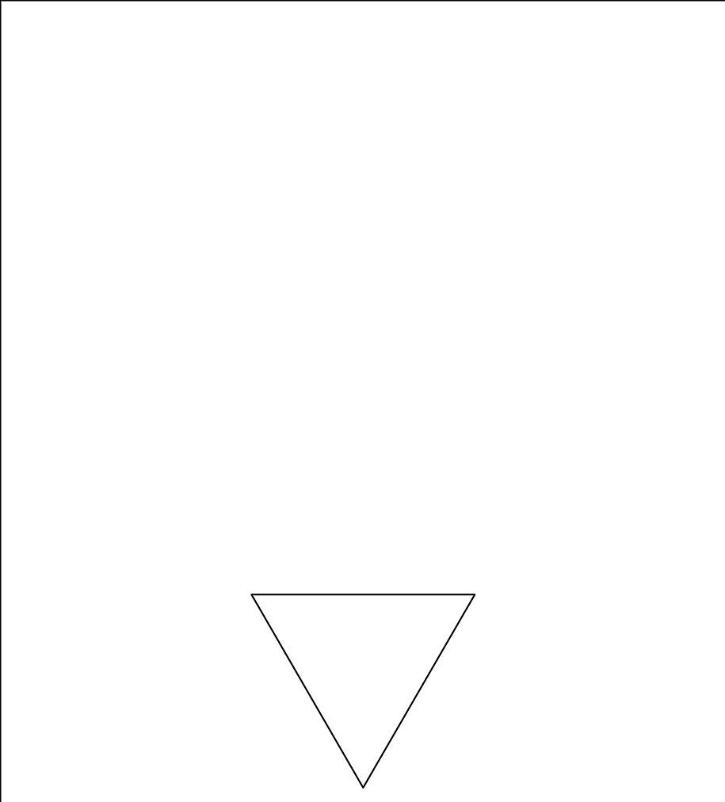
- Expression: ___________________________

- Expression: ___________________________

- 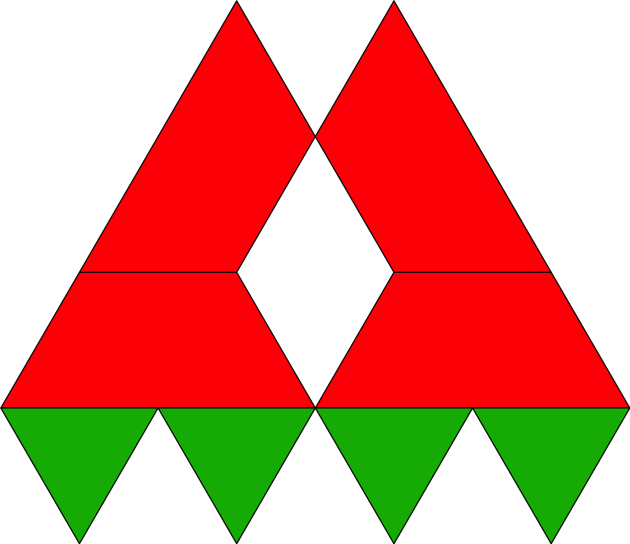
- Expression: ___________________________

3 Centers: Choice Time

Student Task Statement
Choose a center.
Check it Off
Bingo
Find the Value of
Expressions
Shake and Spill
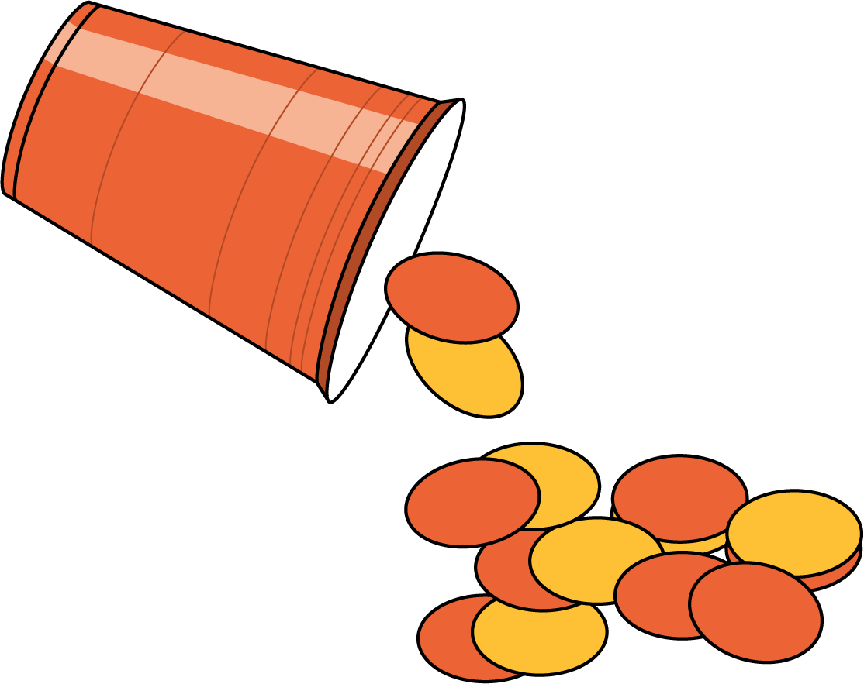

Images for Activity Synthesis
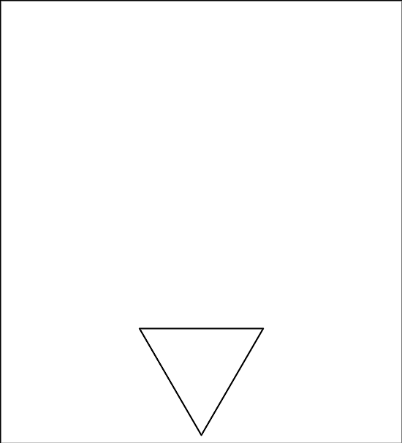
© CC BY 2021 Illustrative Mathematics®

