Lesson 16: Graphing from the Vertex Form
- Let’s graph equations in vertex form.

16.1: Which Form to Use?
Expressions in different forms can be used to define the same function. Here are three ways to define a function $f$.
$f(x)=x^{2}−4x+3$
(standard form)
$f(x)=(x−3)(x−1)$
(factored form)
$f(x)=(x−2)^{2}−1$
(vertex form)
Which form would you use if you want to find the following features of the graph of $f$? Be prepared to explain your reasoning.
- the $x$-intercepts
- the vertex
- the $y$-intercept

16.2: Sharing a Vertex
Here are two equations that define quadratic functions.
$p(x)=\text{-}(x−4)^{2}+10q(x)=\frac{1}{2}(x−4)^{2}+10$
- The graph of $p$ passes through $(0,\text{-}6)$ and $(4,10)$, as shown on the coordinate plane.
- Find the coordinates of another point on the graph of $p$. Explain or show your reasoning. Then, use the points to sketch and label the graph.
- On the same coordinate plane, identify the vertex and two other points that are on the graph of $q$. Explain or show your reasoning. Sketch and label the graph of $q$.
- Priya says, "Once I know the vertex is $(4,10)$, I can find out, without graphing, whether the vertex is the maximum or the minimum of function $p$. I would just compare the coordinates of the vertex with the coordinates of a point on either side of it."
- Complete the table and then explain how Priya might have reasoned about whether the vertex is the minimum or maximum.
- $x$ | - 3 | - 4 | - 5
- $p(x)$ |  | - 10

Are you ready for more?
- Write a the equation for a quadratic function whose graph has the vertex at $(2,3)$ and contains the point $(0,\text{-}5)$.
- Sketch a graph of your function.

16.3: Card Sort: Matching Equations with Graphs
Your teacher will give you a set of cards. Each card contains an equation or a graph that represents a quadratic function. Take turns matching each equation to a graph that represents the same function.
- For each pair of cards that you match, explain to your partner how you know they belong together.
- For each pair of cards that your partner matches, listen carefully to their explanation. If you disagree, discuss your thinking and work to reach an agreement.
- Once all the cards are matched, record the equation, the label and a sketch of the corresponding graph, and write a brief note or explanation about how you knew they were a match.
Equation:
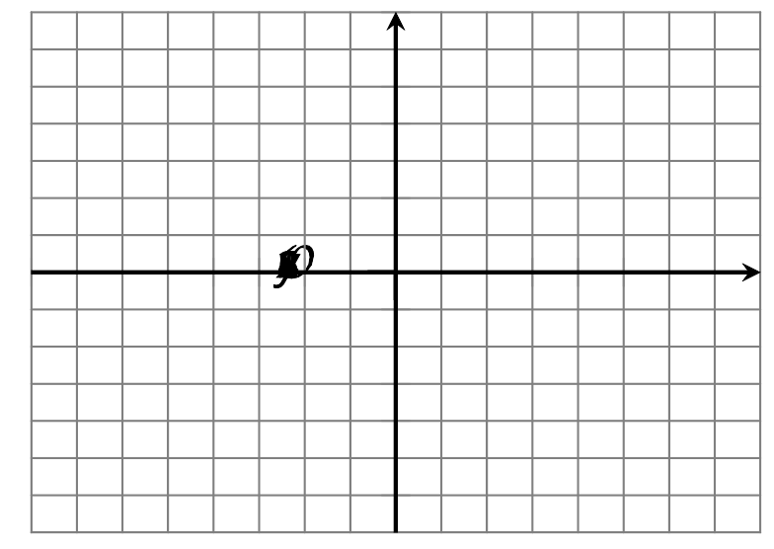
Explanation:
Equation:
Explanation:
Equation:
Explanation:
Equation:
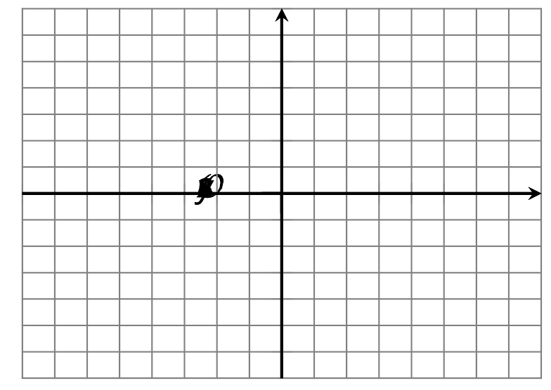
Explanation:
Equation:
Explanation:
Equation:
Explanation:

Lesson 16 Summary
We saw that vertex form is especially helpful for finding the vertex of a graph of a quadratic function. For example, we can tell that the function $p$ given by $p(x)=(x−3)^{2}+1$ has a vertex at $(3,1)$.
We also noticed that, when the squared expression $(x−3)^{2}$ has a positive coefficient, the graph opens upward. This means that the vertex $(3,1)$ represents the minimum function value.
But why does the function $p$ take on its minimum value when $x$ is 3?
Here is one way to explain it: When $x=3$, the squared term $(x−3)^{2}$ equals 0, as $(3−3)^{2}=0^{2}=0$. When $x$ is any other value besides 3, the squared term $(x−3)^{2}$ is a positive number greater than 0. (Squaring any number results in a positive number.) This means that the output when $x≠3$ will always be greater than the output when $x=3$, so the function $p$ has a minimum value at $x=3$.
This table shows some values of the function for some values of $x$. Notice that the output is the least when $x=3$ and it increases both as $x$ increases and as it decreases.
$x$ | 0 | 1 | 2 | 3 | 4 | 5 | 6
$(x−3)^{2}+1$ | 10 | 5 | 2 | 1 | 2 | 5 | 10
The squared term sometimes has a negative coefficient, for instance: $h(x)=\text{-}2(x+4)^{2}$. The $x$ value that makes $(x+4)^{2}$ equal 0 is -4, because $(\text{-}4+4)^{2}=0^{2}=0$. Any other $x$ value makes $(x+4)^{2}$ greater than 0. But when $(x+4)^{2}$ is multiplied by a negative number (-2), the resulting expression, $\text{-}2(x+4)^{2}$, ends up being negative. This means that the output when $x≠\text{-}4$ will always be less than the output when $x=\text{-}4$, so the function $h$ has its maximum value when $x=\text{-}4$.
Remember that we can find the $y$-intercept of the graph representing any function we have seen. The $y$-coordinate of the $y$-intercept is the value of the function when $x=0$. If $g$ is defined by $g(x)=(x+1)^{2}−5$, then the $y$-intercept is $(0,\text{-}4)$ because $g(0)=(0+1)^{2}−5=\text{-}4$. Its vertex is at $(\text{-}1,\text{-}5)$. Another point on the graph with the same $y$-coordinate is located the same horizontal distance from the vertex but on the other side.
© CC BY 2019 by Illustrative Mathematics®

