Lesson 3 Practice Problems
- Consider the equation $x^{2}=9$.
  - Show that 3, -3, $\sqrt{9}$, and $\text{-}\sqrt{9}$ are each a solution to the equation.
  - Show that 9 and $\sqrt{3}$ are each not a solution to the equation.
- Solve ${\left(x−1\right)}^{2}=16$. Explain or show your reasoning.
- Here is one way to solve the equation $\frac{5}{9}y^{2}=5$. Explain what is done in each step.
- $\begin{matrix}\frac{5}{9}y^{2} & =5 & & \text{Original equation} \\ 5y^{2} & =45 & & \text{Step 1} \\ & & & \\ y^{2} & =9 & & \text{Step 2} \\ & & & \\ y=3 & \text{or} y=\text{-}3 & & \text{Step 3}\end{matrix}$
- Diego and Jada are working together to solve the quadratic equation ${\left(x−2\right)}^{2}=100$.
- Diego solves the equation by dividing each side of the equation by 2 and then adding 2 to each side. He writes:
- $\begin{matrix}\left(x−2\right) & =50 \\ x & =52\end{matrix}$
- Jada asks Diego why he divides each side by 2 and he says, “I want to find a number that equals 100 when multiplied by itself. That number is half of 100.”
  - What mistake is Diego making?
  - If you were Jada, what could you say to Diego to help him realize his mistake?
- As part of a publicity stunt (an event designed to draw attention), a TV host drops a watermelon from the top of a tall building. The height of the watermelon $t$ seconds after it is dropped is given by the function $h\left(t\right)=850−16t^{2}$, where $h$ is in feet.
  - Find $h\left(4\right)$. Explain what this value means in this situation.
  - Find $h\left(0\right)$. What does this value tell us about the situation?
  - Is the watermelon still in the air 8 seconds after it is dropped? Explain how you know.
- (From Unit 7, Lesson 1.)
- A zoo offers unlimited drink refills to visitors who purchase its souvenir cup. The cup and the first fill cost $10, and refills after that are $2 each. The expression $10+2r$ represents the total cost of the cup and $r$ refills.
  - A family visited the zoo several times over a summer. That summer, they paid $30 for one cup and multiple refills. How many refills did they buy?
  - A visitor has $18 to spend on drinks at the zoo today and buys a souvenir cup. How many refills can they afford during the visit?
  - Another visitor spent $10 on this deal. Did they buy any refills? Explain how you know.
- (From Unit 7, Lesson 2.)
- Here are a few pairs of positive numbers whose sum is 15. The pair of numbers that have a sum of 15 and will produce the largest possible product is not shown.
- Find this pair of numbers.
- first  number | - second  number | - product
- 1 | - 14 | - 14
- 3 | - 12 | - 36
- 5 | - 10 | - 50
- 7 | - 8 | - 56
- (From Unit 6, Lesson 1.)
- Clare is 5 years older than her sister.
  - Write an equation that defines her sister's age, $s$, as a function of Clare’s age, $c$.
  - Write an equation that defines Clare’s age, $c$, as a function of her sister's age, $s$.
  - Graph each function. Be sure to label the axes.
  - 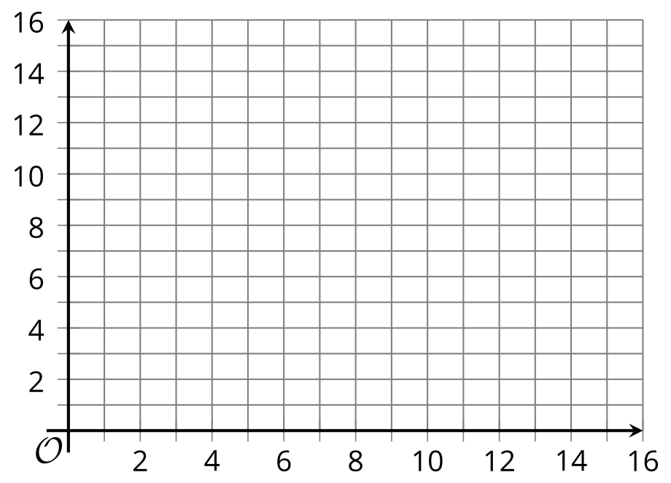
  - Describe how the two graphs compare.
- (From Unit 4, Lesson 15.)
- The graph shows the weight of snow as it melts. The weight decreases exponentially.
  - By what factor does the weight of the snow decrease each hour? Explain how you know.
  - 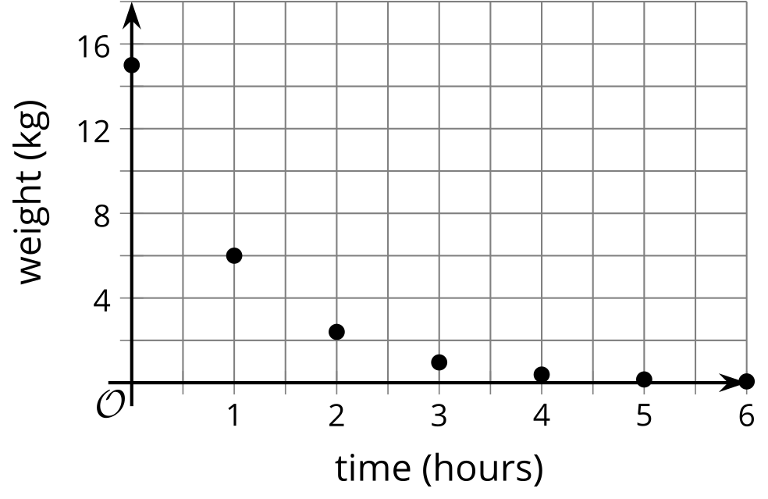
  - Does the graph predict that the weight of the snow will reach 0? Explain your reasoning.
  - Will the weight of the actual snow, represented by the graph, reach 0? Explain how you know.
- (From Unit 5, Lesson 5.)
© CC BY 2019 by Illustrative Mathematics®

