Lesson 13: Incorporating Rotations
Let's draw some transformations.

13.1: Left to Right
The semaphore alphabet is a way to use flags to signal messages. Here's how to signal the letters Z and J. For each, precisely describe a rotation that would take the left hand flag to the right hand flag.

Z
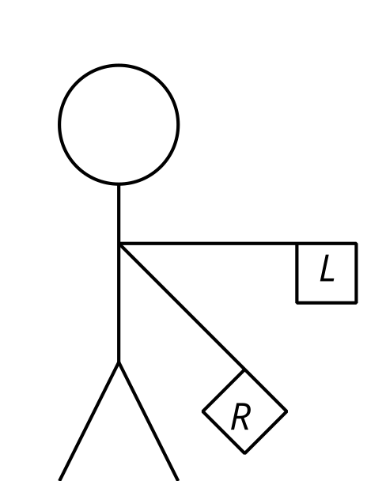

J
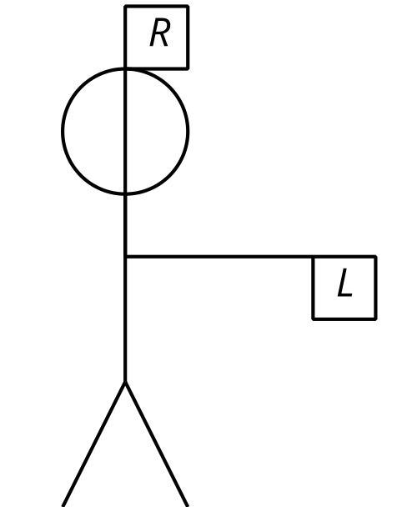

13.2: Turning on a Grid
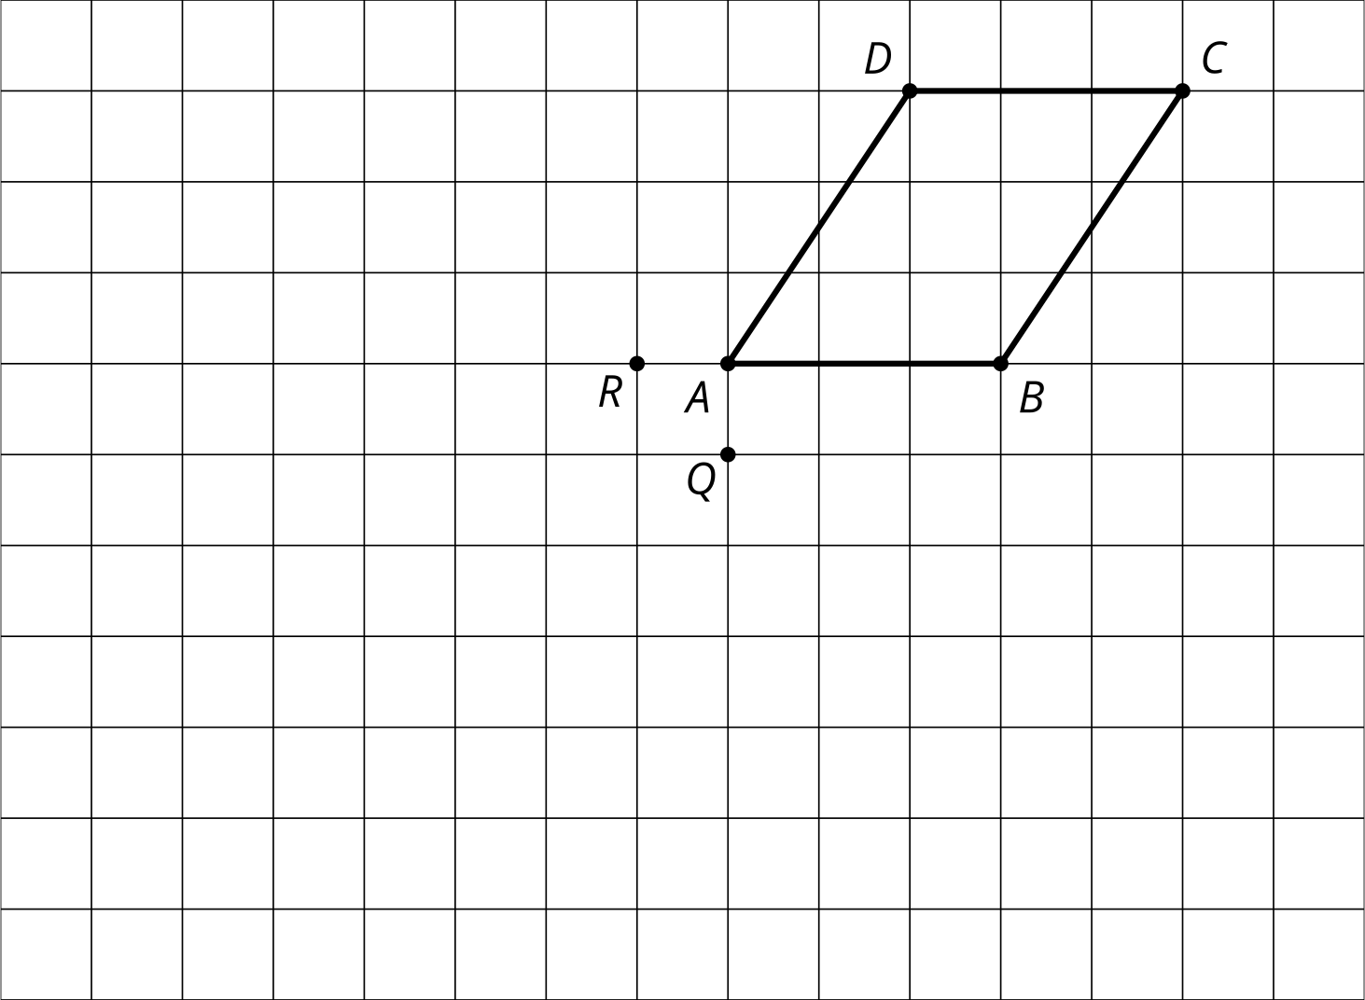
- Rotate $ABCD$ 90 degrees clockwise around $Q$.
- Rotate $ABCD$ 180 degrees around $R$.
- Rotate $HJKLMN$ 120 degrees clockwise around $O$.
- Rotate $HJKLMN$ 60 degrees counterclockwise around $P$.
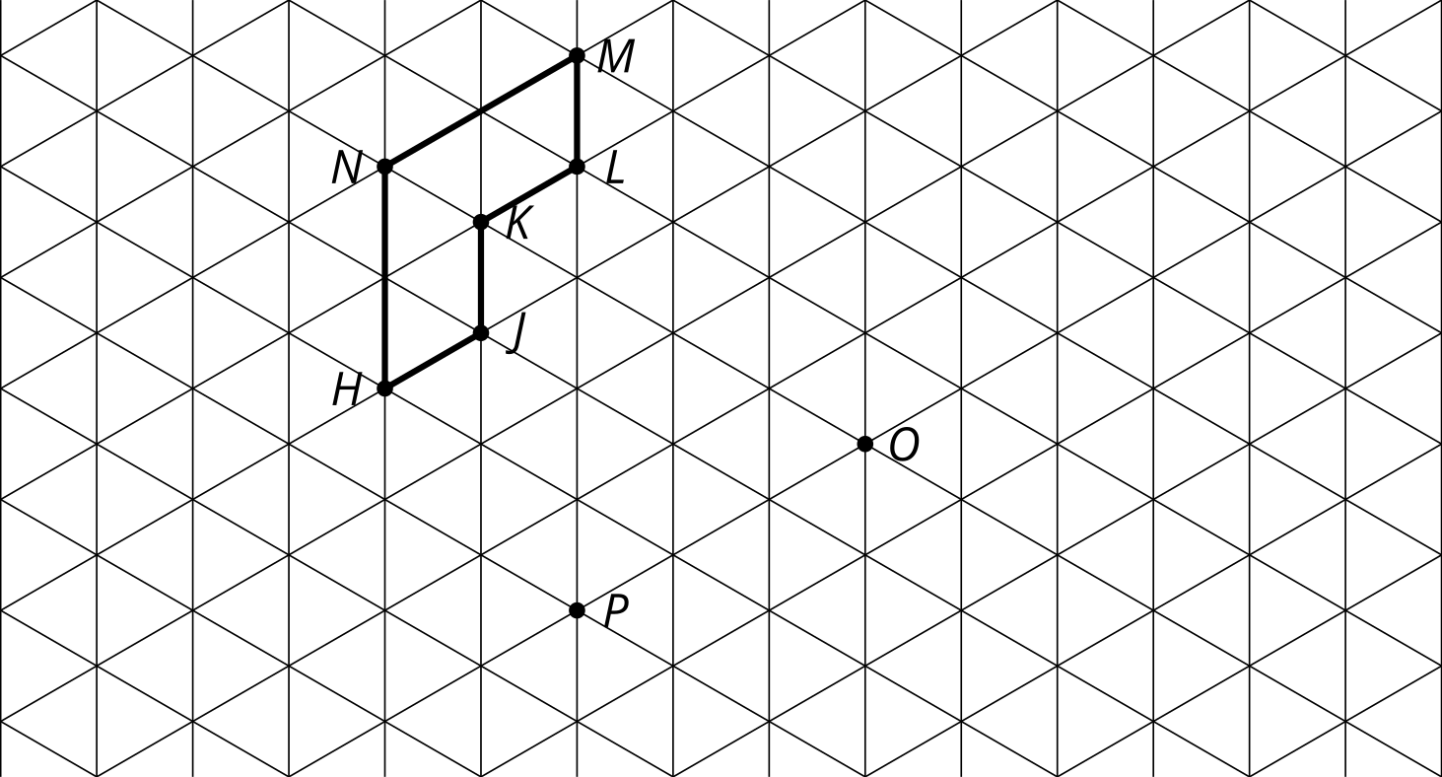

13.3: Translate, Rotate, Reflect
Mai suspects triangle $ABC$ is congruent to triangle $DEF$. She thinks these steps will work to show there is a rigid transformation from $ABC$ to $DEF$.
- Translate by directed line segment $v$.
- Rotate the image ____ degrees clockwise around point $D$.
- Reflect that image over line $DE$.
Draw each image and determine the angle of rotation needed for these steps to take $ABC$ to $DEF$.
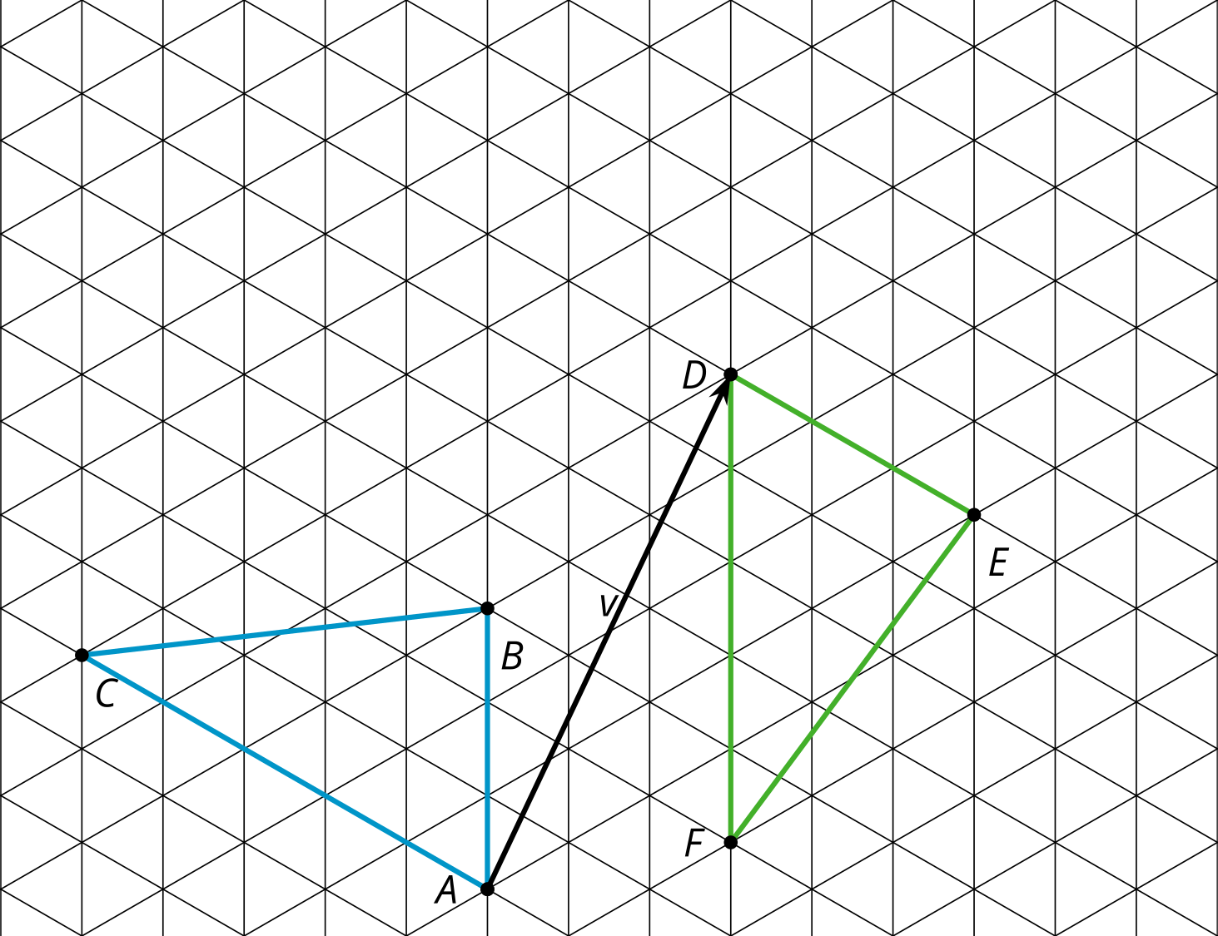

Are you ready for more?
Mai’s first 2 steps could be combined into a single rotation.
- Find the center and angle of this rotation.
- Describe a general procedure for finding a center of rotation.

Lesson 13 Summary
The 3 rigid motions are reflect, translate, and rotate. Each of these rigid motions can be applied to any figure to create an image that is congruent. To do a rotation, we need to know 3 things: the center, the direction, and the angle.
Rotate $ABCD$ 90 degrees clockwise around point $P$.
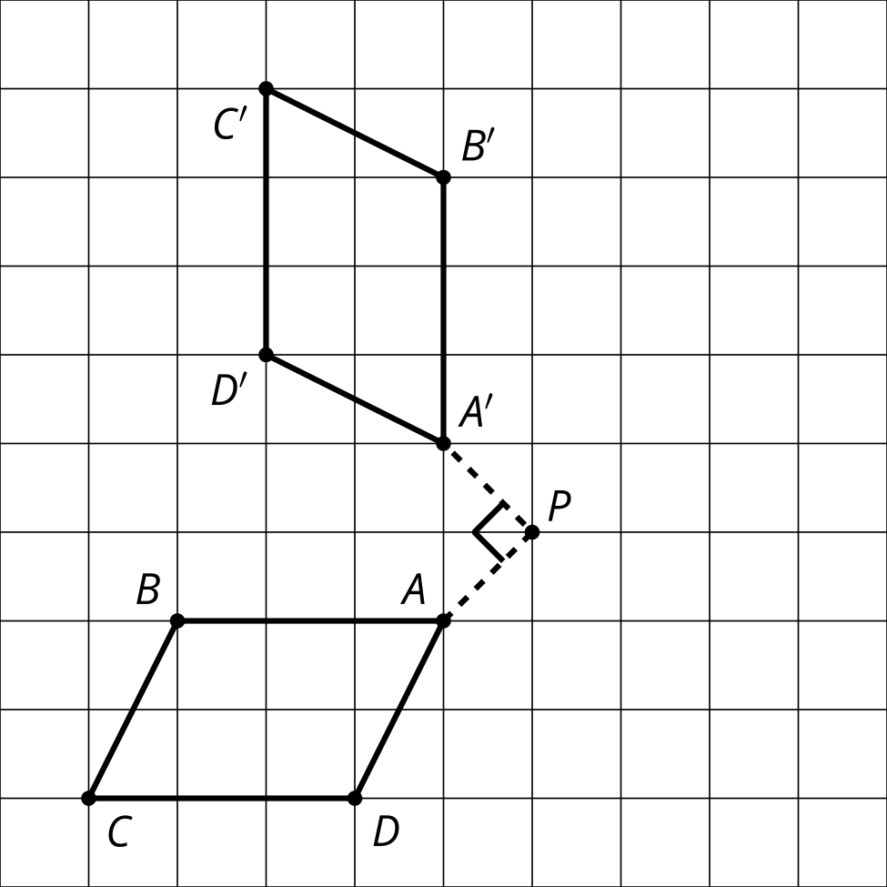
Rotate $EFG$ 120 degrees counterclockwise around point $C$.
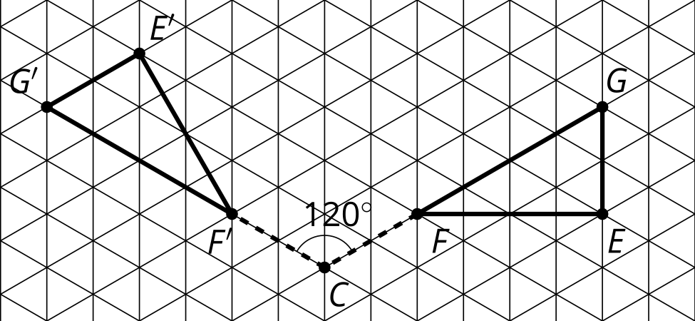
© CC BY 2019 by Illustrative Mathematics®

