Lesson 11: Patterns and Ordered Pairs

Standards Alignments
Addressing | 5.OA.B.3
Building Towards | 5.G.A.1

Teacher-facing Learning Goals
- Form ordered pairs consisting of corresponding terms from two patterns and graph the ordered pairs on a coordinate grid.

Student-facing Learning Goals
- Let’s graph patterns on the coordinate grid.

Lesson Purpose
The purpose of this lesson is for students to represent corresponding terms in two patterns on the coordinate grid.
The purpose of this lesson is to continue to analyze the relationship between two patterns by plotting corresponding numbers on the coordinate grid. After generating patterns in previous lessons, students now make ordered pairs from those numbers and plot them on the coordinate grid. They observe patterns and interpret the meaning of points on the coordinate grid in terms of generating rules.

Access for:

Students with Disabilities
- Action and Expression (Activity 1)

English Learners
- MLR8 (Activity 1)

Instructional Routines
Notice and Wonder (Warm-up)

Lesson Timeline
Warm-up | 10 min
Activity 1 | 20 min
Activity 2 | 15 min
Lesson Synthesis | 10 min
Cool-down | 5 min

Teacher Reflection Question
What strategy did most students use in their work today?

Cool-down
(to be completed at the end of the lesson) 5min
2 Rules

Standards Alignments
Addressing | 5.OA.B.3

Student-facing Task Statement
- Complete the patterns for each rule.
 | - A | - B | - C | - D
- Rule 1: Start at 0. Add 3.
- Rule 2: Start at 0. Add 6.
- What relationships do you notice between corresponding terms in the two patterns?
- Plot and label the points on the coordinate grid.
- 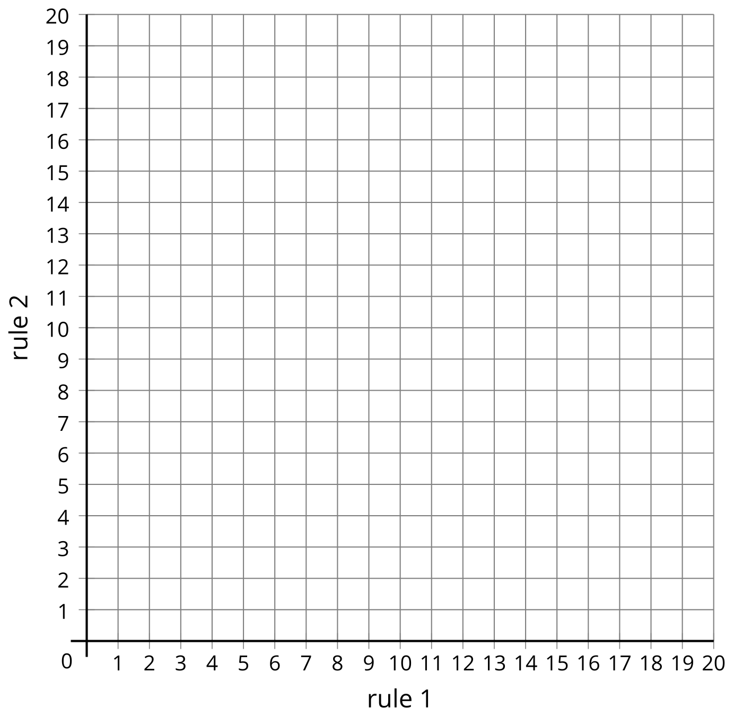

Student Responses
 | - A | - B | - C | - D
- Rule 1: Start at 0. Add 3. | - 0 | - 3 | - 6 | - 9
- Rule 2: Start at 0. Add 6. | - 0 | - 6 | - 12 | - 18
- The numbers with rule 2 are twice as large as the corresponding numbers with rule 1. The numbers with rule 1 are $\frac{1}{2}$ the corresponding numbers with rule 2.

- 