Lesson 11: Class Pet Surveys
- Let’s see what the data tells us.

Warm-up: Notice and Wonder: Tally Marks
What do you notice?
What do you wonder?
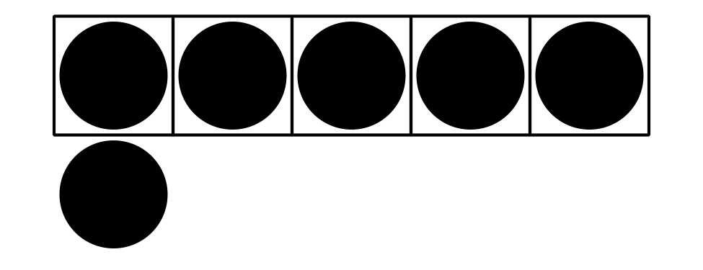

11.1: Jada’s Class Pet Survey
Jada took a survey of her classmates and asked, “Which animal would make the best class pet?”
She showed their responses.
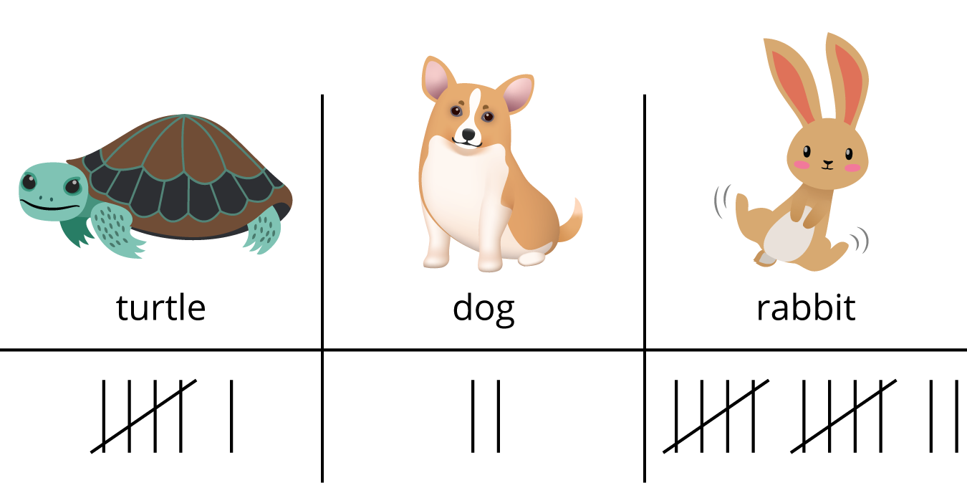
Decide whether each statement is true or false.
Be ready to explain why.
- There are 12 votes for rabbit.
- 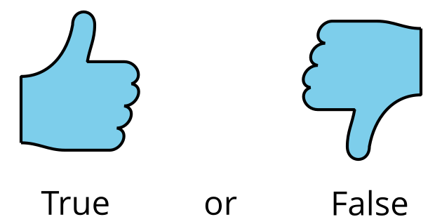
- There are 18 votes all together.
- 14 students voted for turtle or rabbit.
- 8 students voted for dog or turtle.

11.2: Interpret Data About Class Pets
Tyler asked the same survey question to his classmates.
He showed their responses.
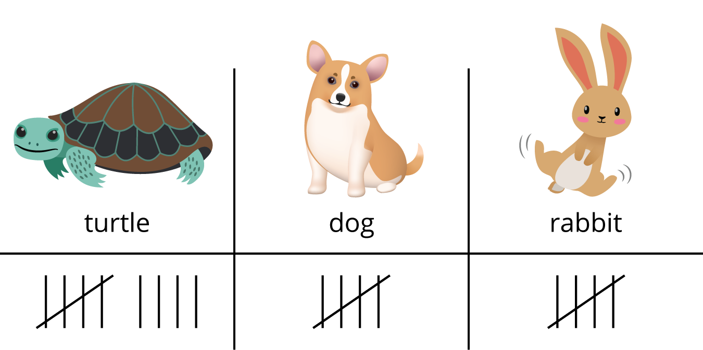
Write 3 things that you learned about Tyler’s survey data from the representation.

11.3: Centers: Choice Time
Choose a center.
What’s Behind My Back
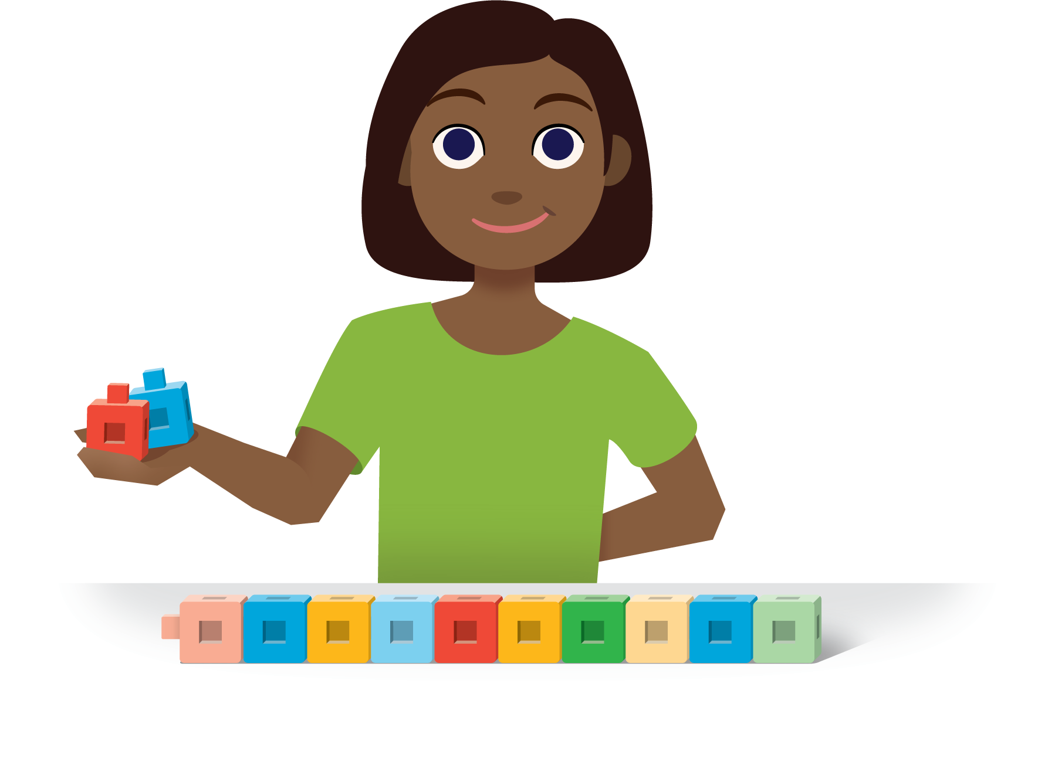
Check it Off
Five in a Row: Addition and Subtraction
Find the Pair
© CC BY 2021 Illustrative Mathematics®

