Unit 4 Lesson 2: Features of a Number Line

WU Choral Count: Count by 5 (Warm up)

Student Task Statement

1 Class Number Line

Student Task Statement

2 Analyze Number Lines

Student Task Statement
Jada's number line
Andre’s number line
Elena’s number line
- How should Jada revise her number line?
- How should Andre revise his number line?
- Elena’s number line
- How should Elena revise her number line?
- Fill in the numbers to create your own number line.
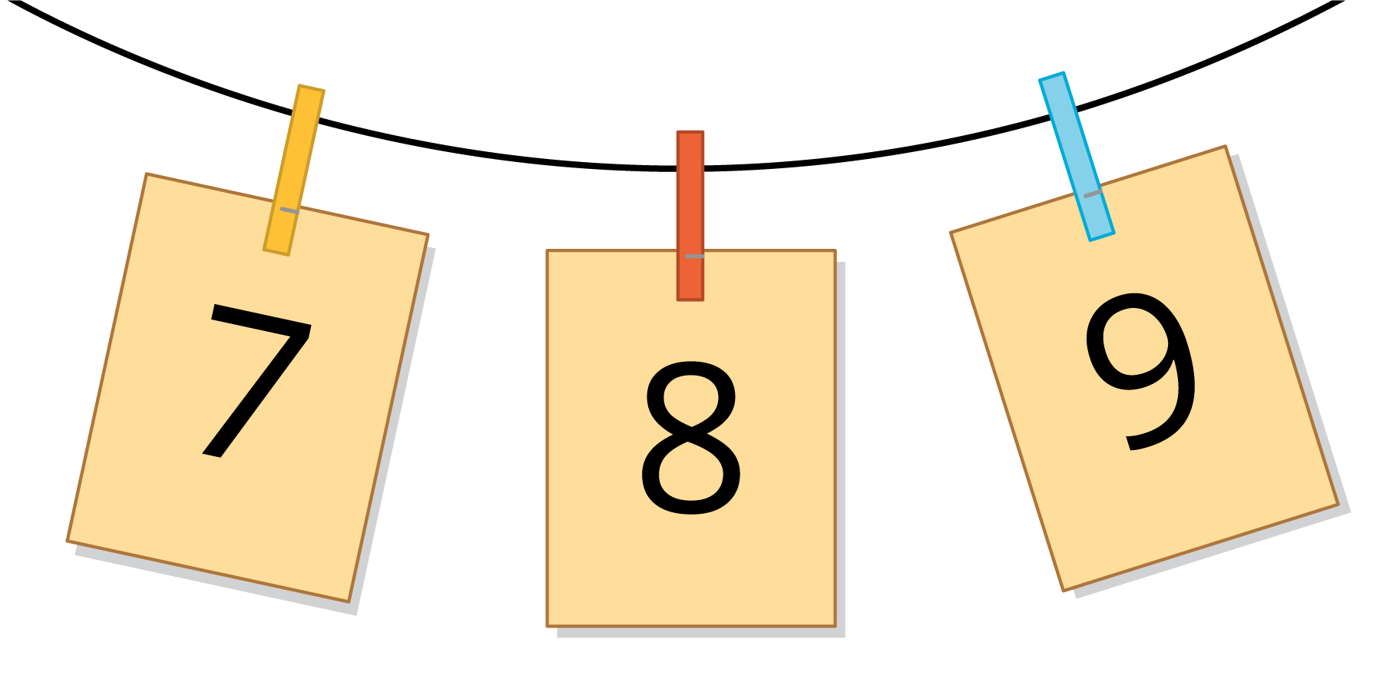
© CC BY 2021 Illustrative Mathematics®

