Unit 2 Lesson 11: Area and the Multiplication Table

WU How Many Do You See: Arrays that Grow (Warm up)

Student Task Statement
How many do you see? How do you see them?
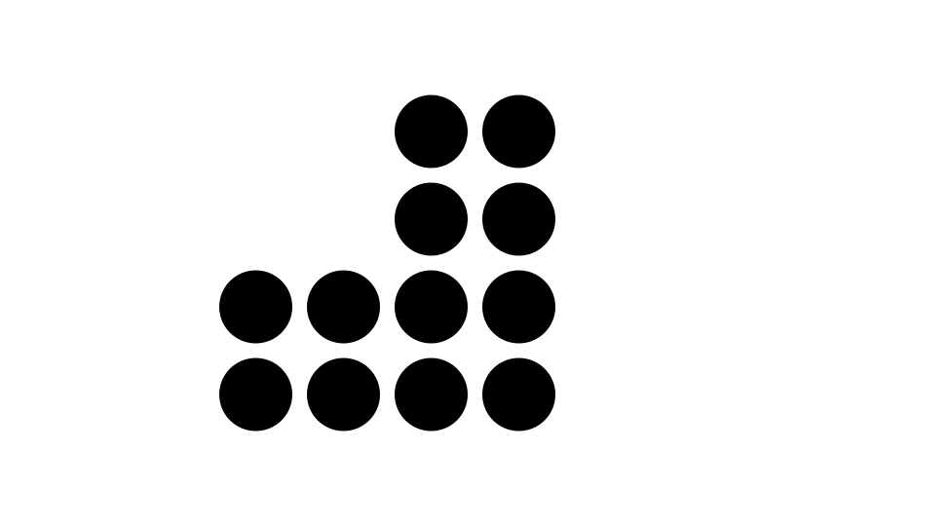
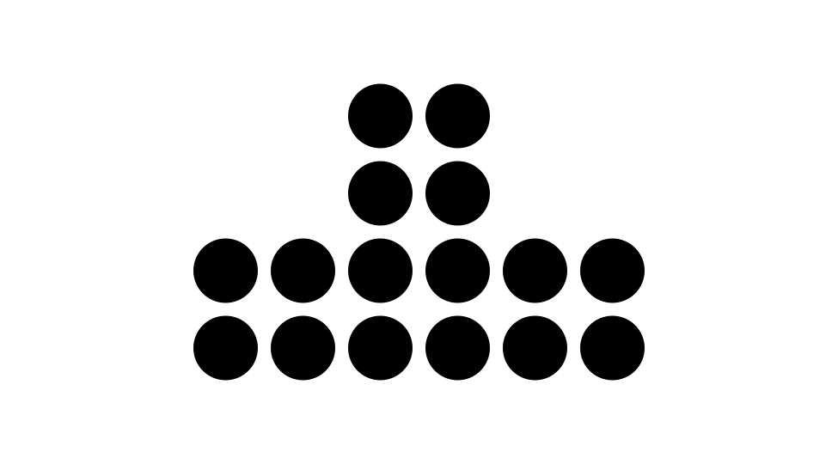

1 Area and the Multiplication Table

Student Task Statement
What do you notice? What do you wonder?
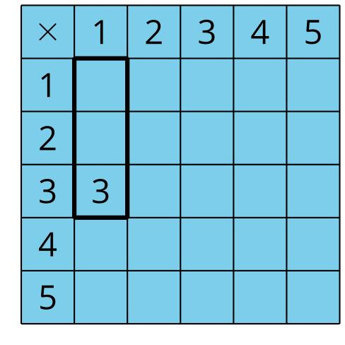
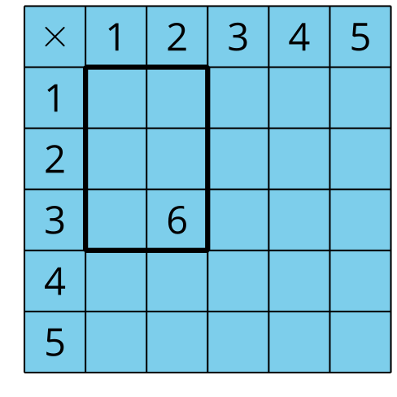
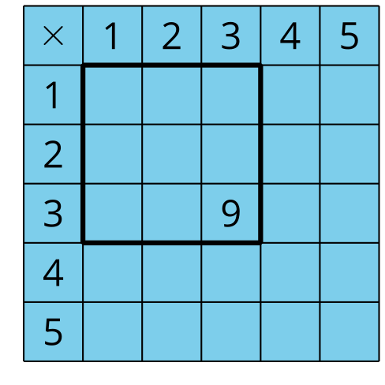
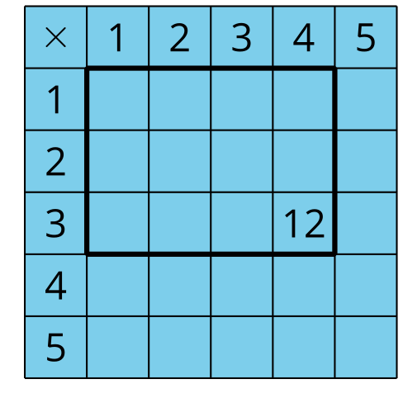
- Use the blank table to create your own rectangle.
- Start from the top left corner. Record the product that the rectangle represents. Be prepared to explain your reasoning.
- 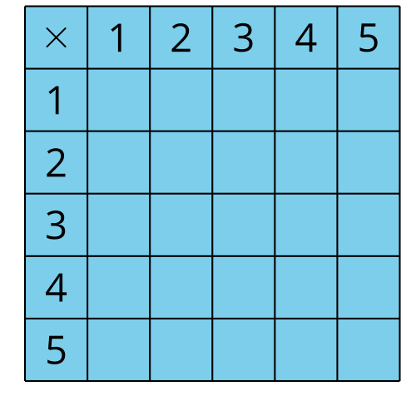
- Use the following table to create a rectangle with an area of 24 square units. Start from the top left corner. Record the product that the rectangle represents. Be prepared to explain your reasoning.
- 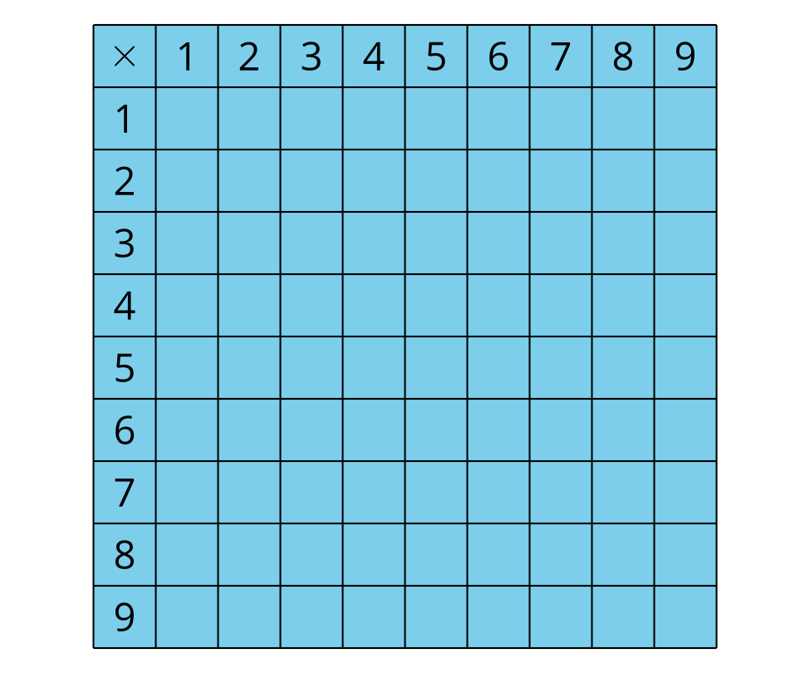

2 Products in the Multiplication Table

Student Task Statement
What do you notice? What do you wonder?
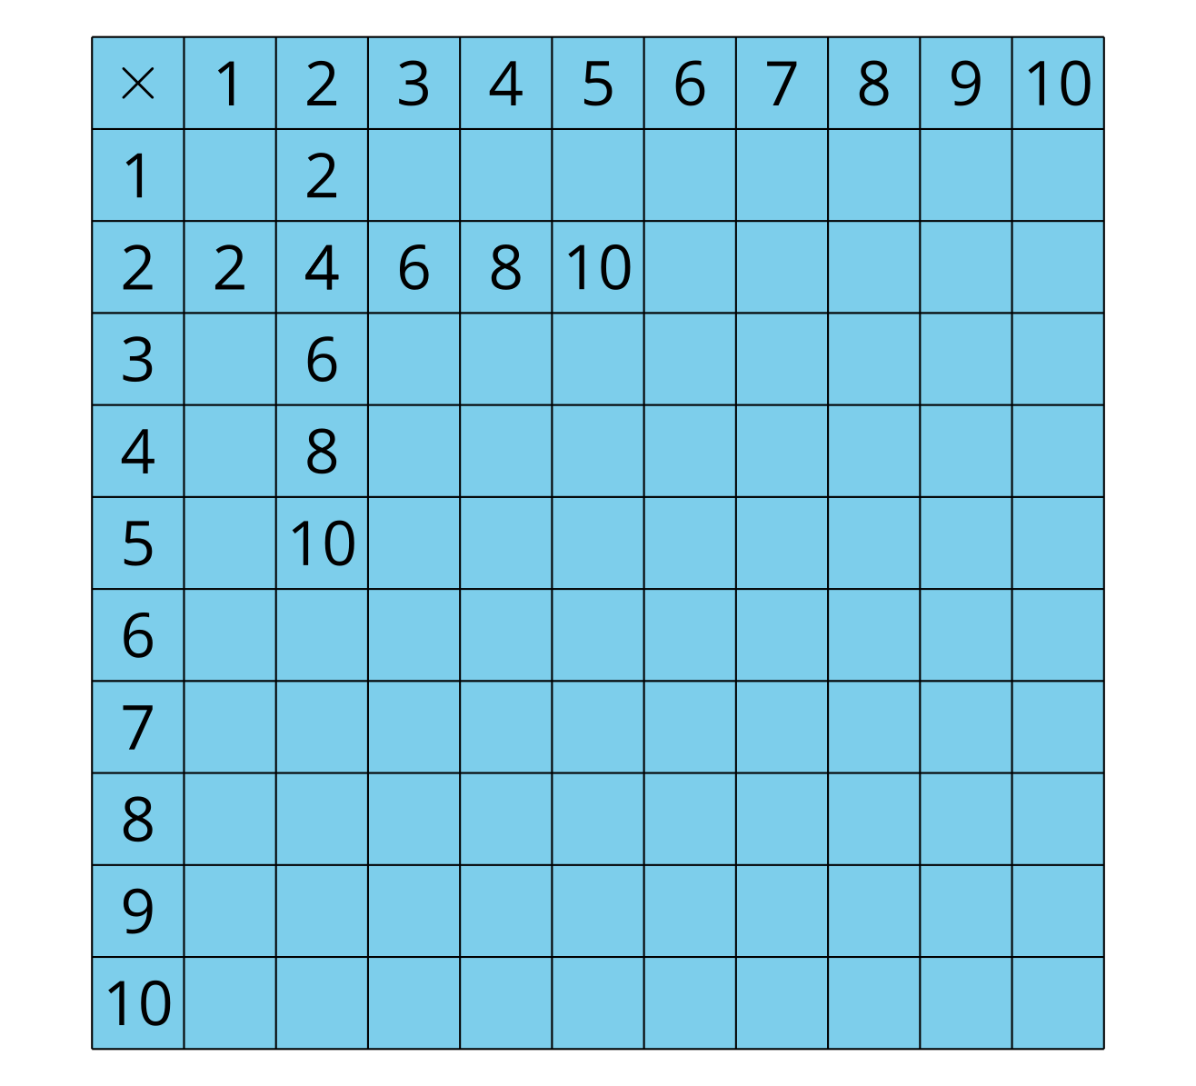
- Find as many other products in the table as you can. You may want to start with rows and columns that show products of 2, 5, and 10.
- What patterns do you see in the row and column that show products of 5?
- Write some equations that show one of the patterns that you see in the multiplication table. Explain or show your reasoning.
© CC BY 2021 Illustrative Mathematics®

