Lesson 1: Equal Groups of Unit Fractions
- Let’s look at equal groups of fractions.

Warm-up: How Many Do You See: Oranges
How many do you see? How do you see them?

1.1: Crackers, Kiwis, and More
- Here are images of some crackers.
- A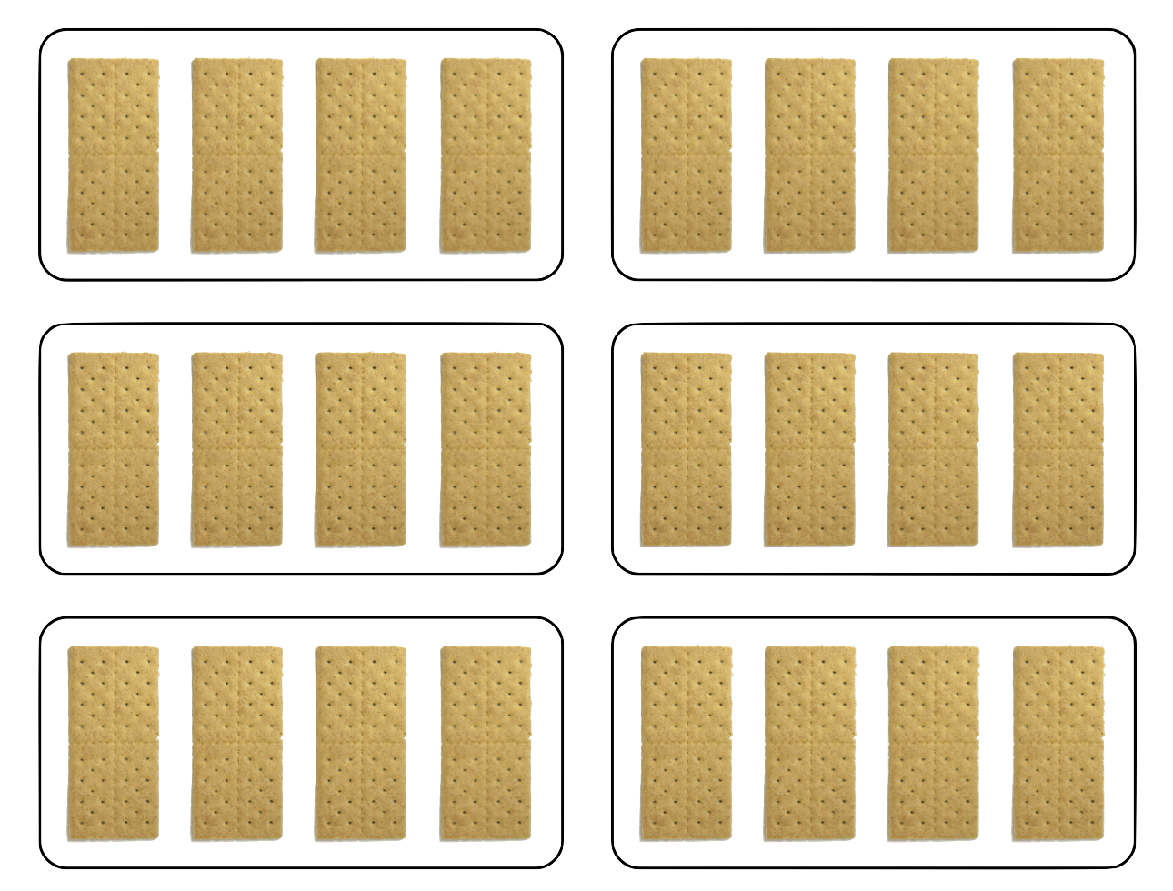
- B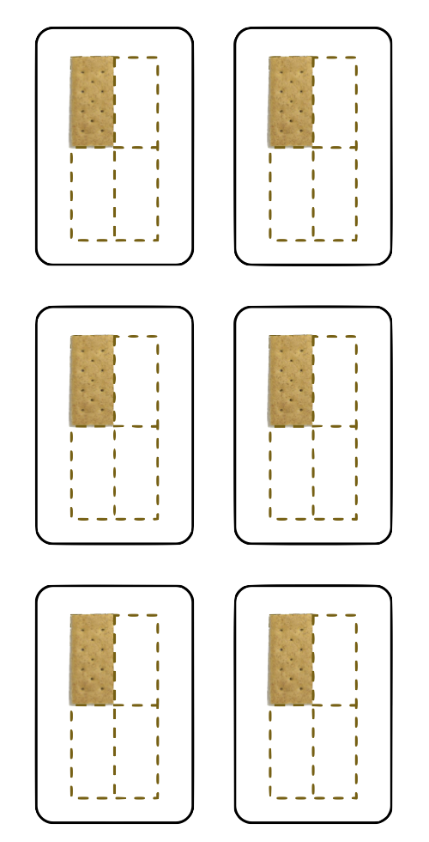
  - How are the crackers in image A like those in B?
  - How are they different?
  - How many crackers are in each image?
  - Write an expression to represent the crackers in each image.
- Here are more images and descriptions of food items. For each, write a multiplication expression to represent the quantity. Then, answer the question.
  - Clare has 3 baskets. She put 4 eggs into each basket. How many eggs did she put in baskets?
  - 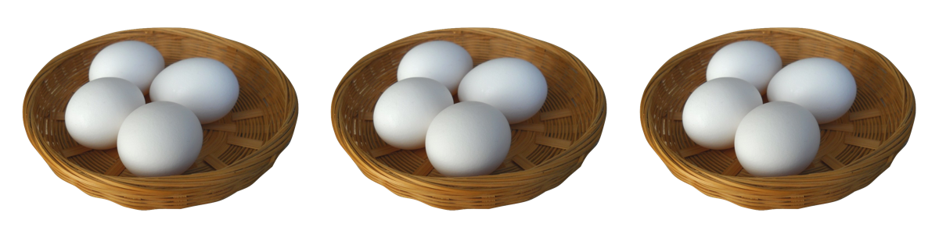
  - Diego has 5 plates. He put $\frac{1}{2}$ of a kiwi fruit on each plate. How many kiwis did he put on plates?
  - 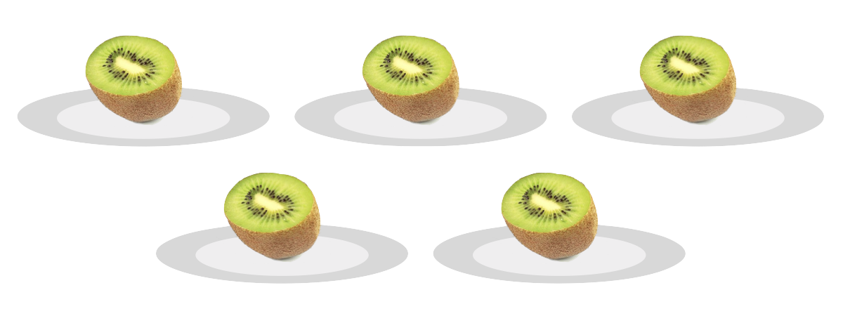
  - Priya prepared 7 plates with $\frac{1}{8}$ of a pie on each. How much pie did she put on plates?
  - 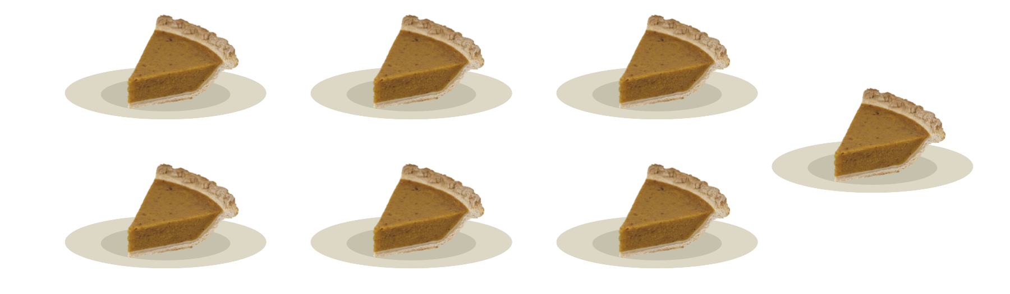
  - Noah scooped $\frac{1}{3}$ cup of brown rice 8 times. How many cups of brown rice did he scoop?
  - 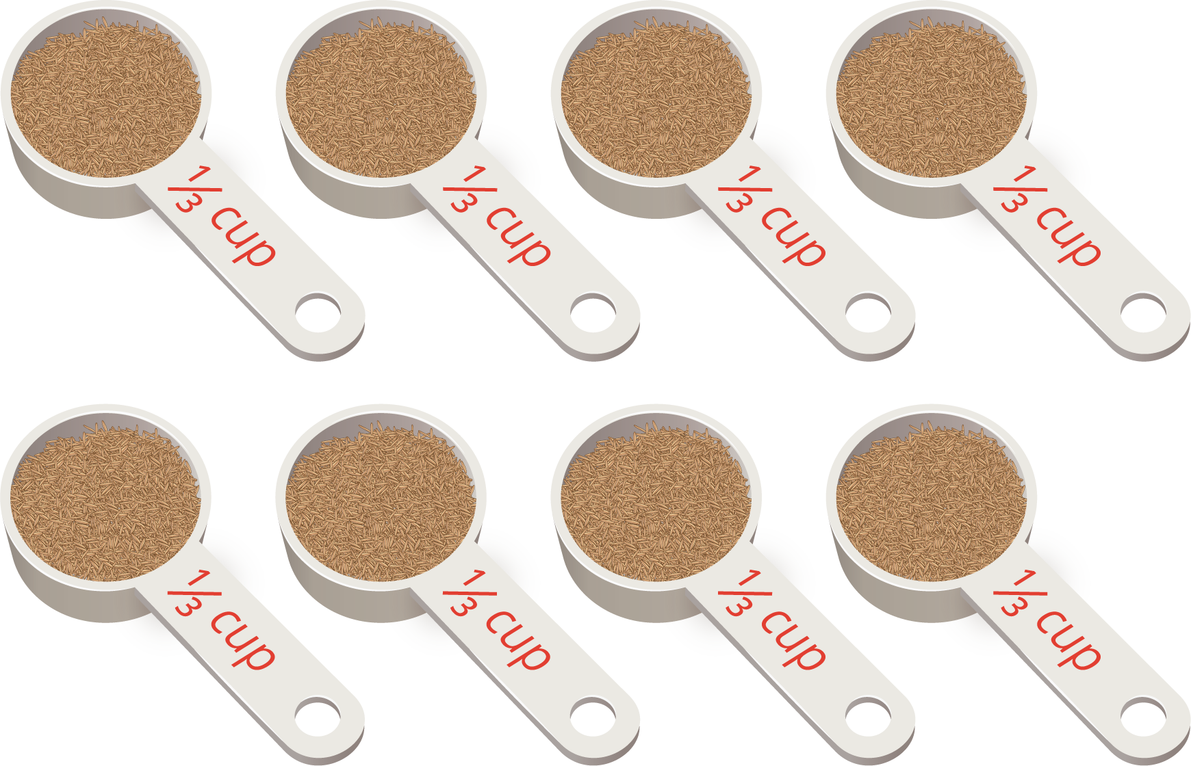

1.2: What Could It Mean?
For each expression:
- Write a story that the expression could represent. The story should be about a situation with equal groups.
- Create a drawing to represent the situation.
- Find the value of the expression. What does this number mean in your story?
- $8×\frac{1}{2}$
- $7×\frac{1}{5}$
© CC BY 2021 Illustrative Mathematics®

