Lesson 7: Classroom Scavenger Hunt
- Let’s look for groups of objects in the classroom.

Warm-up: Act It Out: How Can We Show It?
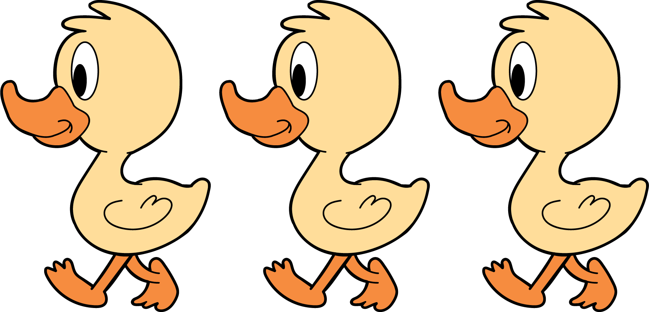
3 little ducks went out one day,
over the hill and far away.
Mother duck said, “Quack, quack, quack.”
Then 3 little ducks came back.

7.1: How Many Do You See: Two Images
How many do you see?
How do you see them?
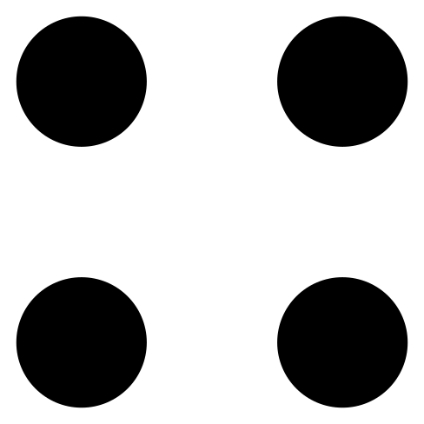

7.3: Centers: Choice Time
Choose a center.
Geoblocks
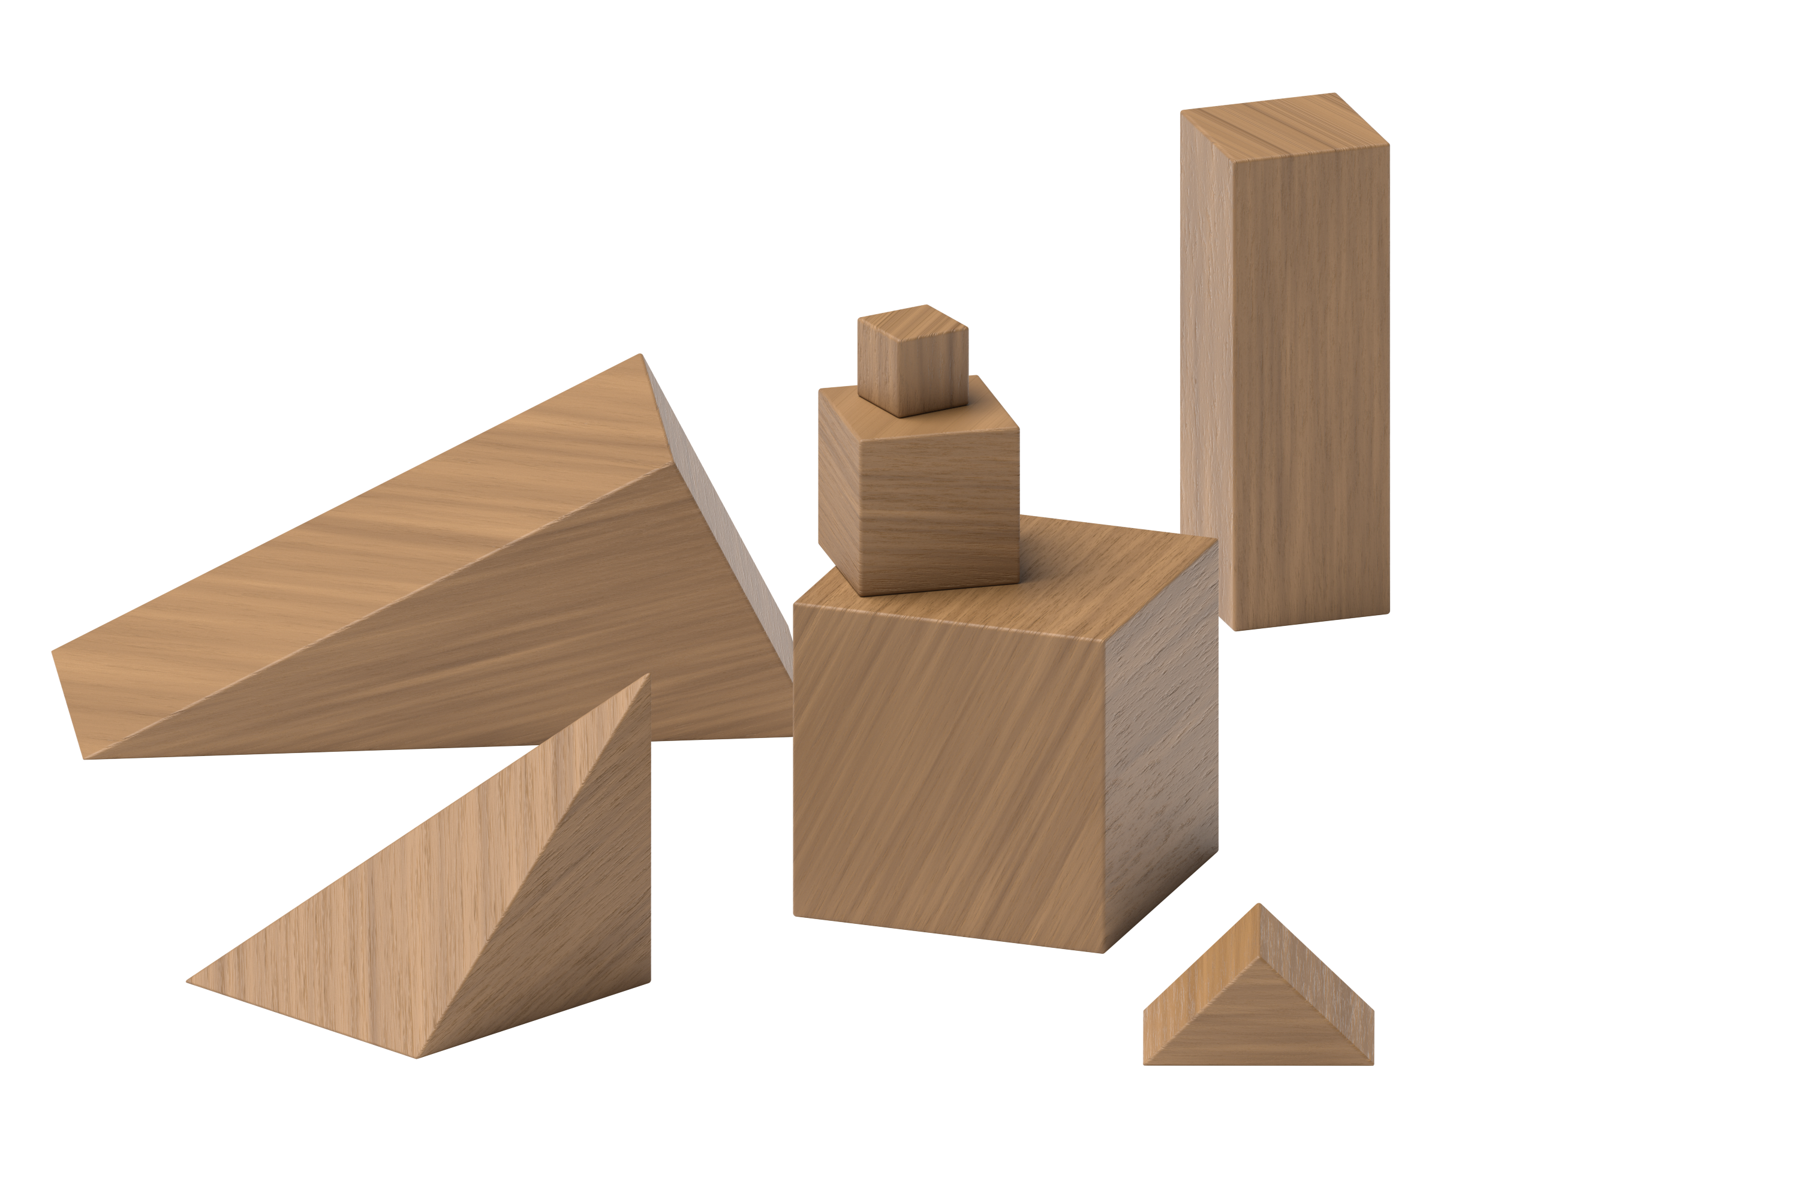
Connecting Cubes
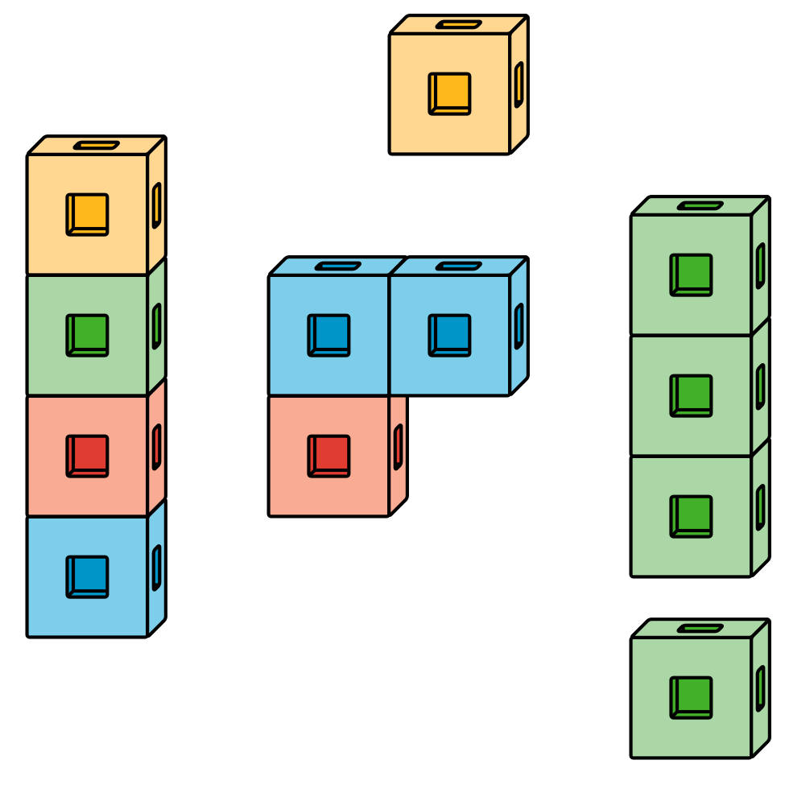
Pattern Blocks
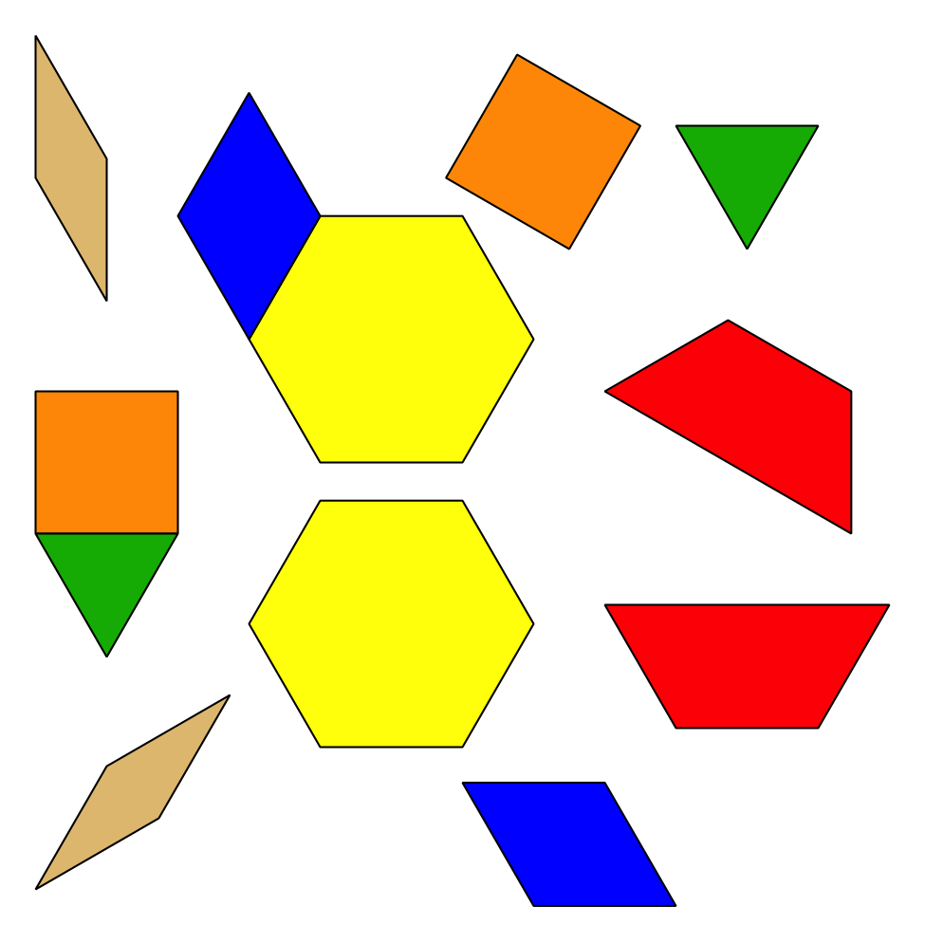
Picture Books
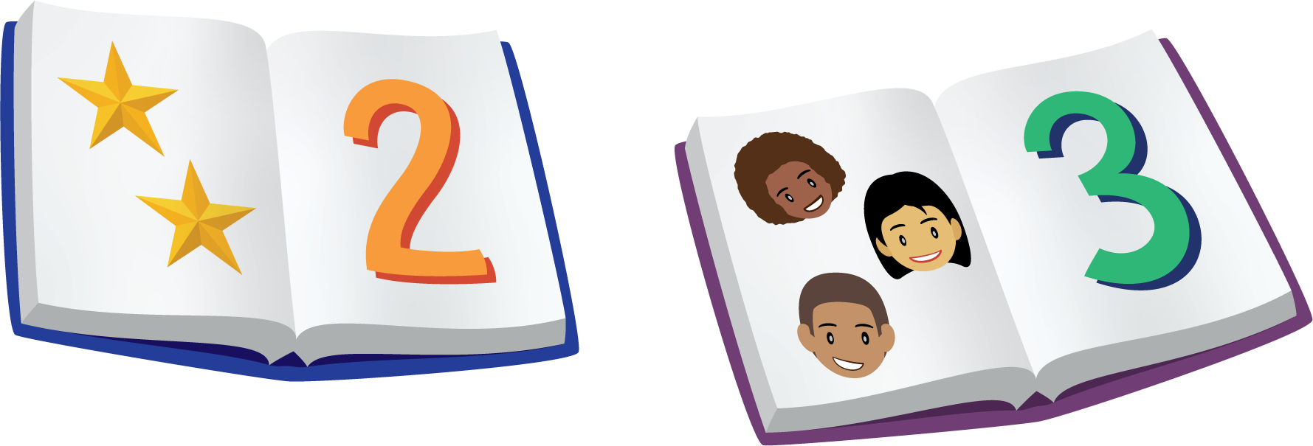
© CC BY 2021 Illustrative Mathematics®

