Lesson 4 Practice Problems
- If the equation $\left(x+10\right)x=0$ is true, which statement is also true according to the zero product property?
  - only $x=0$
  - either $x=0$ or $x+10=0$
  - either $x^{2}=0$ or $10x=0$
  - only $x+10=0$
- What are the solutions to the equation $\left(10−x\right)\left(3x−9\right)=0$?
  - -10 and 3
  - -10 and 9
  - 10 and 3
  - 10 and 9
- Solve each equation.
  - $\left(x−6\right)\left(x+5\right)=0$
  - $\left(x−3\right)\left(\frac{2}{3}x−6\right)=0$
  - $\left(\text{-}3x−15\right)\left(x+7\right)=0$
- Consider the expressions $\left(x−4\right)\left(3x−6\right)$ and $3x^{2}−18x+24$.
- Show that the two expressions define the same function.
- Kiran saw that if the equation $\left(x+2\right)\left(x−4\right)=0$ is true, then, by the zero product property, either $x+2$ is 0 or $x−4$ is 0. He then reasoned that, if $\left(x+2\right)\left(x−4\right)=72$ is true, then either $x+2$ is equal to 72 or $x−4$ is equal to 72.
- Explain why Kiran’s conclusion is incorrect.
- Andre wants to solve the equation $5x^{2}−4x−18=20$. He uses a graphing calculator to graph $y=5x^{2}−4x−18$ and $y=20$ and finds that the graphs cross at the points $\left(\text{-}2.39,20\right)$ and $\left(3.19,20\right)$.
  - Substitute each $x$-value Andre found into the expression $5x^{2}−4x−18$. Then evaluate the expression.
  - Why did neither solution make $5x^{2}−4x−18$ equal exactly 20?
- (From Unit 7, Lesson 2.)
- Select all the solutions to the equation $7x^{2}=343$.
  - 49
  - $\text{-}\sqrt{7}$
  - 7
  - -7
  - $\sqrt{49}$
  - $\sqrt{\text{-}49}$
  - $\text{-}\sqrt{49}$
- (From Unit 7, Lesson 3.)
- Here are two graphs that correspond to two patients, A and B. Each graph shows the amount of insulin, in micrograms (mcg) in a patient's body $h$ hours after receiving an injection. The amount of insulin in each patient decreases exponentially.

- Patient A
- 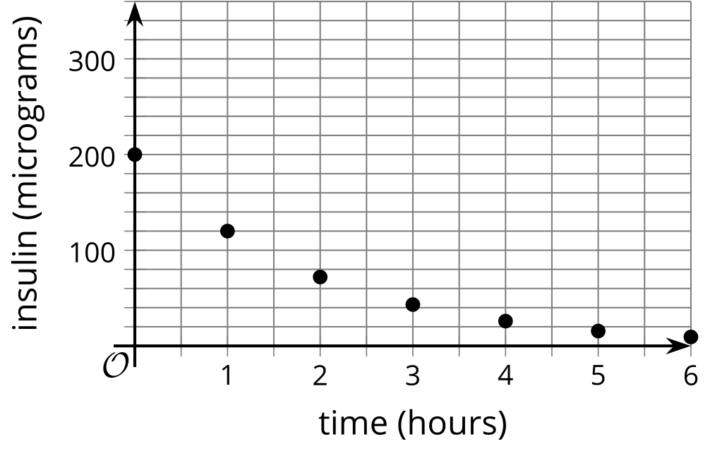
- ​​​​​​

- Patient B
- 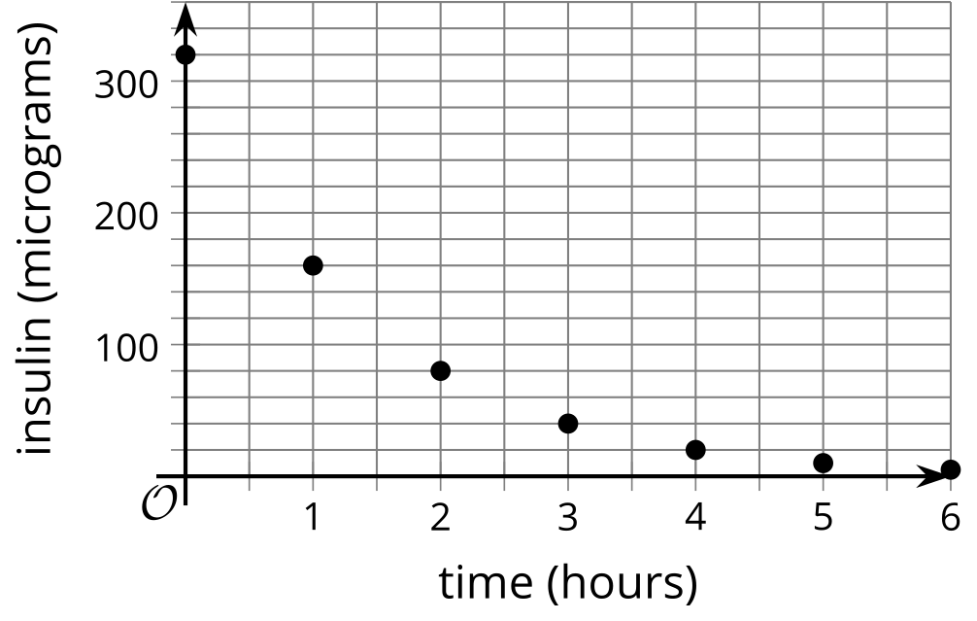
- Select all statements that are true about the insulin level of the two patients.
  - After the injection, the patients have the same amount of insulin in their bodies.
  - An equation for the micrograms of insulin, $a$, in Patient A's body $h$ hours after the injection is $a=200⋅{\left(\frac{3}{5}\right)}^{h}$.
  - The insulin in Patient A is decaying at a faster rate than in Patient B.
  - After 3 hours, Patient A has more insulin in their body than Patient B.
  - At some time between 2 and 3 hours, the patients have the same insulin level.
- (From Unit 5, Lesson 6.)
- Han says this pattern of dots can be represented by a quadratic relationship because the dots are arranged in a rectangle in each step.
- Do you agree? Explain your reasoning.
- 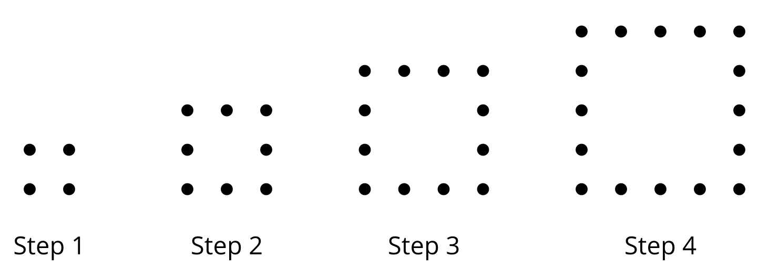
- (From Unit 6, Lesson 2.)
© CC BY 2019 by Illustrative Mathematics®

