Lesson 14: Defining Rotations
- Let’s rotate shapes precisely.

14.1: Math Talk: Comparing Angles
For each figure, which pair of angles appears congruent? How could you check?

Figure 1
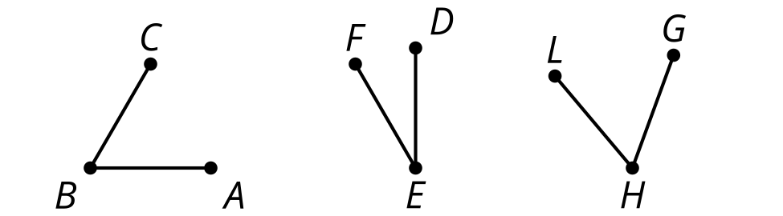

Figure 2
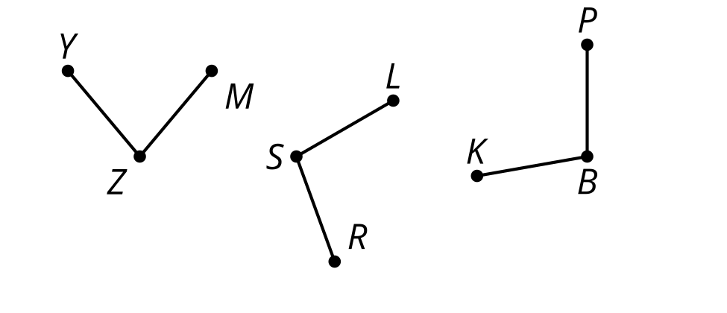

Figure 3
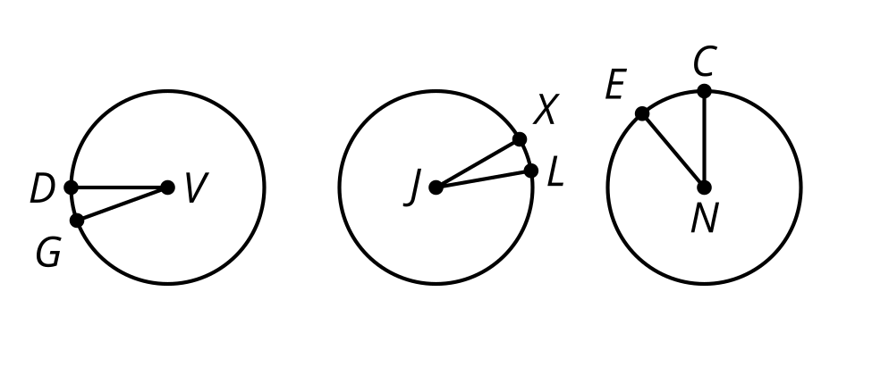

Figure 4
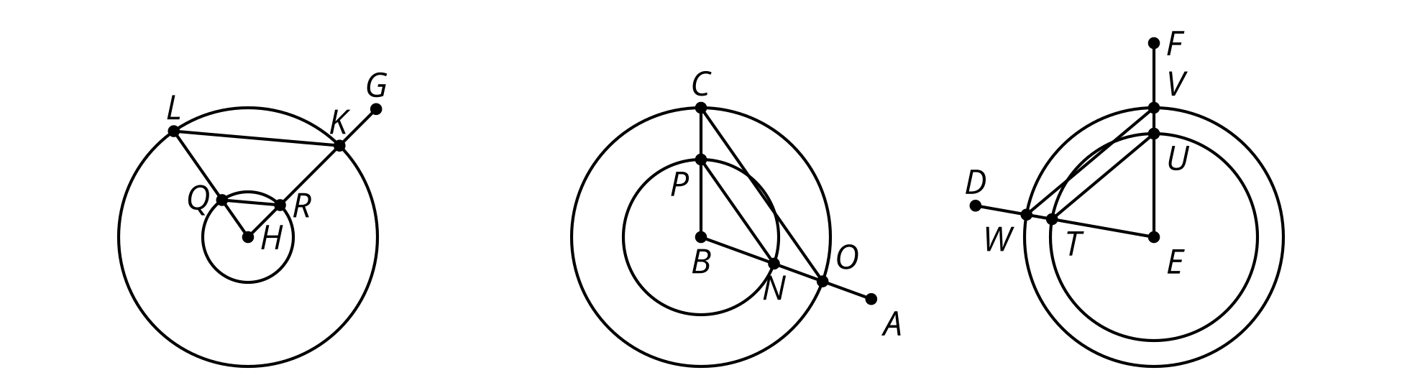

14.2: Info Gap: What’s the Point: Rotations
Your teacher will give you either a problem card or a data card. Do not show or read your card to your partner.
If your teacher gives you the data card:
- Silently read the information on your card.
- Ask your partner “What specific information do you need?” and wait for your partner to ask for information. Only give information that is on your card. (Do not figure out anything for your partner!)
- Before telling your partner the information, ask “Why do you need to know (that piece of information)?”
- Read the problem card, and solve the problem independently.
- Share the data card, and discuss your reasoning.
If your teacher gives you the problem card:
- Silently read your card and think about what information you need to answer the question.
- Ask your partner for the specific information that you need.
- Explain to your partner how you are using the information to solve the problem.
- When you have enough information, share the problem card with your partner, and solve the problem independently.
- Read the data card, and discuss your reasoning.
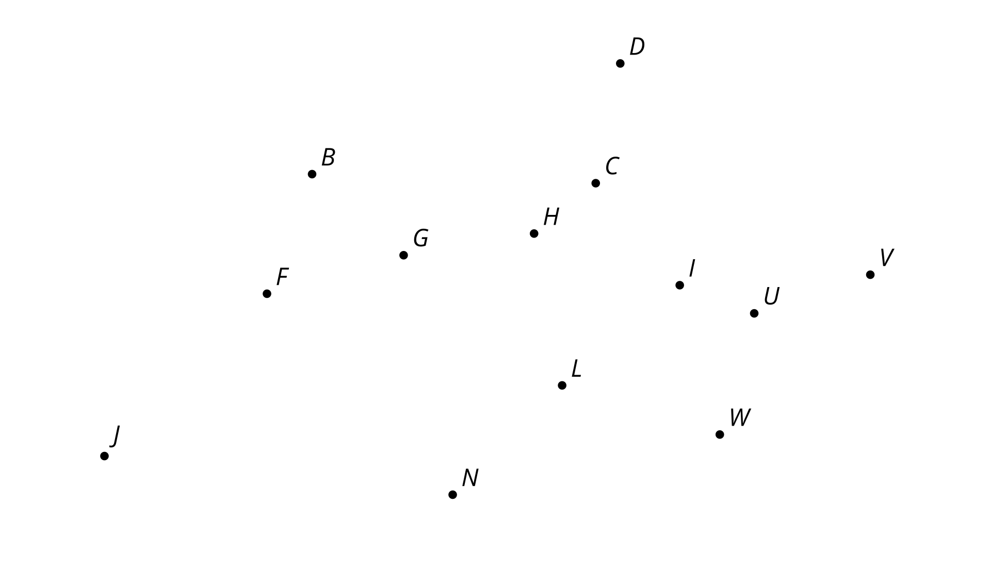

14.3: Turning into Triangles
- Draw a segment. Label the endpoints $A$ and $B$.
  - Rotate segment $AB$ clockwise around center $B$ by 90 degrees. Label the new endpoint $A^{′}$.
  - Connect $A$ to $A^{′}$ and lightly shade in the resulting triangle.
  - What kind of triangle did you draw? What other properties do you notice in the figure? Explain your reasoning.
- Draw a segment. Label the endpoints $C$ and $D$.
  - Rotate segment $CD$ counterclockwise around center $D$ by 30 degrees. Label the new endpoint $C^{′}$.
  - Rotate segment $C^{′}D$ counterclockwise around center $D$ by 30 degrees. Label the new endpoint $C^{″}$.
  - Connect $C$ to $C^{″}$ and lightly shade in the resulting triangle.
  - What kind of triangle did you draw? What other properties do you notice in the figure? Explain your reasoning.

Are you ready for more?
You constructed an equilateral triangle by rotating a given segment around one of its endpoints by a specific angle measure. An equilateral triangle is an example of a regular polygon: a polygon with all sides congruent and all interior angles congruent. Try to construct some other regular polygons with this method.

Lesson 14 Summary
A rotation is a transformation with a center, an angle, and a direction (clockwise or counterclockwise).
Here is how a rotation with a center point $C$, an angle that measures $t$ degrees, and a counterclockwise direction transforms a point $P$:
- The rotation sends point $P$ to a point $P^{′}$ on the circle of radius $CP$.
- The angle $PCP^{′}$ measures $t$ degrees and $P^{′}$ is counterclockwise around the circle from $P$.
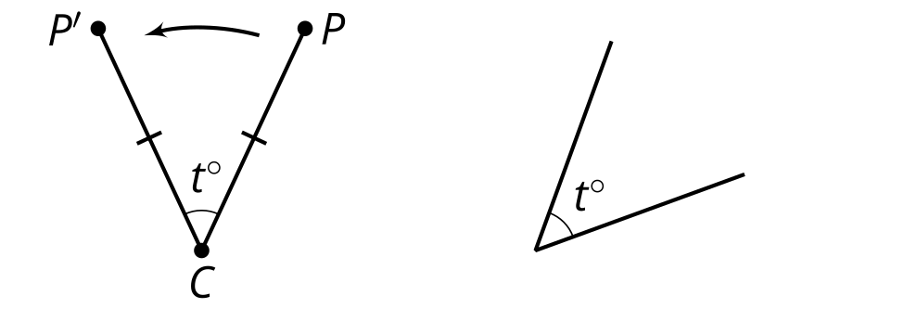
If the direction were clockwise instead, then $P^{′}$ would be clockwise around the circle of radius $CP$. If $P$ and $C$ are in the same place, then the rotation sends $P$ to $P^{′}$ on the circle of radius zero, and so points $P$, $C$, and $P^{′}$ are all in the same place.
© CC BY 2019 by Illustrative Mathematics®

