Lesson 12: Represent Problems on the Coordinate Grid

Standards Alignments
Addressing | 5.G.A.2, 5.OA.A.2

Teacher-facing Learning Goals
- Represent real world and mathematical problems by graphing points in the first quadrant of the coordinate grid, and interpret coordinate values of points in the context of the situation.

Student-facing Learning Goals
- Let’s represent problems on the coordinate grid.

Lesson Purpose
The purpose of this lesson is for students to represent situations by plotting and interpreting points on the coordinate grid.
The purpose of this lesson is to use the coordinate grid to represent real world data. Students work with coins in two different ways. In the first activity, they flip the coin 10 times and plot the number of heads and number of tails they get. Students plot their results on the coordinate grid and also interpret points in terms of coin flipping. In the second activity, students consider the number of coins and their total value. Again the focus is on plotting and interpreting points representing different sets of coins (MP2).

Access for:

Students with Disabilities
- Engagement (Activity 1)

Instructional Routines
MLR6 Three Reads (Activity 1), True or False (Warm-up)

Materials to Gather
- Coins: Activity 1

Lesson Timeline
Warm-up | 10 min
Activity 1 | 15 min
Activity 2 | 15 min
Lesson Synthesis | 10 min
Cool-down | 5 min

Teacher Reflection Question
With only one lesson remaining in the unit, where do you see evidence of growth in each of your students’ understandings? For students about whom you are not sure, make a note and find out more about their thinking tomorrow.

Cool-down
(to be completed at the end of the lesson) 5min
Half Dollar

Standards Alignments
Addressing | 5.G.A.2

Student-facing Task Statement
The coordinate grid shows the weight of some half dollars.
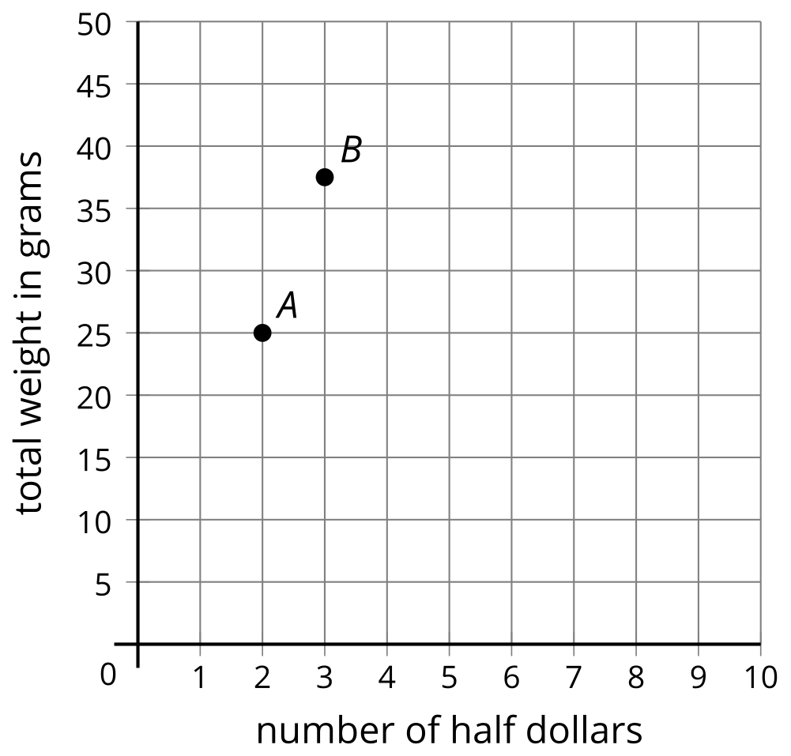
Pick one of the points and describe what it represents.

Student Responses
Sample responses:
A. 2 half dollars weigh 25 grams
B. 3 half dollars weigh 37.5 grams (or 37 grams or 38 grams)

