Lesson 1: Standard Units of Measure
- Let’s measure length.

Warm-up: What Do You Know About Measuring?
What do you know about measuring?

1.1: Priya’s Pet
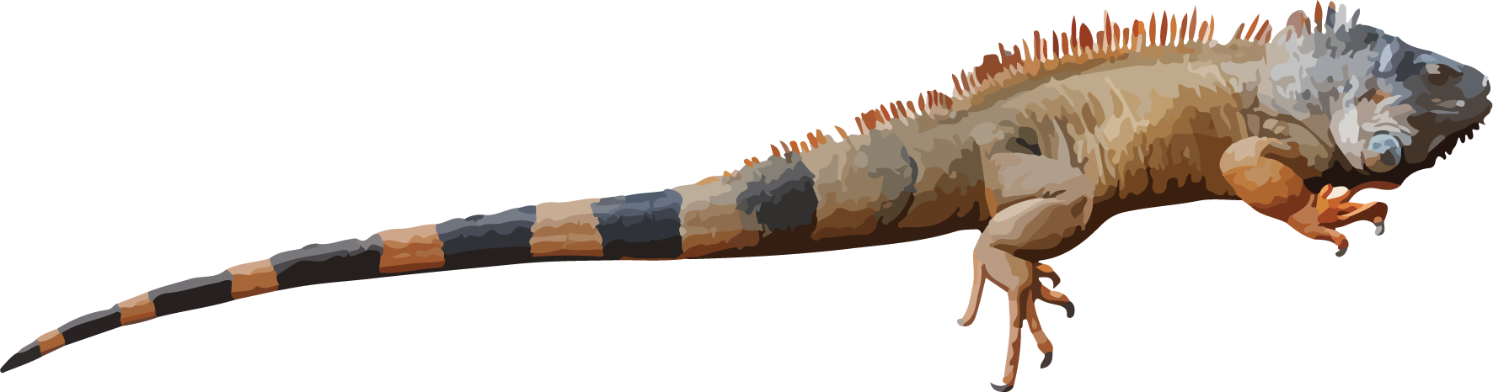
Use straws to measure the string that shows how long Priya's iguana is.
Priya’s iguana is ____________ straws long.

1.2: Use a Standard Unit
Use the cubes to measure Priya’s string.
- Priya’s iguana is ______ cubes long.
- Compare your measurement with another group.
© CC BY 2021 Illustrative Mathematics®

