Unit 4 Lesson 3: Unlabeled Tick Marks

WU Notice and Wonder: From 0 to 30 (Warm up)

Student Task Statement
What do you notice? What do you wonder?
A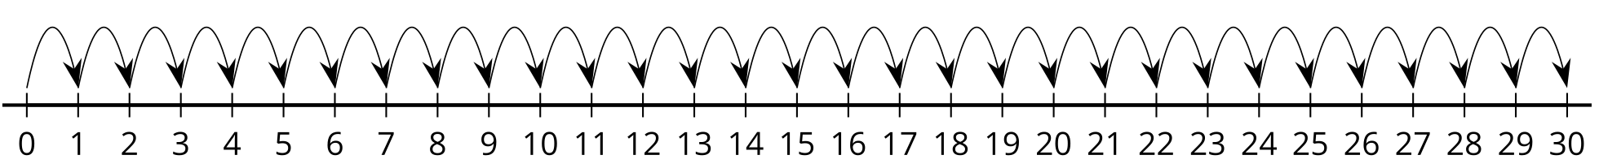
B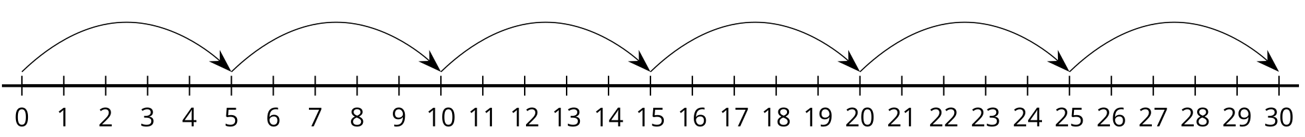
C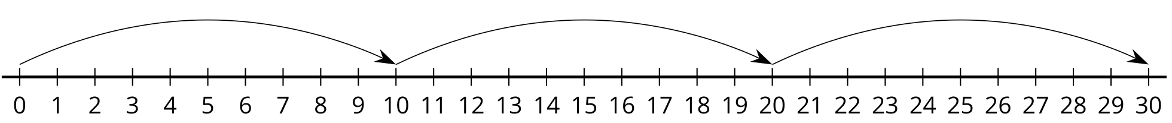

1 Locate the Numbers

Images for Launch

Student Task Statement
- Locate 24 on the number line. Mark it with a point.
- Locate 37 on the number line. Mark it with a point.
- Locate 48 on the number line. Mark it with a point.
- Locate 83 on the number line. Mark it with a point.
- Explain how you know the numbers you located are at the right spot on each number line.

2 Are You Missing Something?

Student Task Statement
Complete each number line by filling in the labels with the number the tick mark represents. Then, locate each number, mark it with a point, and label it with the number it represents.
- Locate and label 17 on the number line.
- 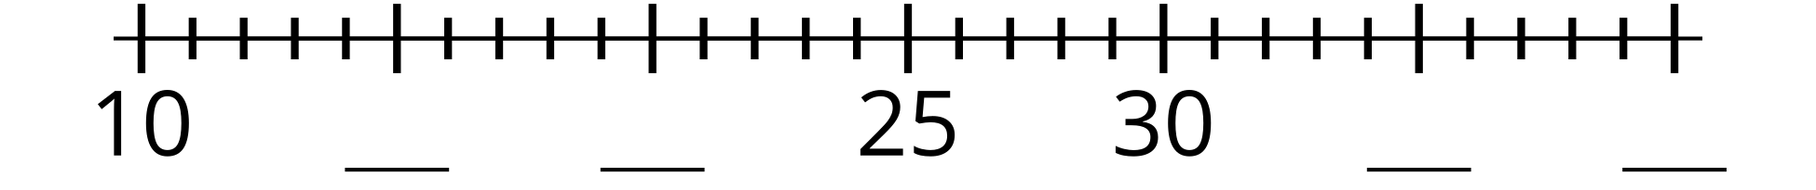
- Locate and label 59 on the number line.
- 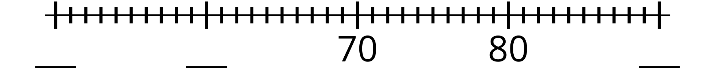
- Locate and label 43 on the number line.
- 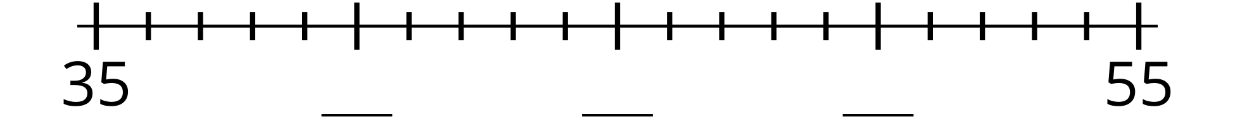
- Locate and label 35 on the number line.
- Share your number lines with your partner.
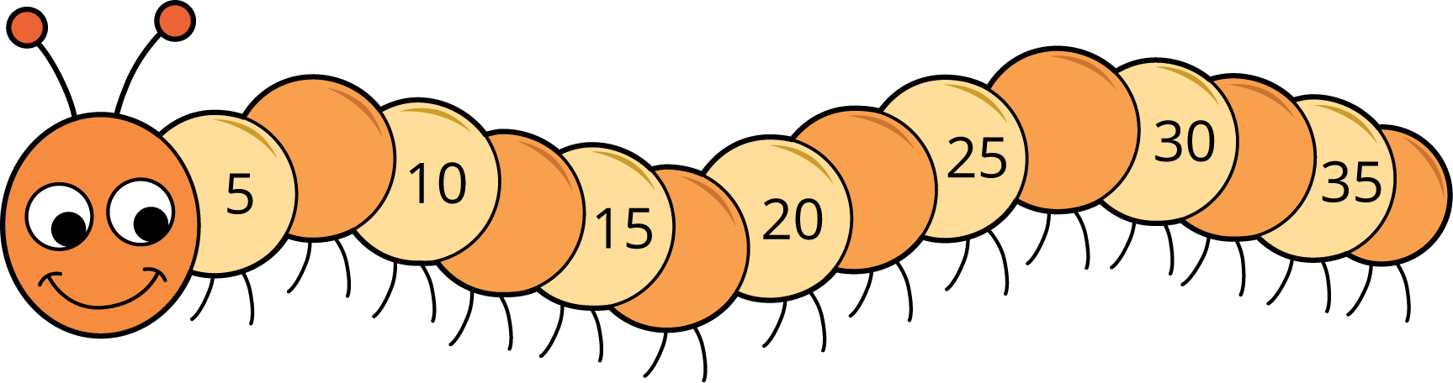
© CC BY 2021 Illustrative Mathematics®

