Unit 5 Lesson 9: All Kinds of Numbers on the Number Line

WU Which One Doesn’t Belong: Many Number Lines (Warm up)

Student Task Statement
Which one doesn’t belong?
A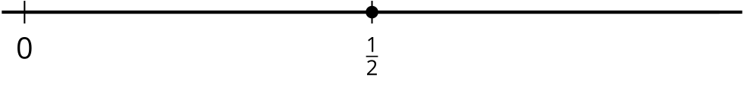
B
C
D

1 Locate 1 Again

Student Task Statement
- Locate and label 1 on each number line.

- Use any of the number lines to explain how you located 1.
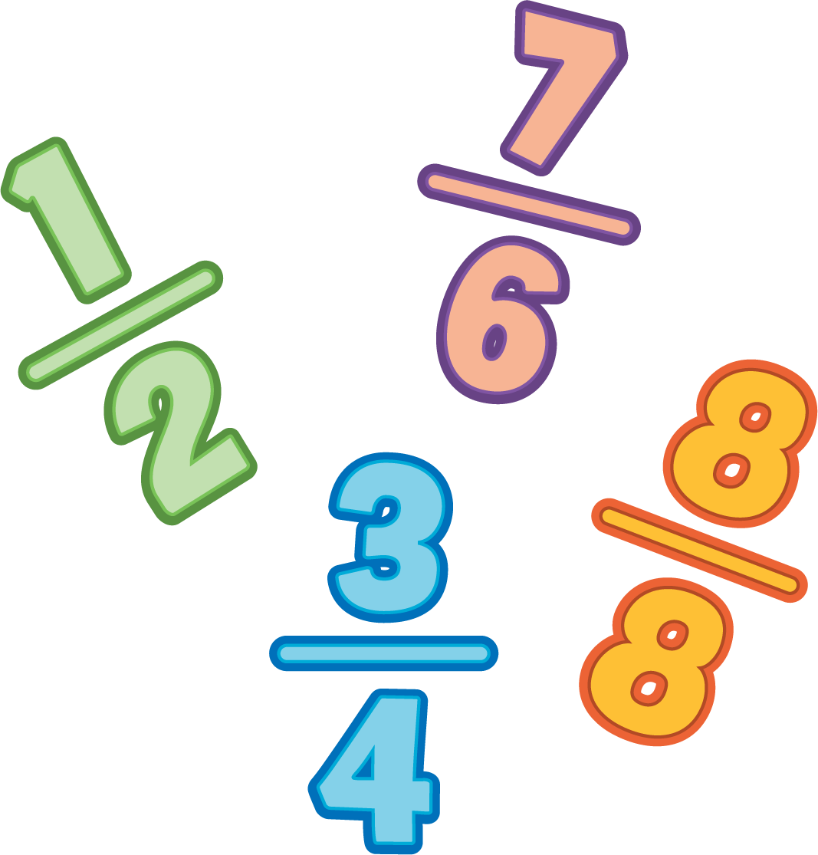

2 Locate $\frac{3}{4}$ (Optional)

Student Task Statement
Locate and label $\frac{3}{4}$ on the number line. Be prepared to explain your reasoning.
© CC BY 2021 Illustrative Mathematics®

