Unit 2 Lesson 12: Area and Addition

WU Number Talk: So Close (Warm up)

Student Task Statement
Find the value of each expression mentally.
- $9+6$
- $29+6$
- $59+6$
- $49+8$

1 Rectangles in Rectangles

Student Task Statement
- This rectangle represents space in a community garden. The shaded part is covered with vegetables and the unshaded part is covered with flowers. Each square represents 1 square foot.
- 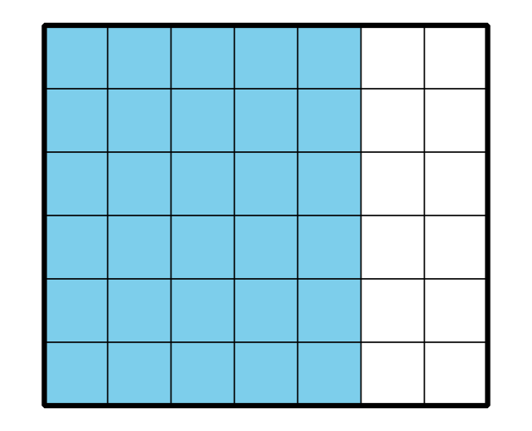
- What is the area of the whole space?
- Design your own garden. Find the area of each part of the garden and the area of the whole garden.

2 Find the Rectangles

Student Task Statement
What do you notice? What do you wonder?
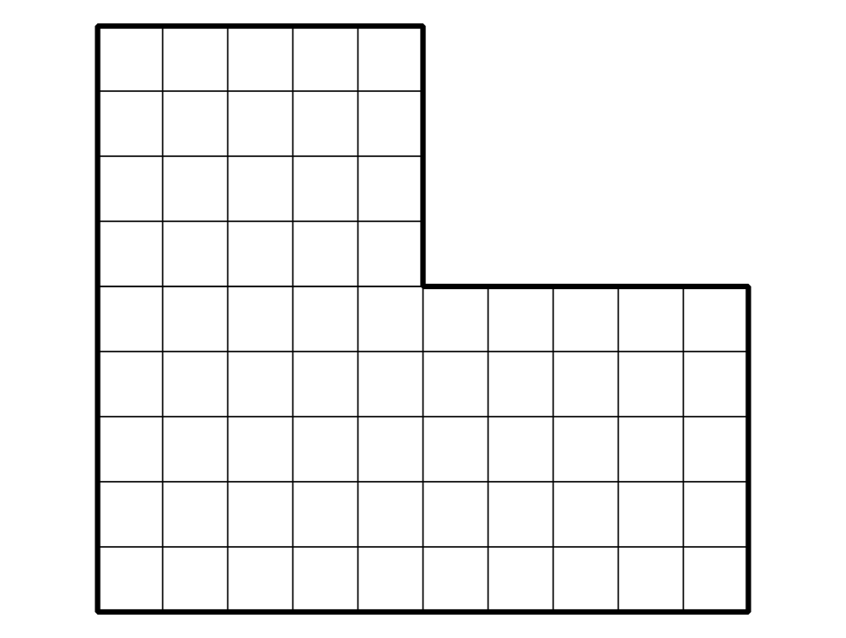
Find the area of this figure. Explain or show your reasoning. Organize it so it can be followed by others.
© CC BY 2021 Illustrative Mathematics®

