Lesson 2: Representations of Equal Groups of Fractions
- Let’s look at diagrams and expressions that can help us multiply a whole number and a fraction.

Warm-up: Number Talk: Three, Six, Nine, Twelve
Find the value of each expression mentally.
- $3×6$
- $3×9$
- $6×9$
- $12×9$

2.1: Card Sort: Expressions and Diagrams
Your teacher will give you a set of cards with expressions and diagrams.
- Match each expression with a diagram that represents the same quantity.
- Record each expression without a match.
- Han started drawing a diagram to represent $7×\frac{1}{8}$ and did not finish. Complete his diagram. Be prepared to explain your reasoning.
- 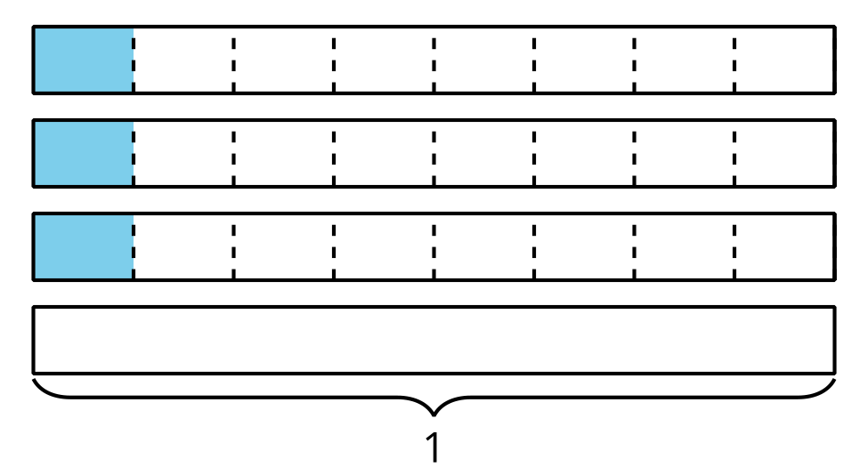
- Choose one expression that you recorded earlier that didn't have a match.
- Draw a diagram that can be represented by the expression. What value do the shaded parts of your diagram represent?

2.2: Different Representations

  - Write a multiplication expression that represents the shaded parts of the diagram. Then, find the value of the expression.
  - Diagram:
  - 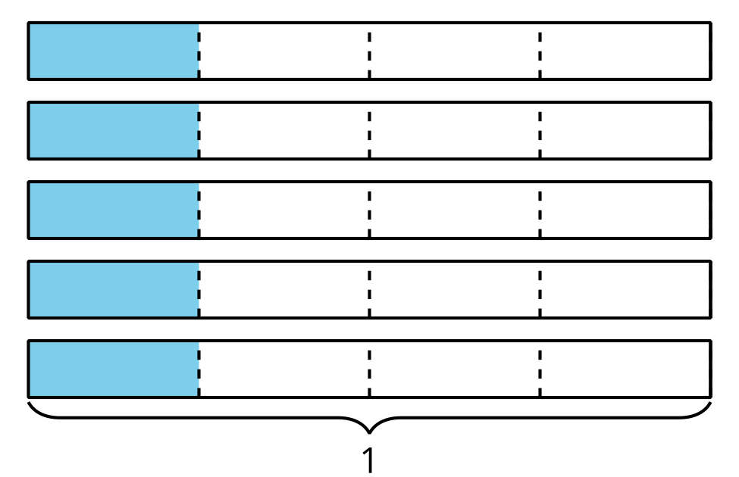
  - Expression:
  - Value:
  - Draw a diagram that the expression $6×\frac{1}{3}$ could represent. Then, find the value of the expression.
  - Diagram:
  - Expression: $6×\frac{1}{3}$
  - Value:
  - Draw a diagram and write an expression that gives the value $\frac{7}{2}$.
  - Diagram:
  - Expression:
  - Value: $\frac{7}{2}$
- To represent $4×\frac{1}{3}$, Diego drew this diagram:

- 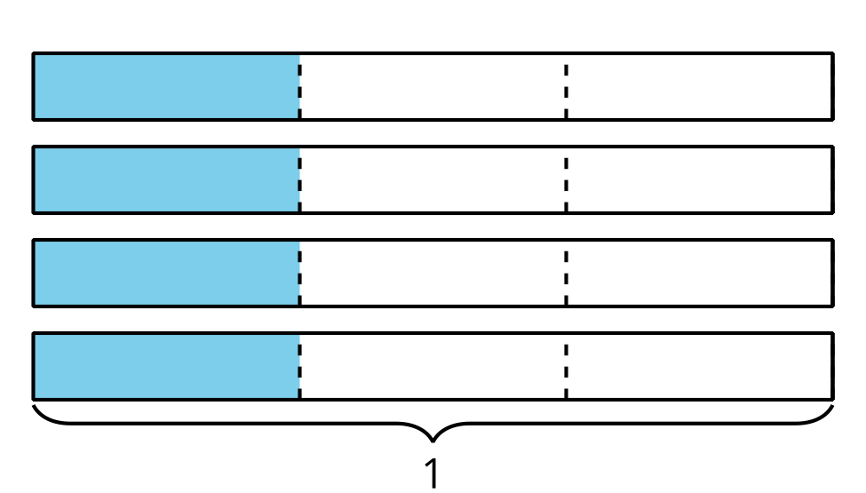

- Elena drew this diagram:

- 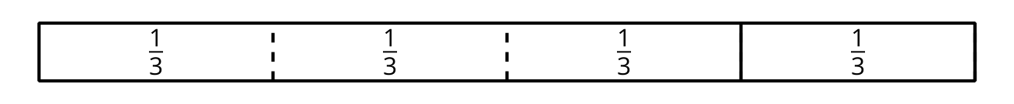

- Are they representing the same expression and value? Explain or show how you know.
© CC BY 2021 Illustrative Mathematics®

