Lesson 9 Practice Problems
- Cell phone Plan A costs $70 per month and comes with a free $500 phone. Cell phone Plan B costs $50 per month but does not come with a phone. If you buy the $500 phone and choose Plan B, how many months is it until your cost is the same as Plan A's?
- Priya and Han are biking in the same direction on the same path.
  - Han is riding at a constant speed of 16 miles per hour. Write an expression that shows how many miles Han has gone after $t$ hours.
  - Priya started riding a half hour before Han. If Han has been riding for $t$ hours, how long has Priya been riding?
  - Priya is riding at a constant speed of 12 miles per hour. Write an expression that shows how many miles Priya has gone after Han has been riding for $t$ hours.
  - Use your expressions to find when Han and Priya meet.
- Which story matches the equation $\text{-}6+3x=2+4x$?
  - At 5 p.m., the temperatures recorded at two weather stations in Antarctica are -6 degrees and 2 degrees. The temperature changes at the same constant rate, $x$ degrees per hour, throughout the night at both locations. The temperature at the first station 3 hours after this recording is the same as the temperature at the second station 4 hours after this recording.
  - Elena and Kiran play a card game. Every time they collect a pair of matching cards, they earn $x$ points. At one point in the game, Kiran has -6 points and Elena has 2 points. After Elena collects 3 pairs and Kiran collects 4 pairs, they have the same number of points.
- For what value of $x$ do the expressions $\frac{2}{3}x+2$ and $\frac{4}{3}x−6$ have the same value?
- Decide whether each equation is true for all, one, or no values of $x$.
  - $2x+8=\text{-}3.5x+19$
  - $9\left(x−2\right)=7x+5$
  - $3\left(3x+2\right)−2x=7x+6$
- (From Unit 4, Lesson 8.)
- Solve each equation. Explain your reasoning.
- $3d+16=\text{-}2\left(5−3d\right)$
- $2k−3\left(4−k\right)=3k+4$
- $\frac{3y−6}{9}=\frac{4−2y}{\text{-}3}$
- (From Unit 4, Lesson 6.)
- Describe a rigid transformation that takes Polygon A to Polygon B.
- 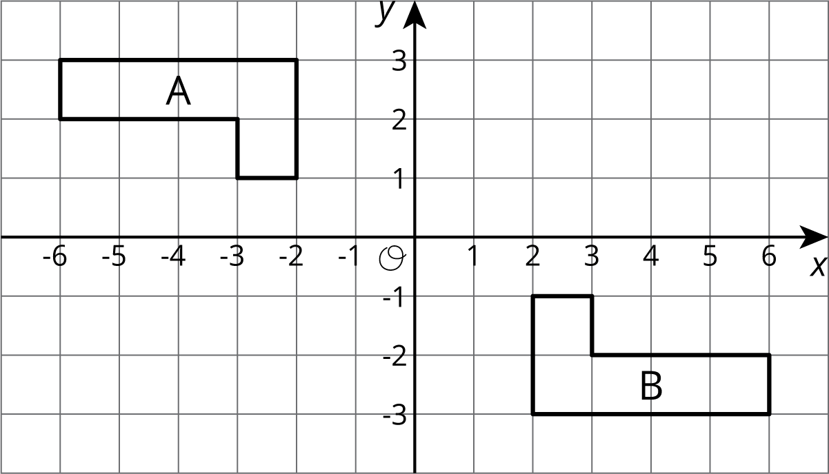
- (From Unit 1, Lesson 7.)
© CC BY Open Up Resources. Adaptations CC BY IM.

