Lesson 11: Get Enough
- Let’s get enough pencils for everyone.

Warm-up: How Many Do You See: In a Flash
How many do you see?
How do you see them?

11.1: Act It Out: Four Little Speckled Frogs (Part 2)
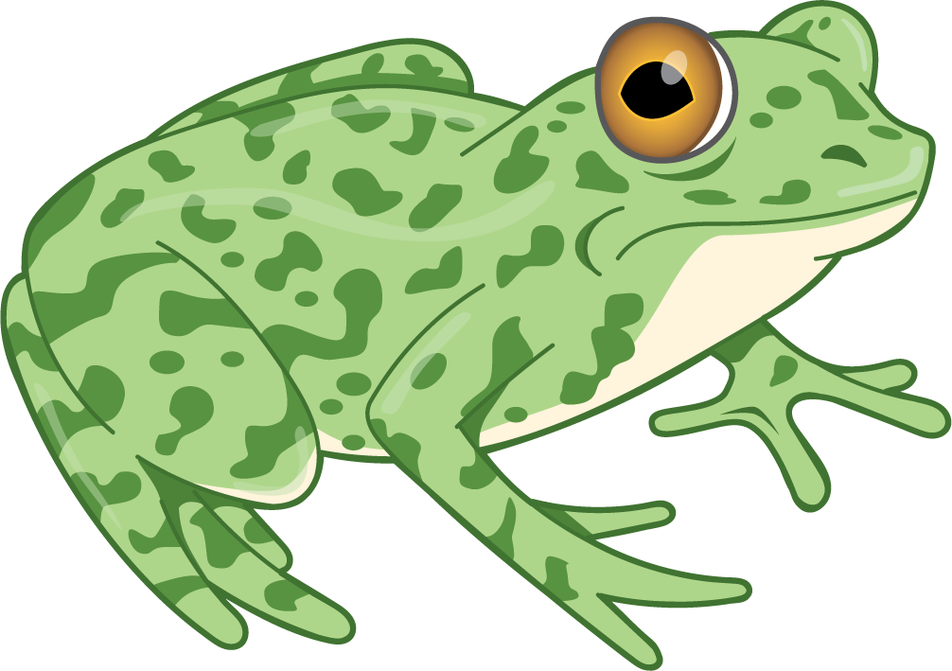
4 little speckled frogs sat on a speckled log,
eating the most delicious bugs. Yum! Yum!
1 jumped into the pool, where it was nice and cool.
Now there are 3 green speckled frogs. Glub! Glub!

11.2: Get Enough

11.3: Centers: Choice Time
Choose a center.
Geoblocks
Connecting Cubes
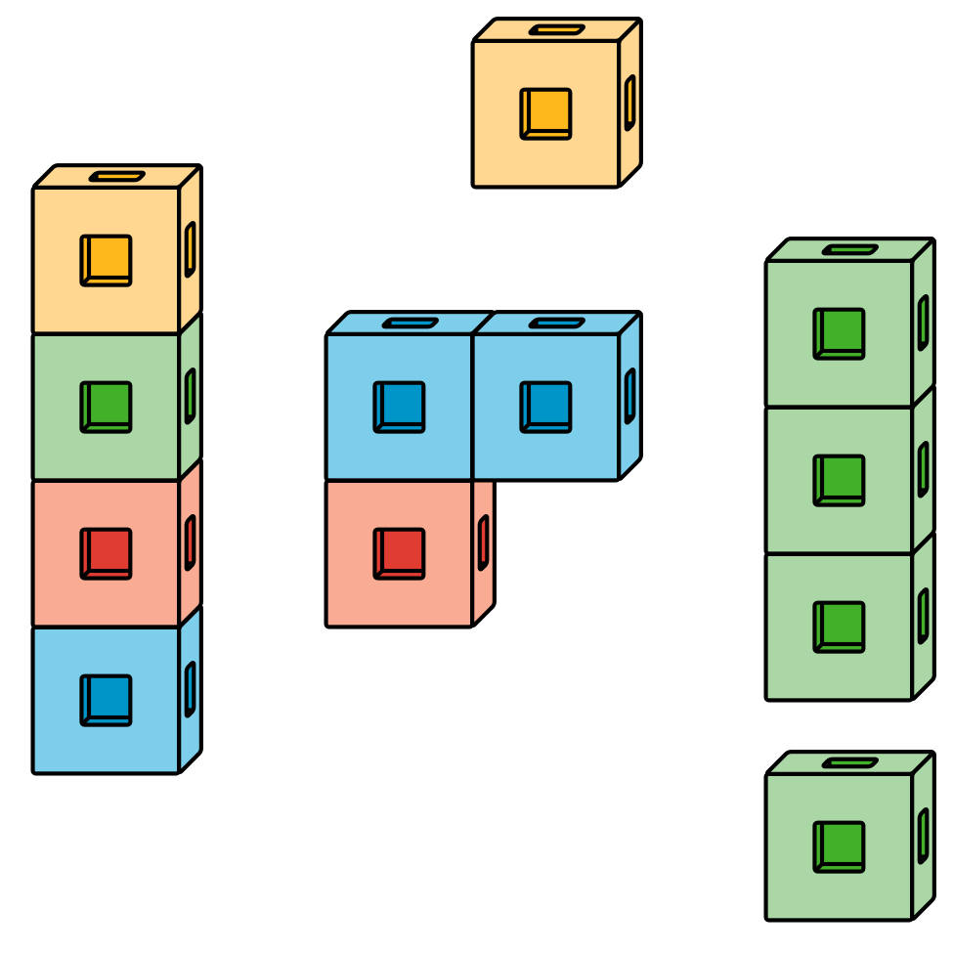
Pattern Blocks
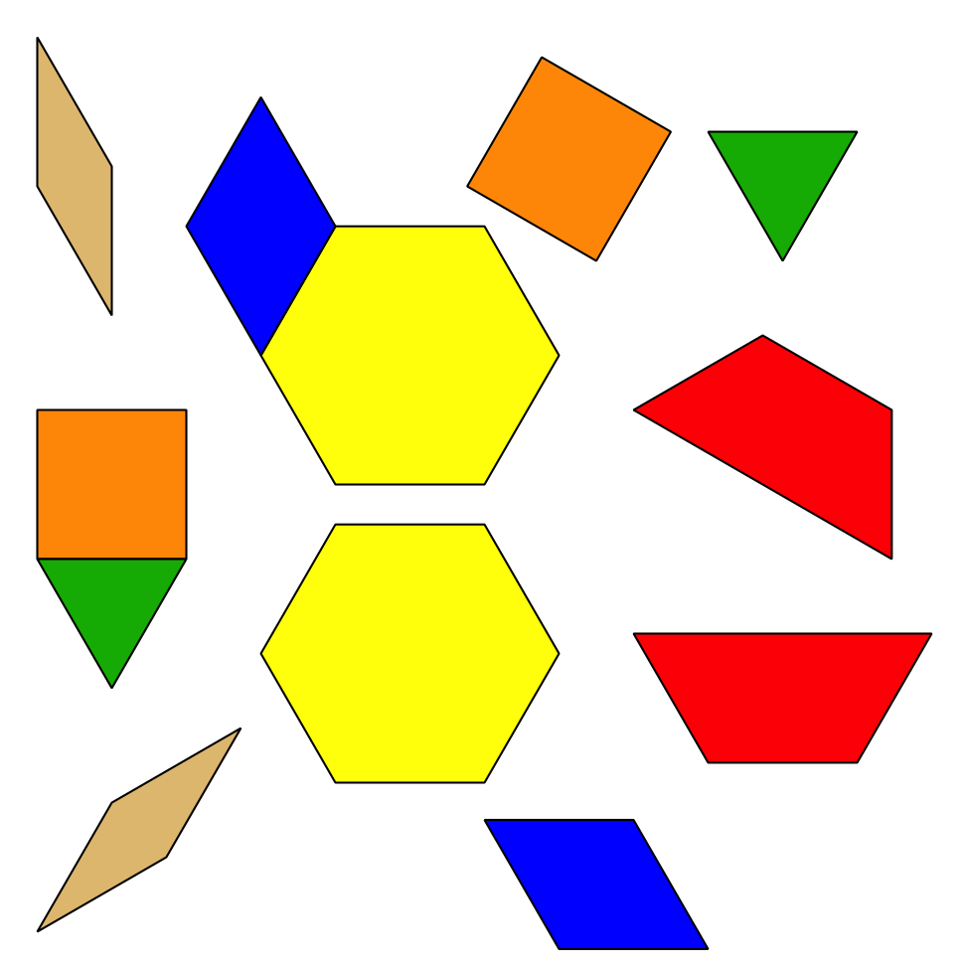
Picture Books

Section Summary
Section Summary
In this section, we figured out if there were enough pencils for everyone in our group.
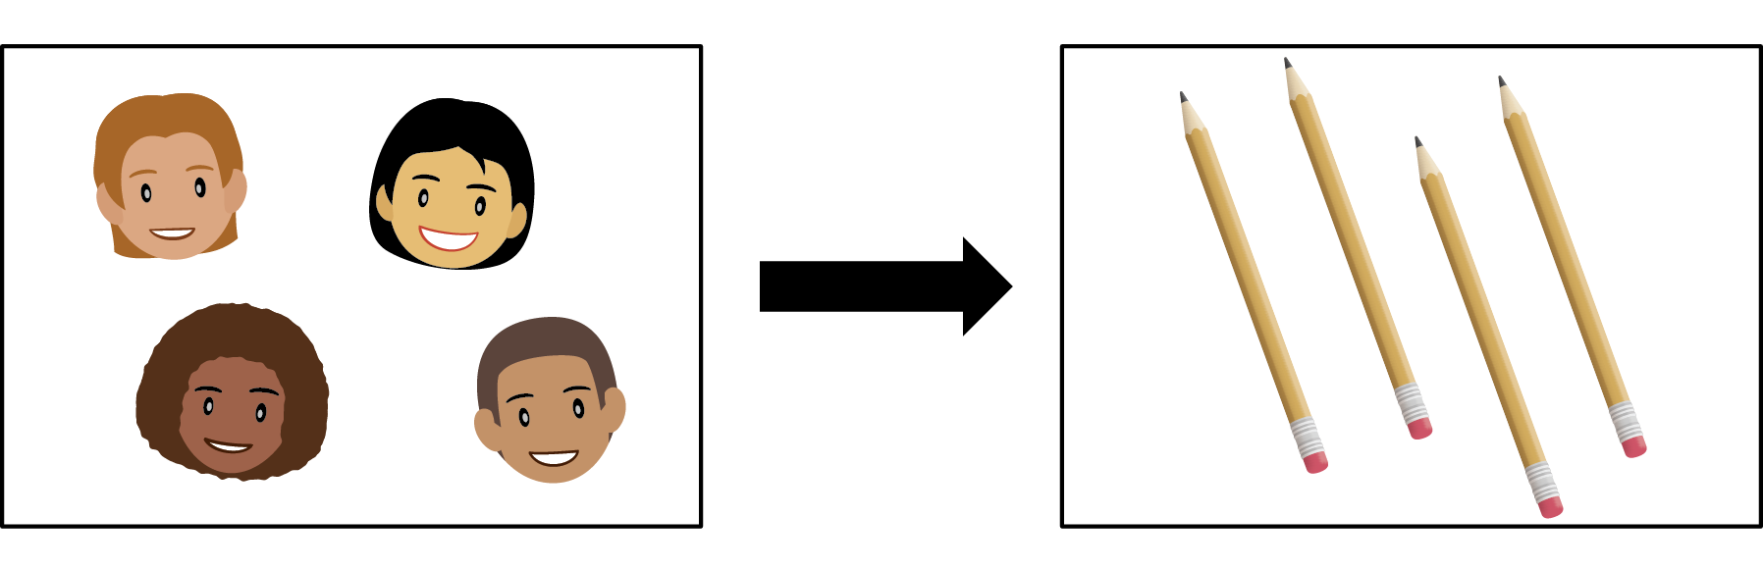
We matched each pencil with one person.
We also got enough pencils so that each person could have one.
© CC BY 2021 Illustrative Mathematics®

