Unit 5 Lesson 7: Solve Both Addends Unknown Story Problems

Which One Doesn’t Belong: Decompose with Math Tools (Warm up)

Student Task Statement
Which one doesn’t belong?
A
B
C
D

1 Fruit for Paletas

Student Task Statement
Jada made 6 paletas with her brother.
They made two flavors, lime and coconut.
How many of the paletas were lime?
Then how many of the paletas were coconut?
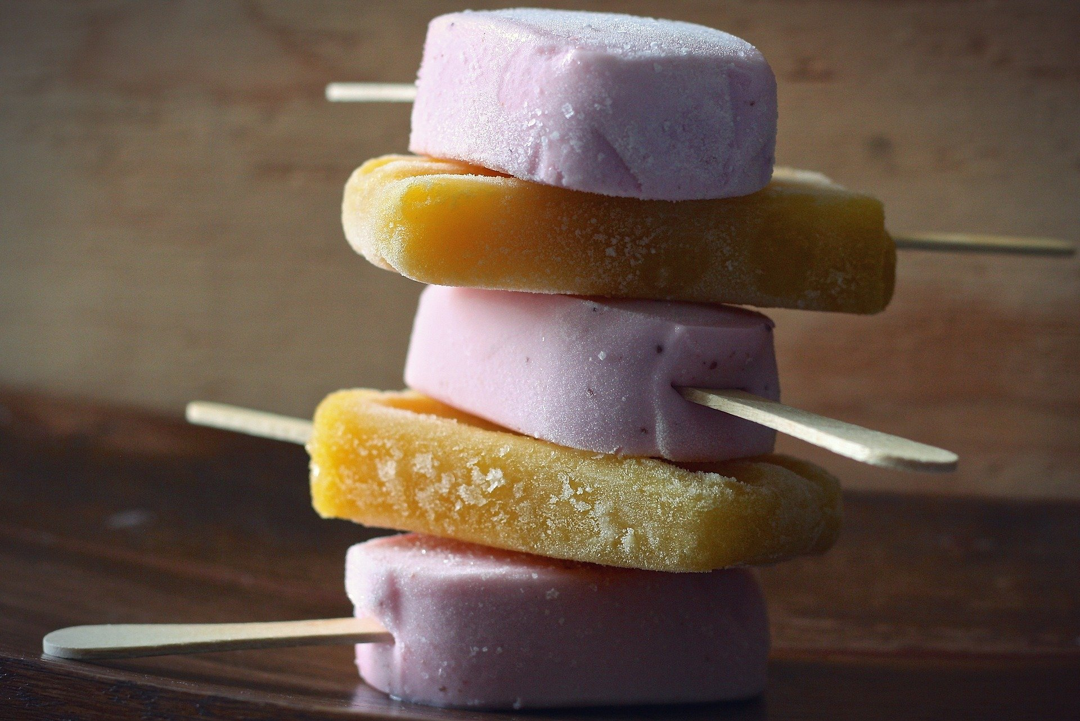

2 Pomegranates

Student Task Statement
Kiran had 7 pomegranates in his bag.
He put some of the pomegranates on the shelf.
He put the rest of the pomegranates in a basket.
How many of the pomegranates were on the shelf?
Then how many of the pomegranates were in the basket?
Expression: _________________________________
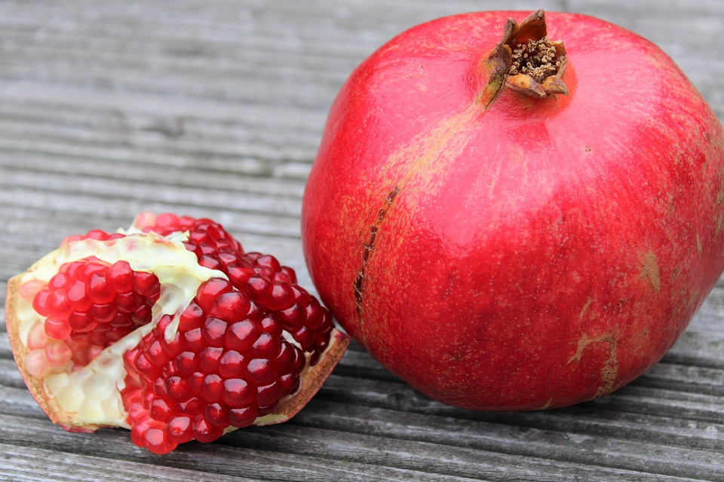

3 Introduce Math Stories, How Many of Each?

Student Task Statement
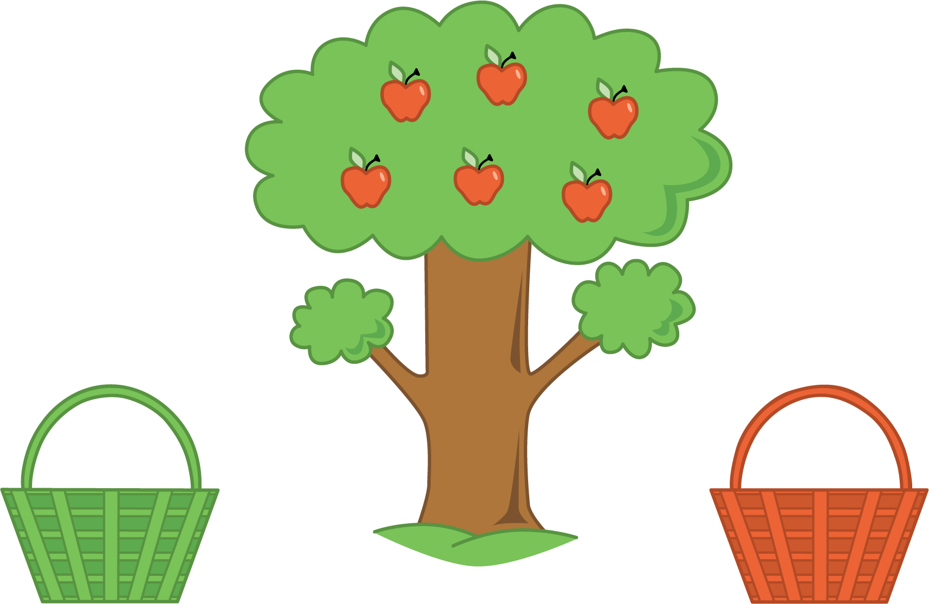
Choose a center.
What’s Behind My Back?
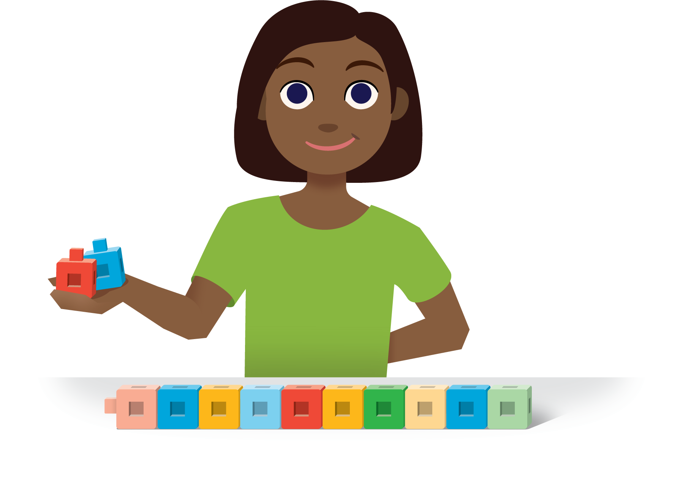
5-frames
Make or Break Apart Numbers
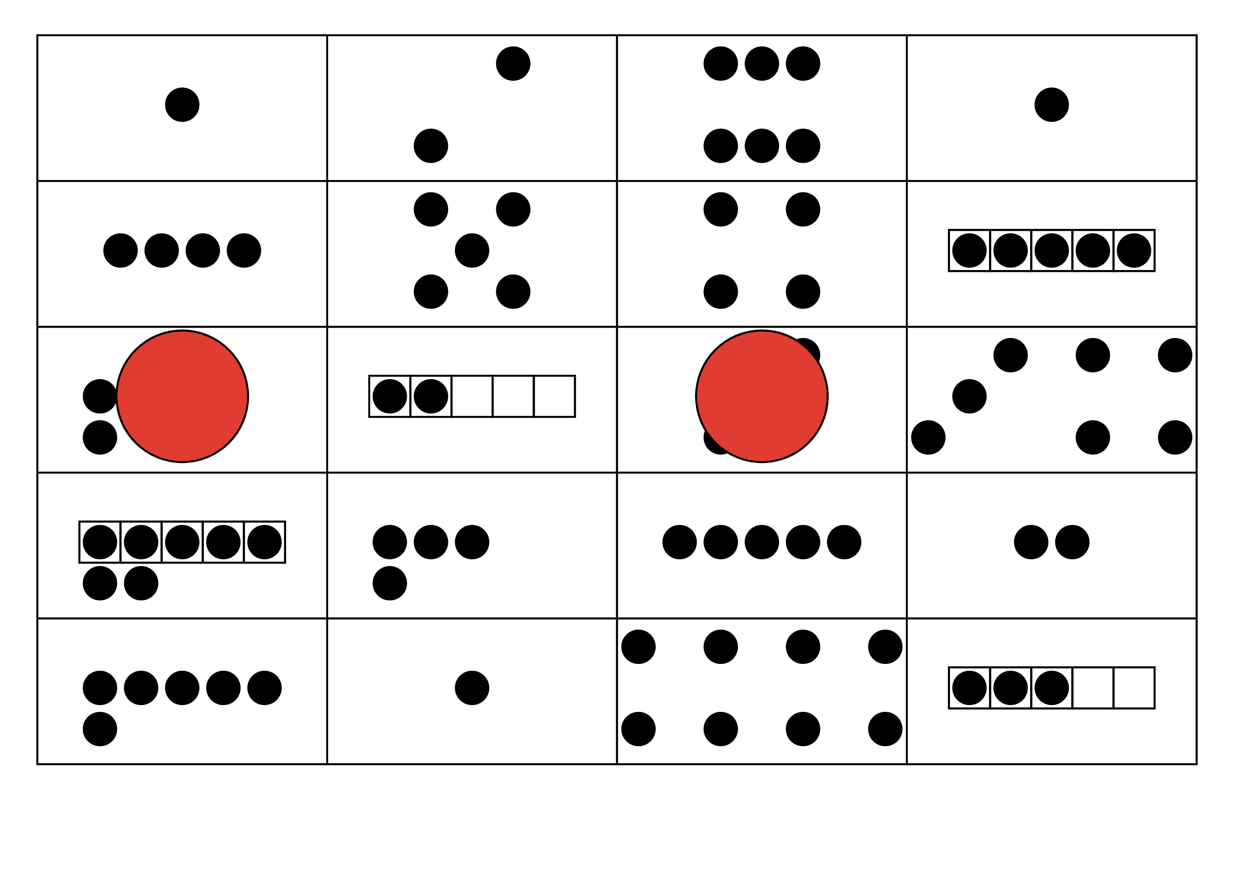
Math Stories
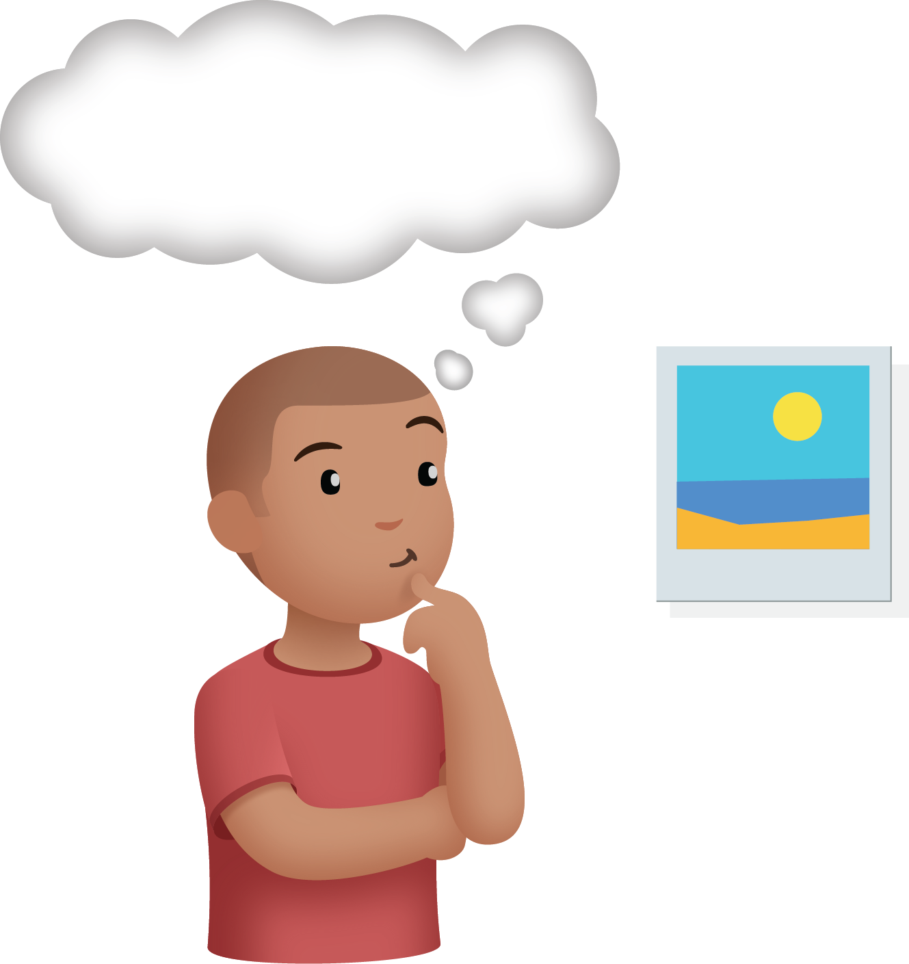

Images for Activity Synthesis
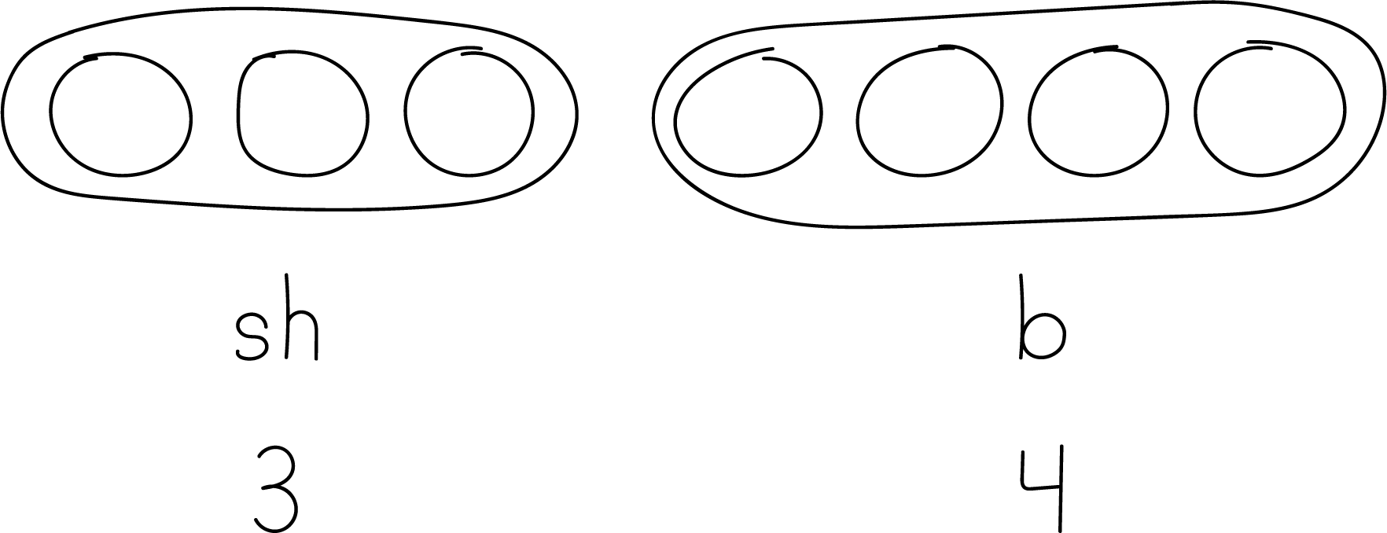
© CC BY 2021 Illustrative Mathematics®

