Curated Practice Problem Set

Unit 5 Lesson 6 Cumulative Practice Problems
- Classify each function as odd, even, or neither.
  - $f(x)=3x^{4}+3$
  - $f(x)=x^{3}−4x$
  - $f(x)=\frac{1}{x^{2}+1}$
  - $f(x)=x^{2}+x−3$
- Here is a graph of a function $f$ for $0≤x≤5$.
- 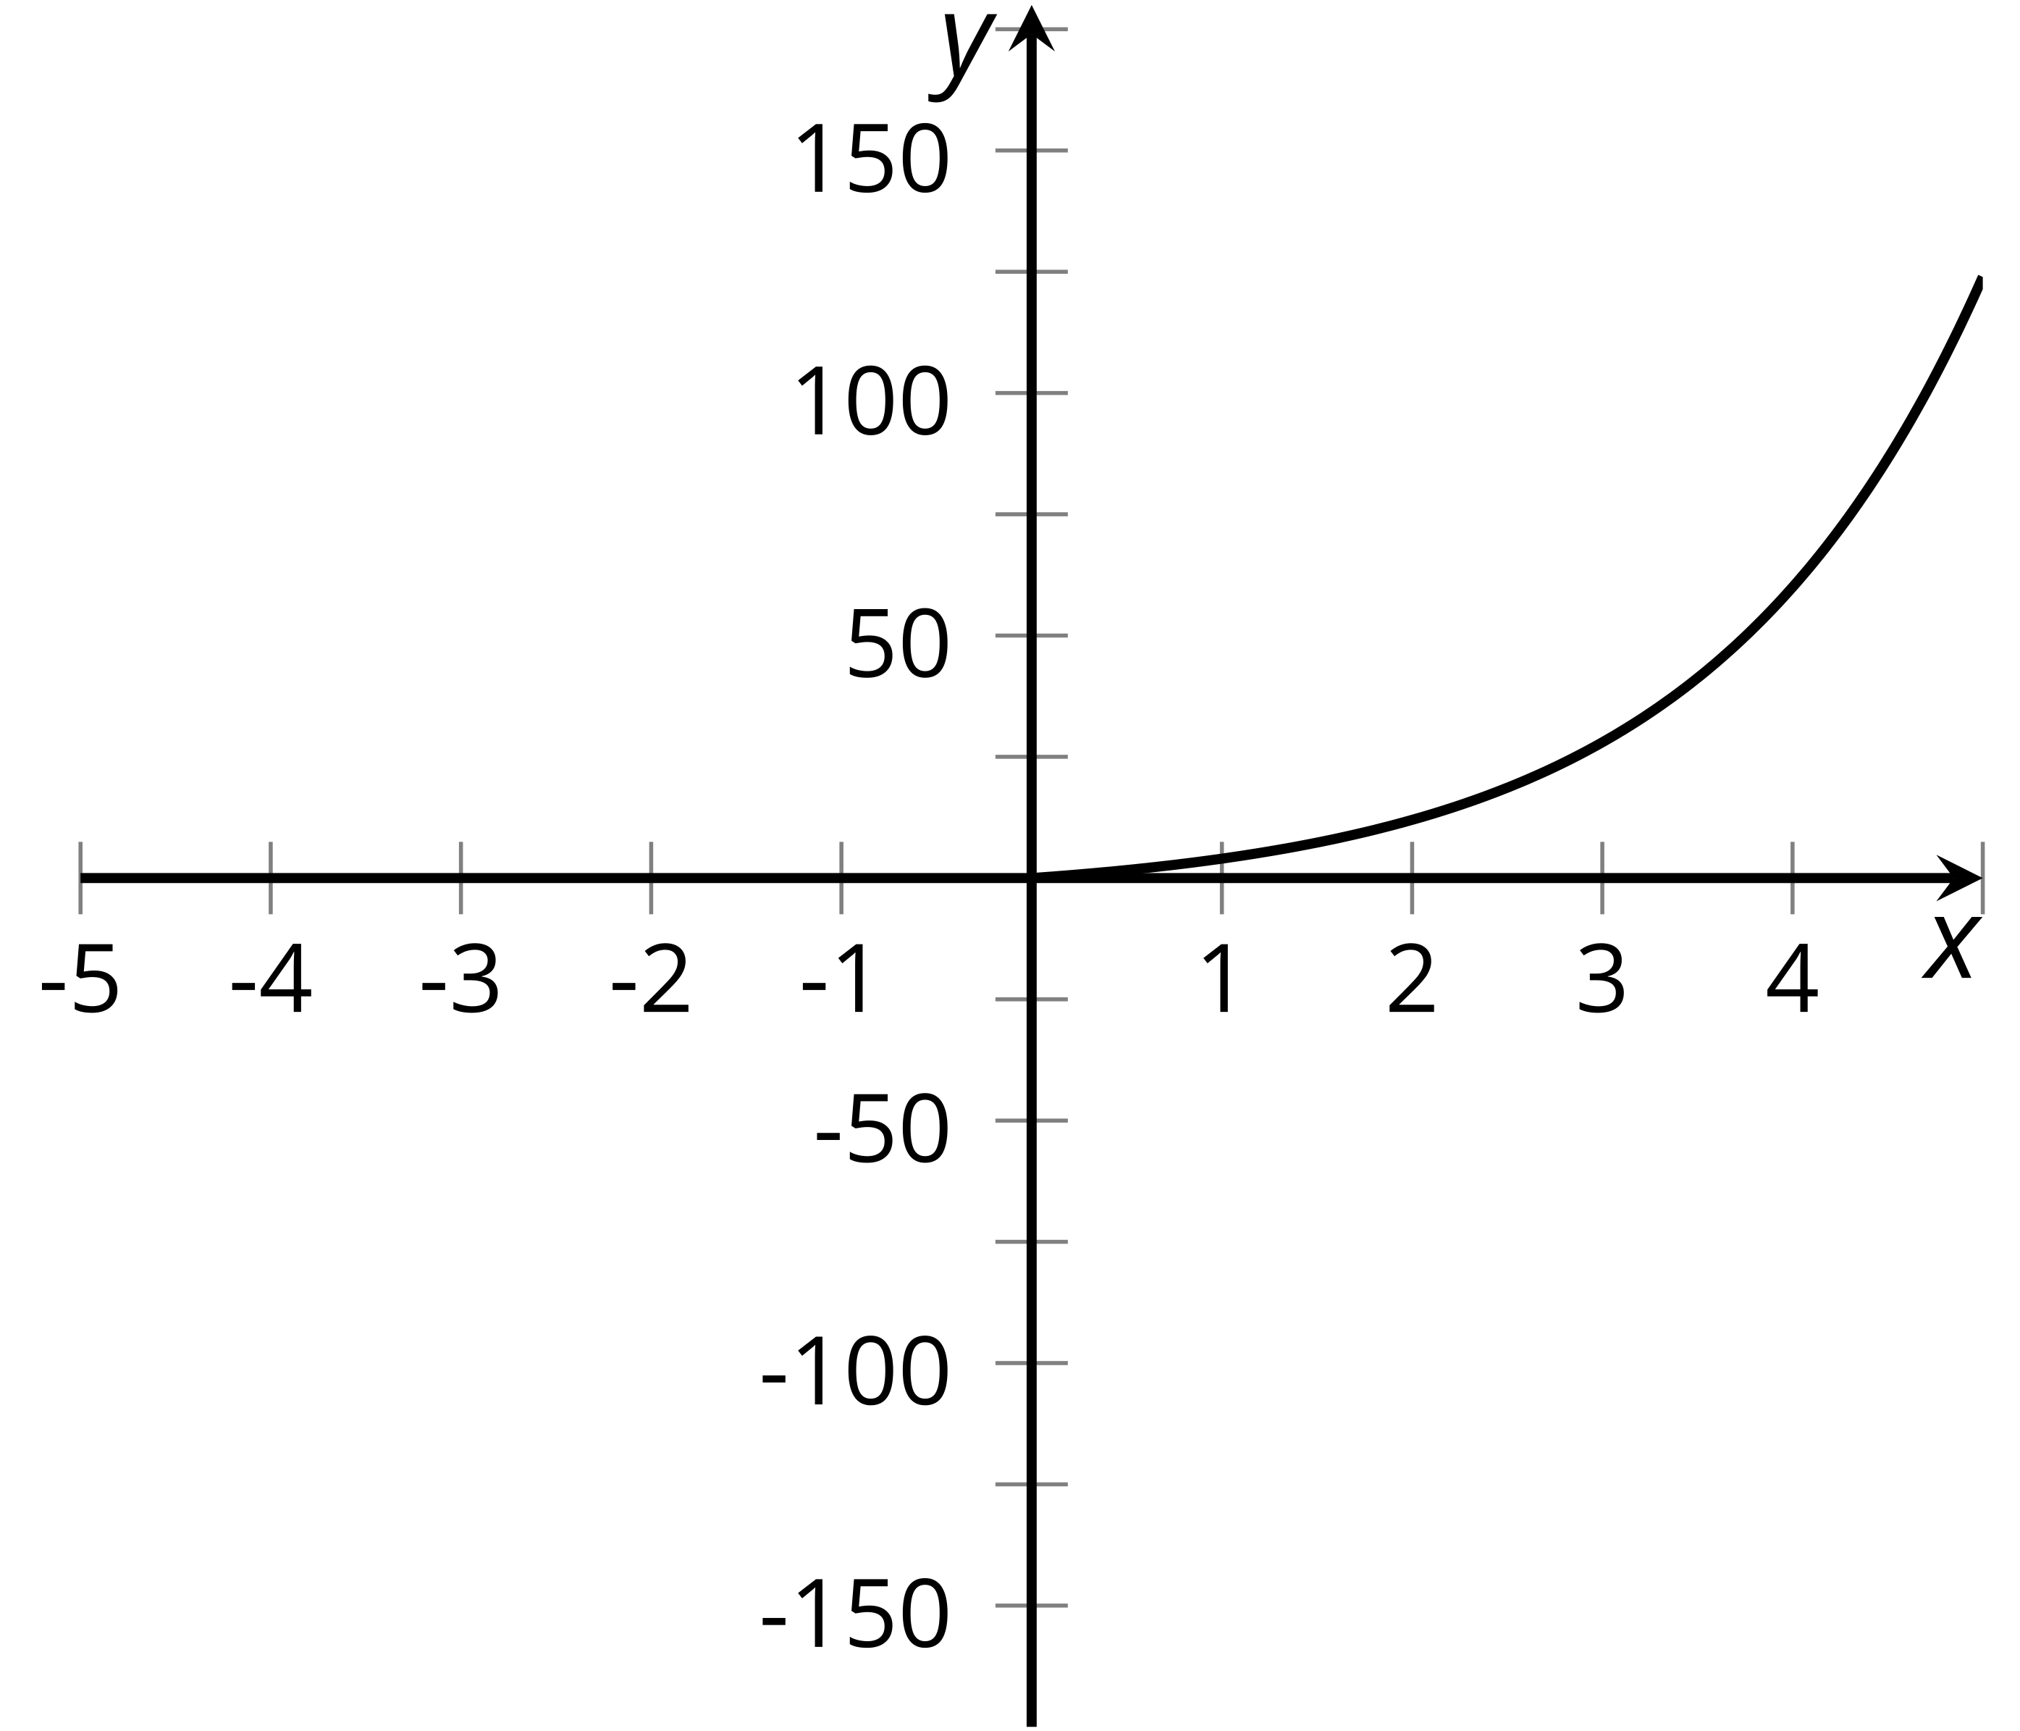
  - The function $g$ is even and takes the same values as $f$ for $0≤x≤5$. Sketch a graph of $g$.
  - The function $h$ is odd and takes the same values as $f$ for $0≤x≤5$. Sketch a graph of $h$.
- The linear function $f$ is given by $f(x)=mx+b$. If $f$ is even, what can you conclude about $m$ and $b$?
- Here are the graphs of $y=f(x)$ and $y=f(x−1)$ for a function $f$.
- 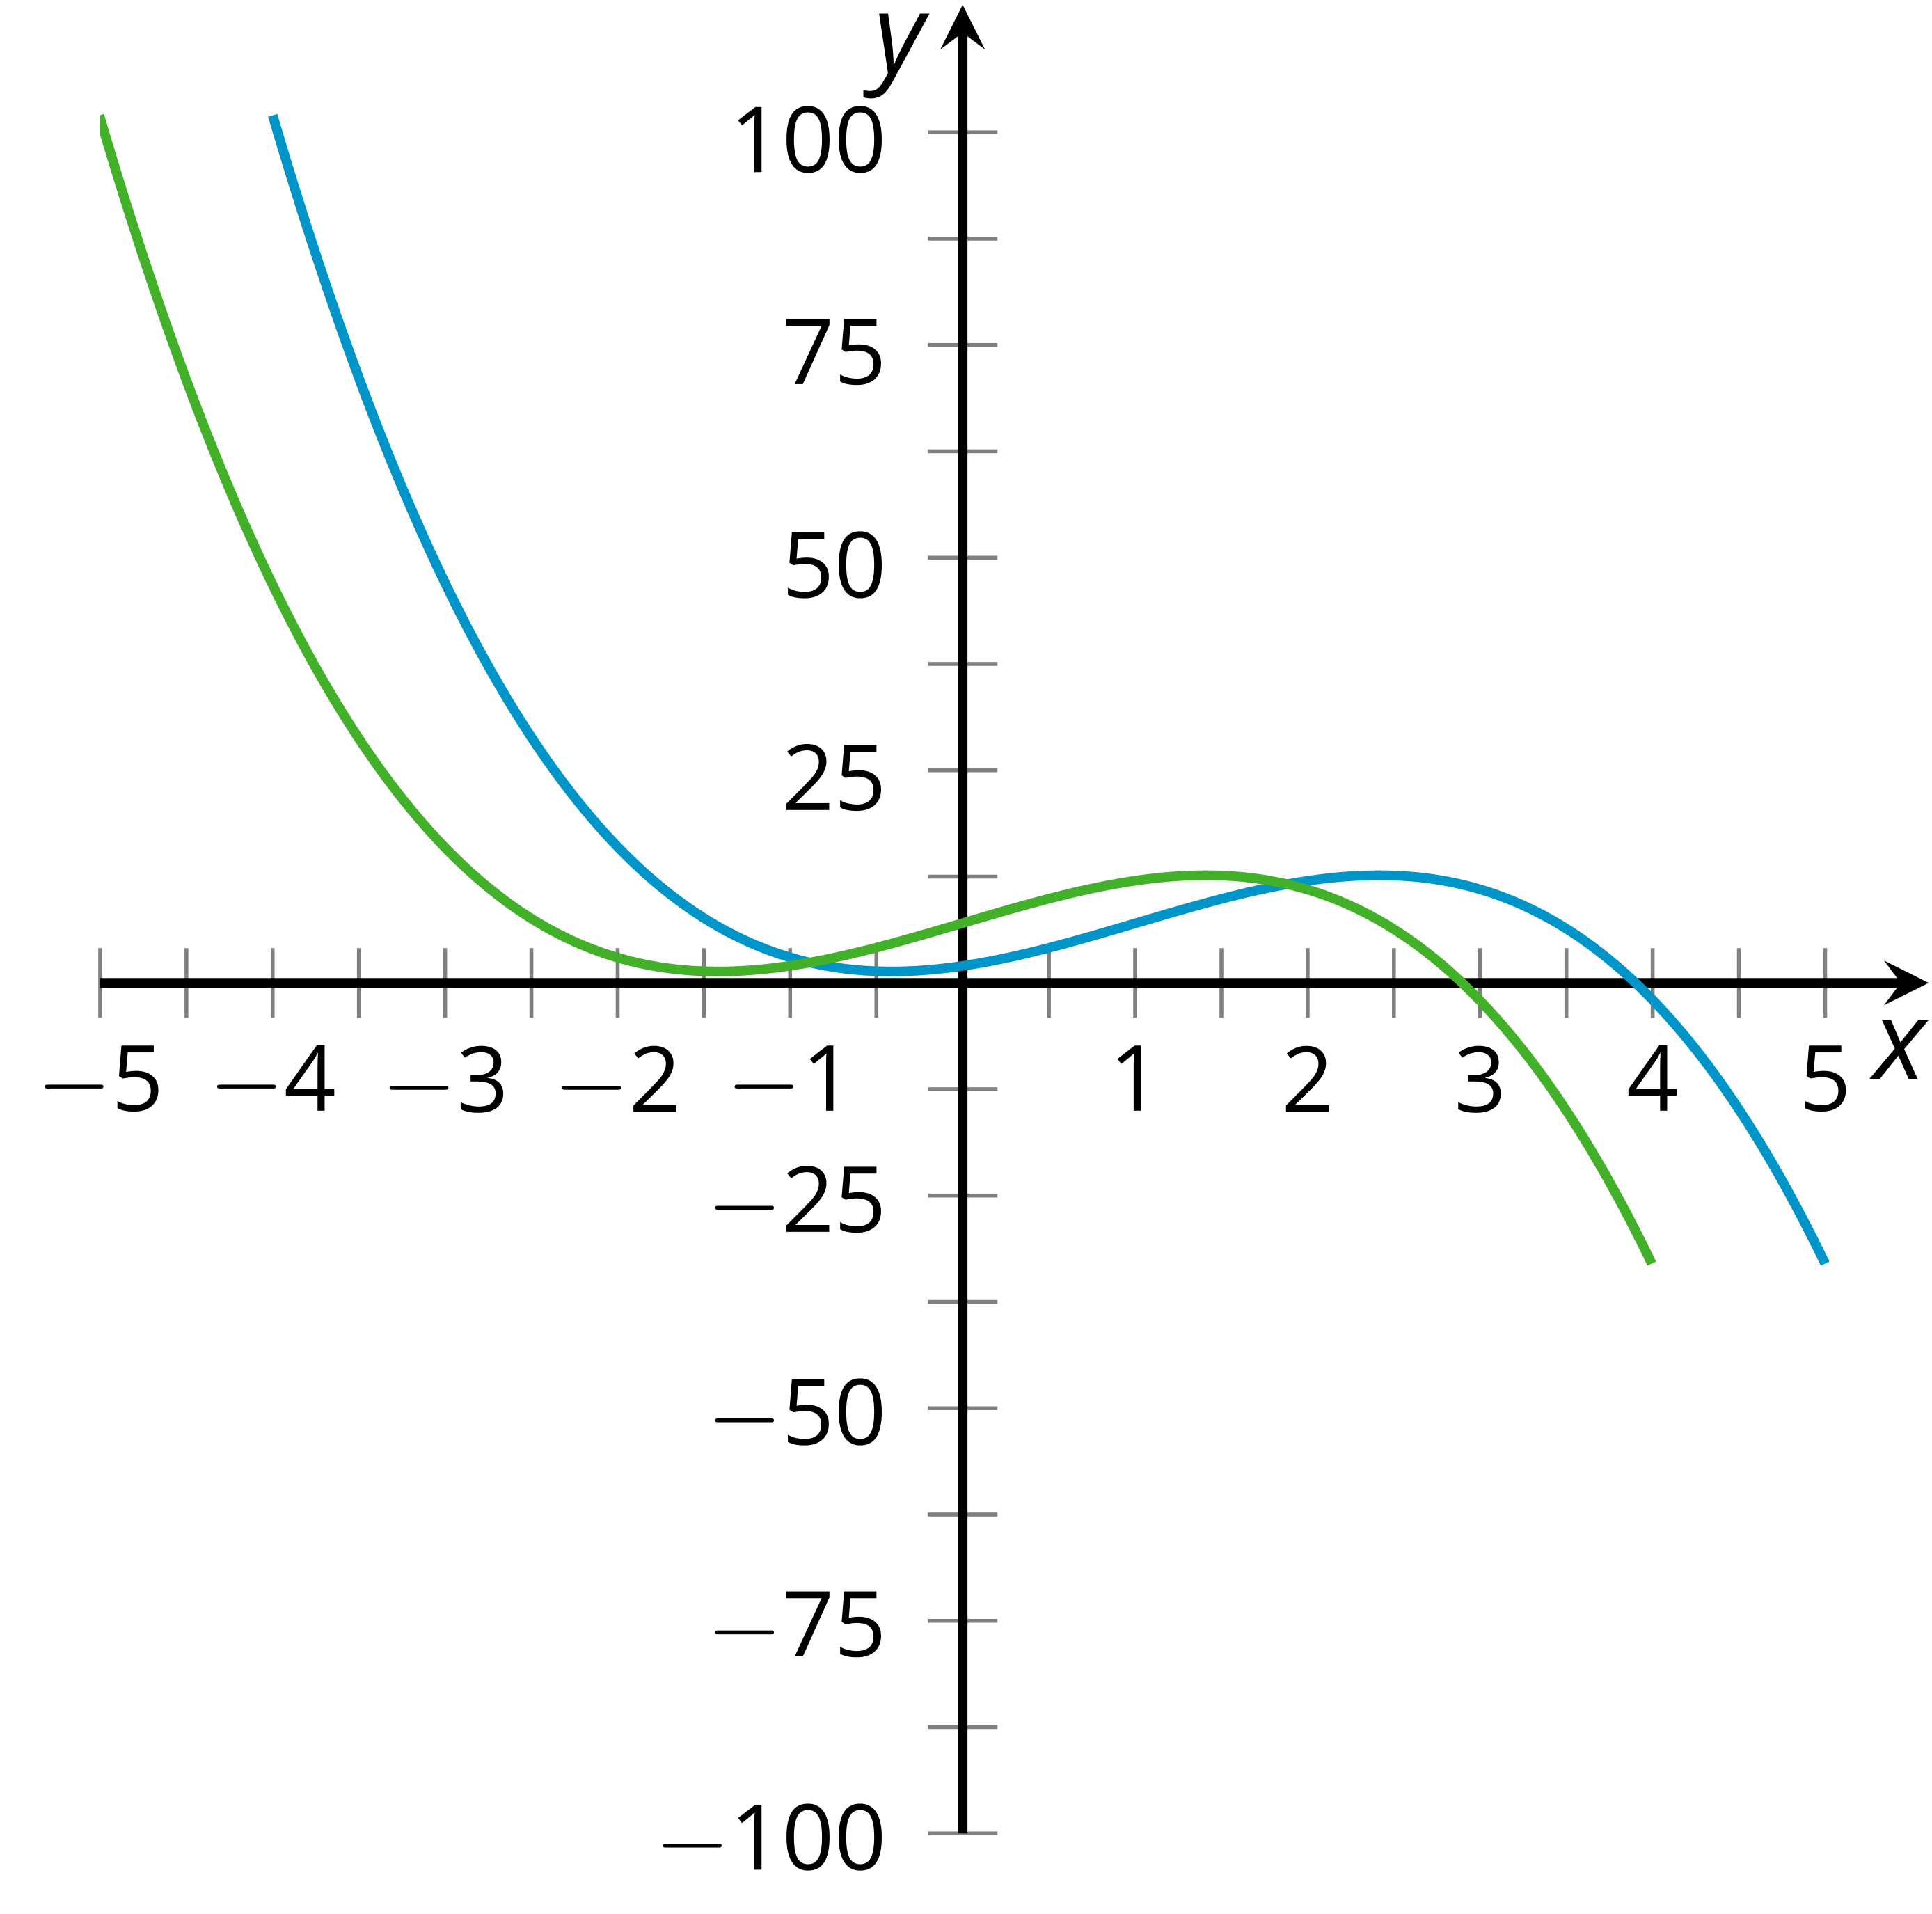
- Which graph corresponds to each equation? Explain how you know.
- (From Unit 5, Lesson 2.)
- Write an expression for two of the graphs in terms of $f(x)$.
- 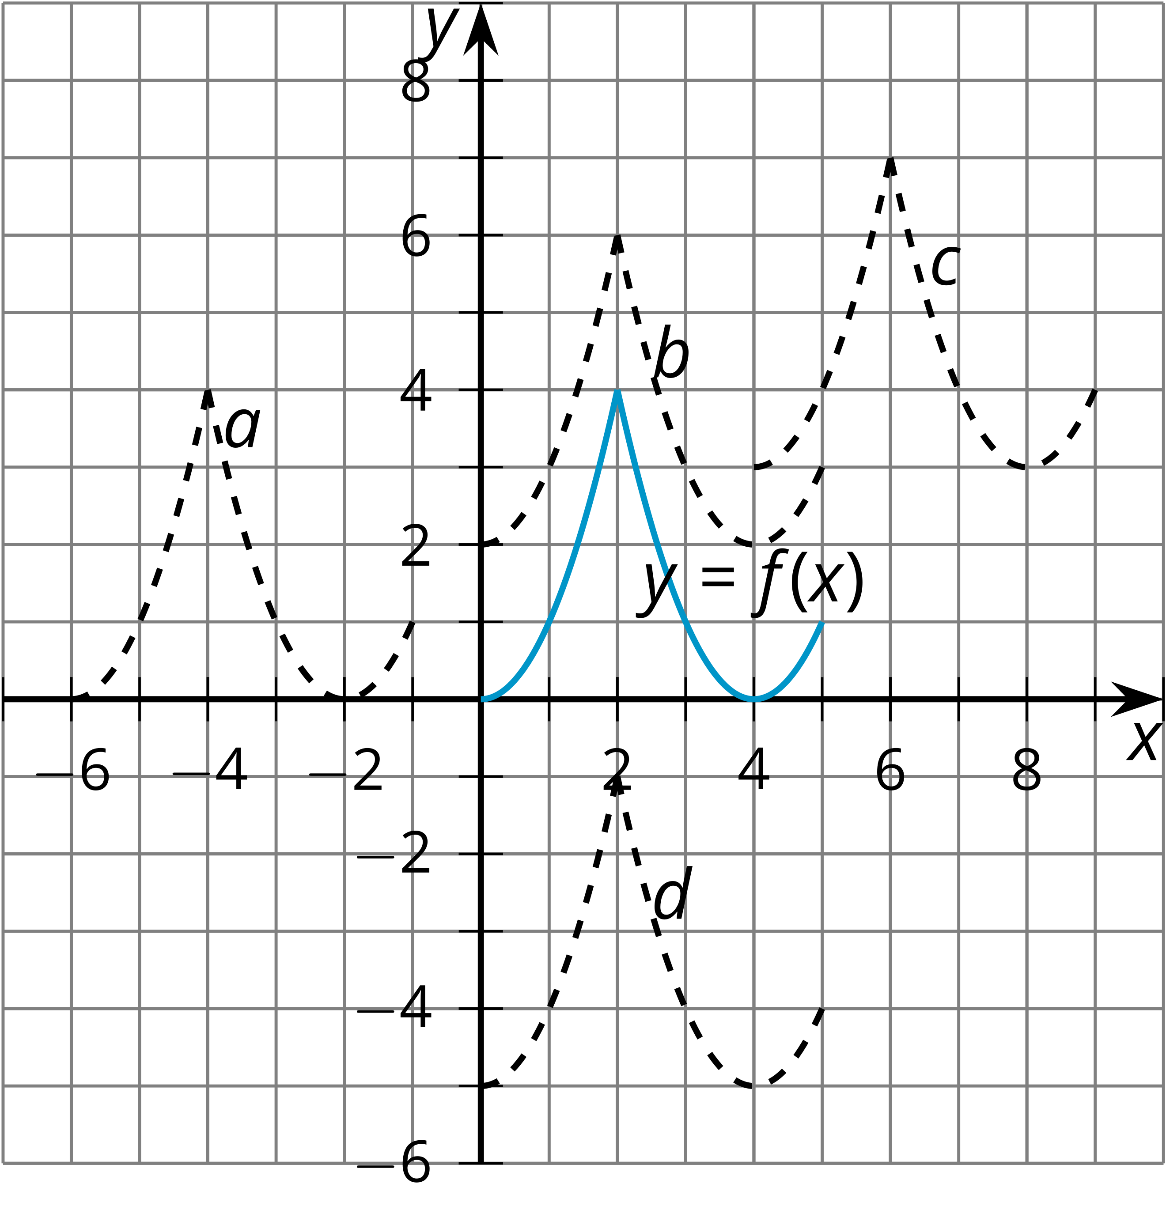
- (From Unit 5, Lesson 3.)
- Here is a graph of the function $f$ given by $f(x)=x^{3}$.
- 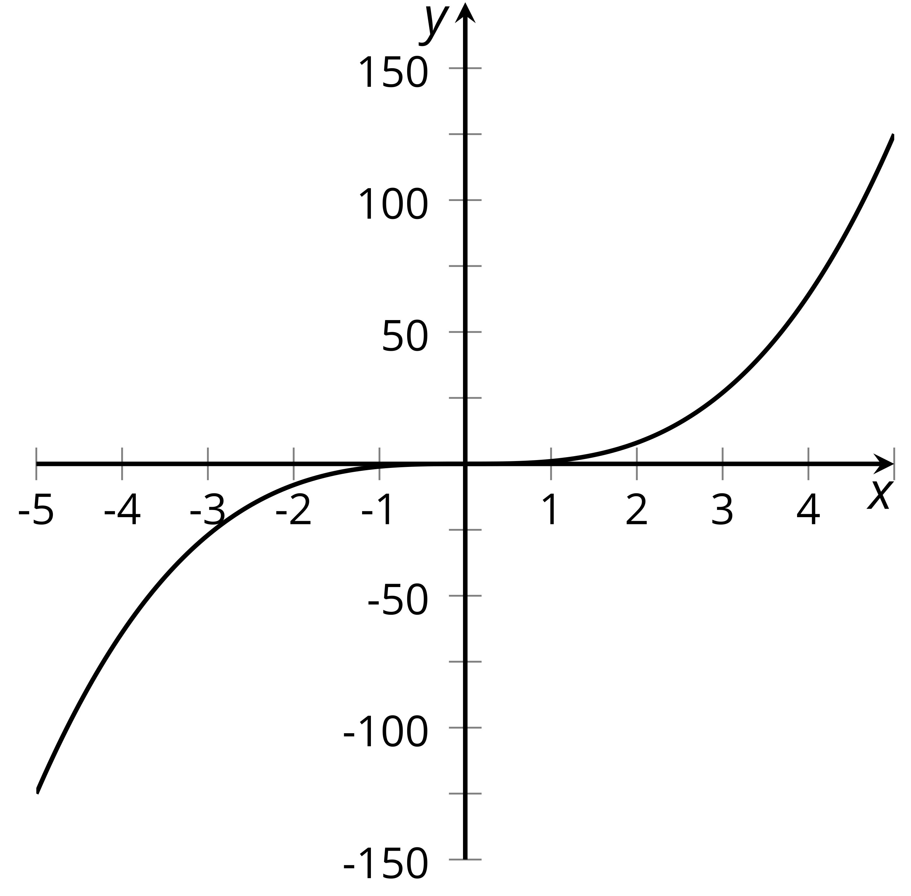
  - What happens if you reflect the graph across the $x$-axis and then across the $y$-axis?
  - Is $f$ even, odd, or neither?
- (From Unit 5, Lesson 5.)
© CC BY 2019 by Illustrative Mathematics

