Unit 4 Lesson 15: Inverse Functions

1 What Does It Say? (Warm up)

Student Task Statement
Here is an encoded message, a message that has been converted into a code.
WRGDB LV D JRRG GDB.
Can you figure out what it says in English? How was the original message encoded?

2 Caesar Says Shift

Student Task Statement
- Now it’s your turn to write a secret code!
  - Write a short and friendly message with 3–4 words.
  - Pick a number from 1 to 10. Then, encode your message by shifting each letter that many steps forward or backward in the alphabet, wrapping around from Z to A as needed.
  - Consider using this table to create a key for your cipher.
- plain text | - A | - B | - C | - D | - E | - F | - G | - H | - I | - J | - K | - L | - M | - N | - O | - P | - Q | - R | - S | - T | - U | - V | - W | - X | - Y | - Z
  - cipher text
  - Give your encoded message to a partner to decode. If requested, give the number you used.
  - Decode the message from your partner. Ask for their number, if needed.
- Suppose $m$ and $c$ each represent the position number of a letter in the alphabet, but $m$ represents the letters in the original message and $c$ the letters in your secret code.
  - Complete the table.
  - letter in message
- $m$ | - 6 | - 9 | - 19 | - 8
  - $c$
  - letter in code
  - Use $m$ and $c$ to write an equation that can be used to encode an original message into your secret code.
  - Use $m$ and $c$ write an equation that can be used to decode your secret code into the original message.

3 U.S. Dollars and Mexican Pesos

Student Task Statement
An American traveler who is heading to Mexico exchanges some U.S. dollars for Mexican pesos. At the time of his travel, 1 dollar can be exchanged for 19.32 pesos.
At the same time, a Mexican businesswoman who is in the United States is exchanging some Mexican pesos for U.S. dollars at the same exchange rate.
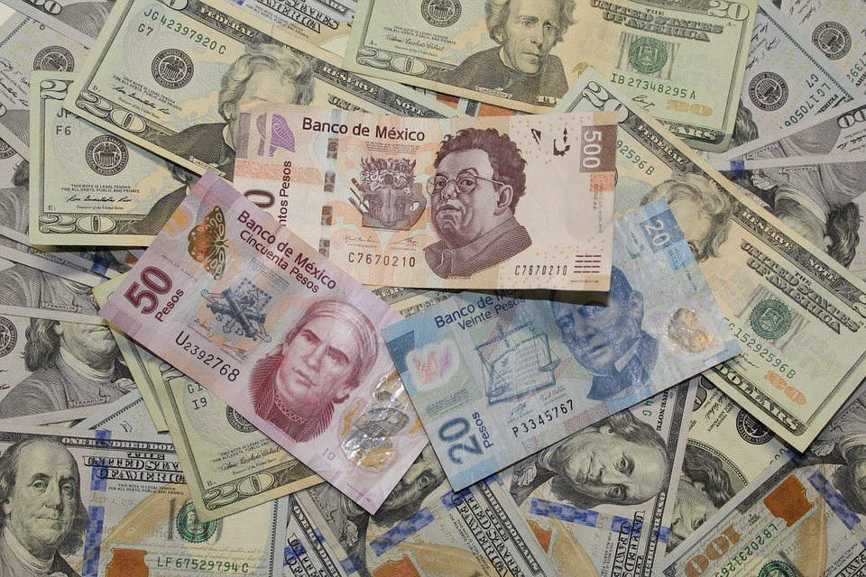
- Find the amount of money in pesos that the American traveler would get if he exchanged:
  - 100 dollars
  - 500 dollars
- Write an equation that gives the amount of money in pesos, $p$, as a function of the dollar amount, $d$, being exchanged.
- Find the amount that the Mexican businesswoman would get if she exchanged:
  - 1,000 pesos
  - 5,000 pesos
- Explain why it might be helpful to write the inverse of the function you wrote earlier. Then, write an equation that defines the inverse function.

Activity Synthesis
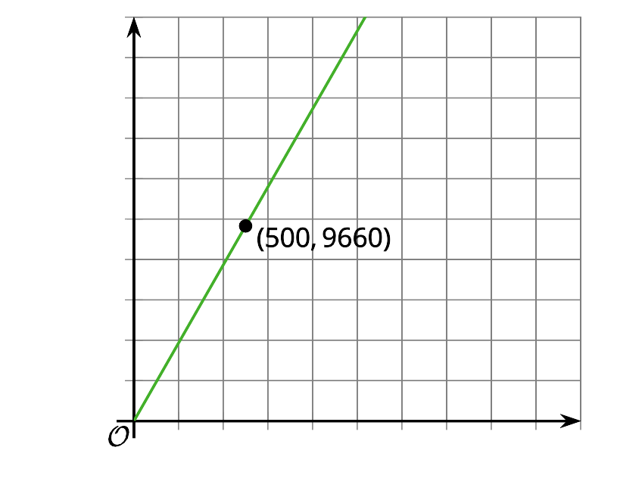
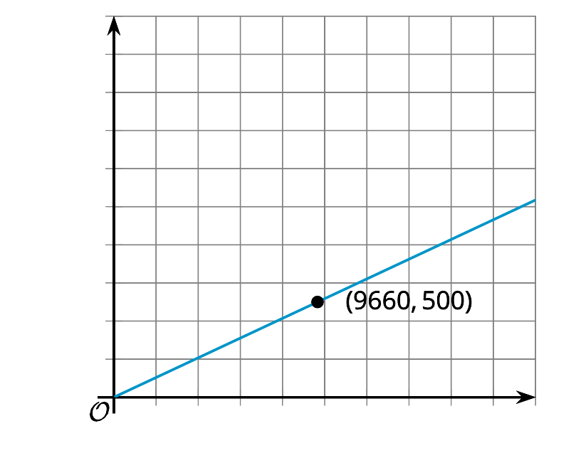
© CC BY 2019 by Illustrative Mathematics

