Unit 3 Lesson 4: Sums of 10

WU True or False: Equal Expressions (Warm up)

Student Task Statement
Decide if each statement is true or false.
Be prepared to explain your reasoning.
- $3+5=8$
- $6+3=8$
- $3+5=5+3$

1 Shake and Spill: 10 Counters

Student Task Statement

2 All The Ways To Make 10

Student Task Statement
- Show all the ways to make 10.
- 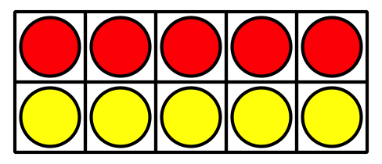
- How do you know that you have found all the ways?
Be ready to explain your thinking in a way that others will understand.

3 Centers: Choice Time

Student Task Statement
Choose a center.
Number Puzzles
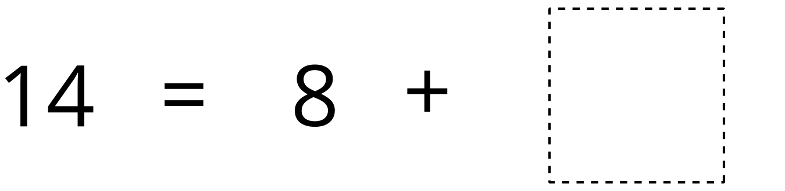
Check it Off
Find the Pair
© CC BY 2021 Illustrative Mathematics®

