Lesson 2: Patterns that Repeat

Standards Alignments
Addressing | 4.OA.C.5
Building Towards | 4.OA.C.5

Teacher-facing Learning Goals
- Analyze, describe, and generate patterns that follow a given rule.

Student-facing Learning Goals
- Let’s look at shapes that repeat by a rule and make some predictions about the patterns they create.

Lesson Purpose
The purpose of this lesson is for students to analyze, describe, extend, and generate visual patterns in which a series of symbols or shapes repeat by a rule, using structure and mathematical reasoning to do so.
In an earlier lesson, students analyzed and described features of patterns that followed a rule. In this lesson, students do the same with designs with shapes that repeat according to a rule. Students begin by examining the patterns visually. They look for structure and make use of it to extend the patterns (MP7). Later, they represent each shape in the pattern with numbers and reason about the repetition mathematically—by using operations and observing the properties of the numbers (MP2). The third activity is optional as it provides an opportunity for extra practice.

Access for:

Students with Disabilities
- Action and Expression (Activity 3)

English Learners
- MLR8 (Activity 1)

Instructional Routines
How Many Do You See? (Warm-up)

Lesson Timeline
Warm-up | 10 min
Activity 1 | 20 min
Activity 2 | 15 min
Activity 3 | 15 min
Lesson Synthesis | 10 min
Cool-down | 5 min

Teacher Reflection Question
In an upcoming section, students will learn to multiply multi-digit numbers. What do you notice in their work from today’s lesson that you might leverage in that future lesson?

Cool-down
(to be completed at the end of the lesson) 5min
Happy Faces

Standards Alignments
Addressing | 4.OA.C.5

Student-facing Task Statement
Diego created a pattern with smiley faces.
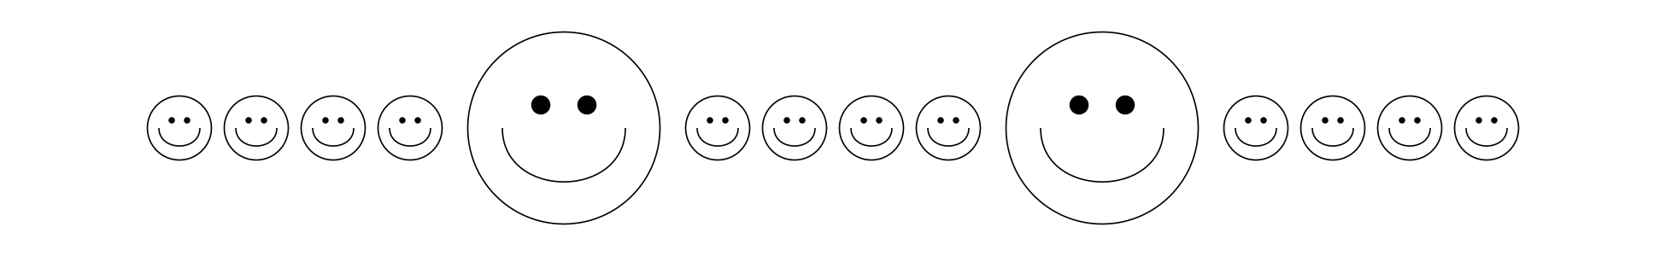
- Extend Diego’s pattern by drawing the next 5 shapes.
- If Diego numbered the smiley faces, what numbers would he write for the first 5 large smiley faces?
- Will the 42nd smiley face be a large one or a small one? Explain or show your reasoning.

Student Responses
- Draws 1 large smiley face and 4 smaller faces added to the original pattern.
- 5, 10, 15, 20, 25
- Small smiley face. Sample response: The large ones are multiples of 5, and 42 is not a multiple of 5.

