Unit 4 Lesson 3: Interpreting Division Situations

1 Dot Image: Properties of Multiplication (Warm up)

Student Task Statement
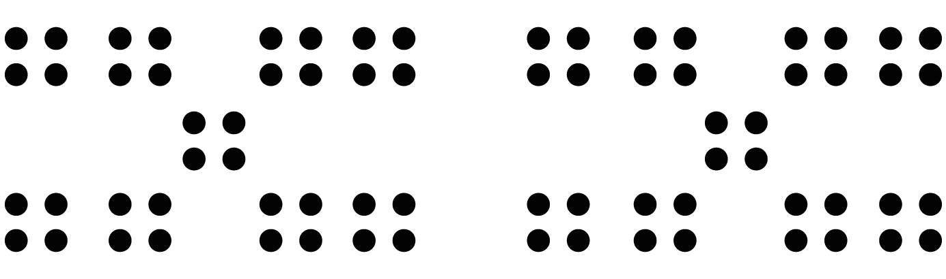

2 Homemade Jams

Images for Launch
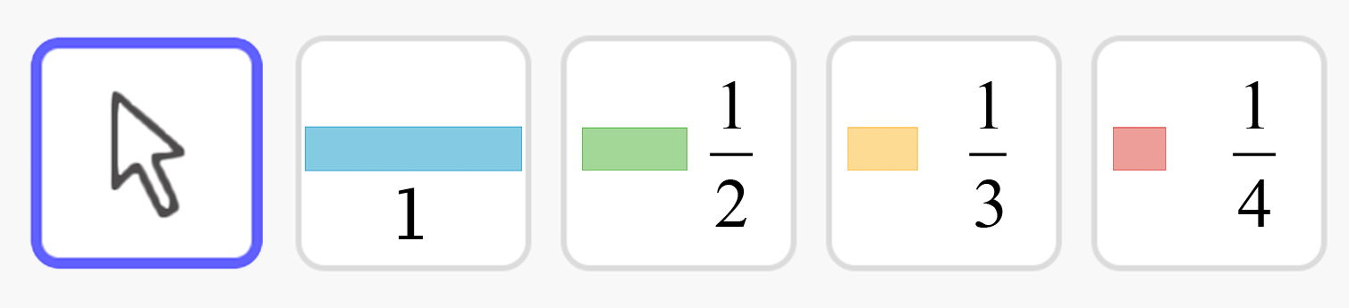

Student Task Statement
Draw a diagram, and write a multiplication equation to represent each situation. Then answer the question.
- Mai had 4 jars. In each jar, she put $2\frac{1}{4}$ cups of homemade blueberry jam. Altogether, how many cups of jam are in the jars?
- Priya filled 5 jars, using a total of $7\frac{1}{2}$ cups of strawberry jam. How many cups of jam are in each jar?
- Han had some jars. He put $\frac{3}{4}$ cup of grape jam in each jar, using a total of $6\frac{3}{4}$ cups. How many jars did he fill?

Activity Synthesis
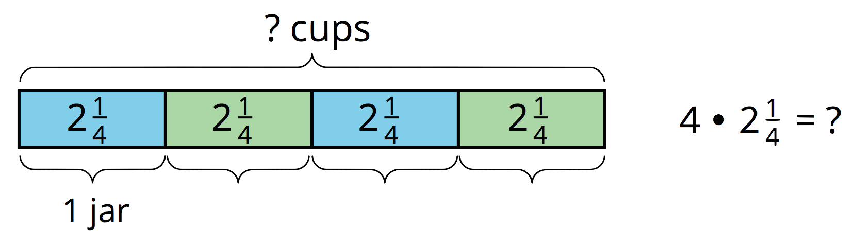
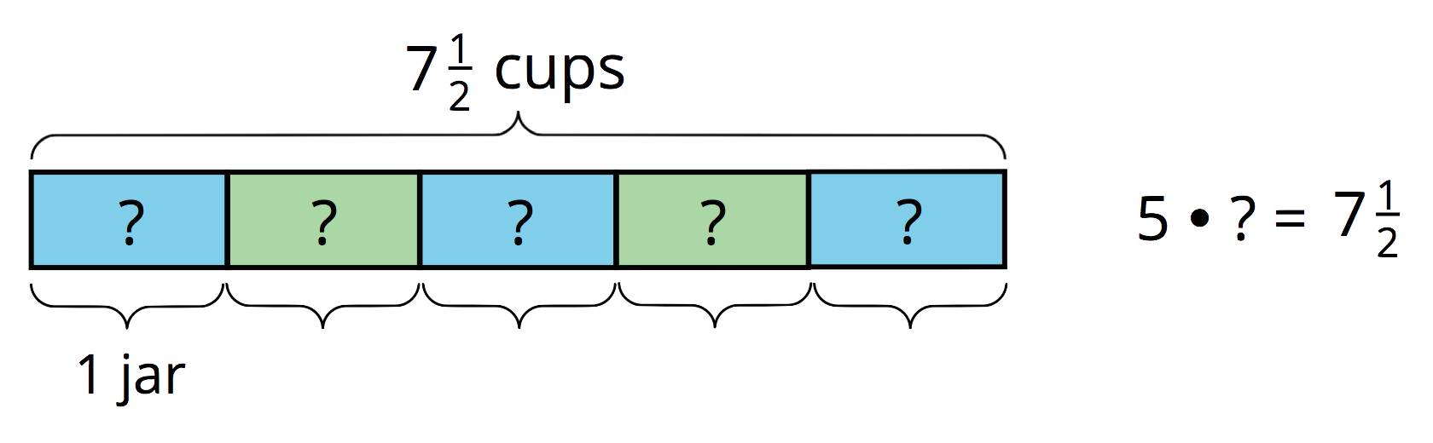
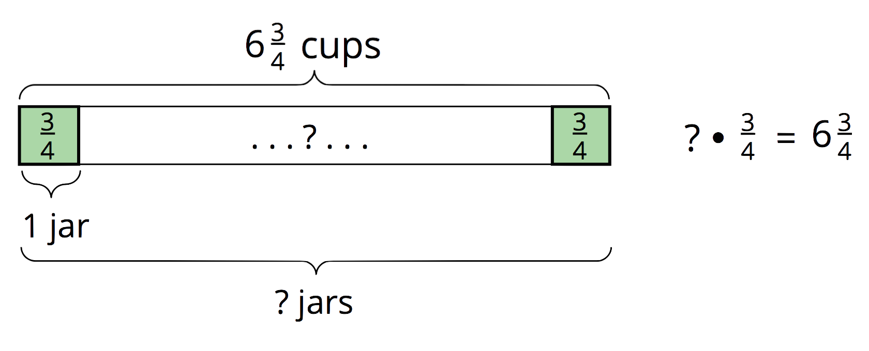

3 Making Granola

Student Task Statement
- Consider the problem: To make 1 batch of granola, Kiran needs 26 ounces of oats. The only measuring tool he has is a 4-ounce scoop. How many scoops will it take to measure 26 ounces of oats?
  - Will the answer be more than 1 or less than 1?
  - Write a multiplication equation and a division equation that represent this situation. Use “?” to represent the unknown quantity.
  - Find the unknown quantity. If you get stuck, consider drawing a diagram.
- The recipe calls for 14 ounces of mixed nuts. To get that amount, Kiran uses 4 bags of mixed nuts.
  - Write a mathematical question that might be asked about this situation.
  - What might the equation $14÷4= ?$ represent in Kiran’s situation?
  - Find the quotient. Show your reasoning. If you get stuck, consider drawing a diagram.

Activity Synthesis
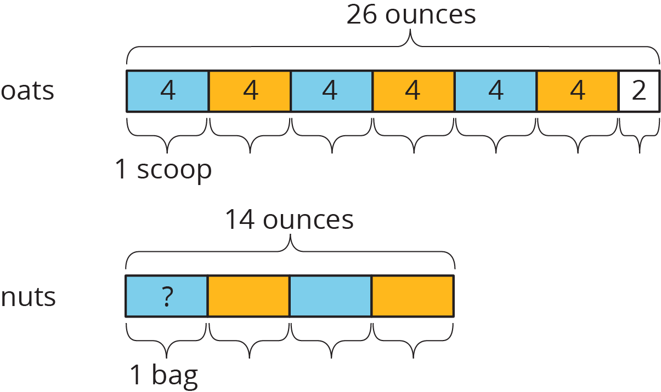
© CC BY Open Up Resources. Adaptations CC BY IM.

