Lesson 8: Different Groups, Same Quantity
- Let’s find groups that have the same number of things.

Warm-up: Act It Out: Another Way
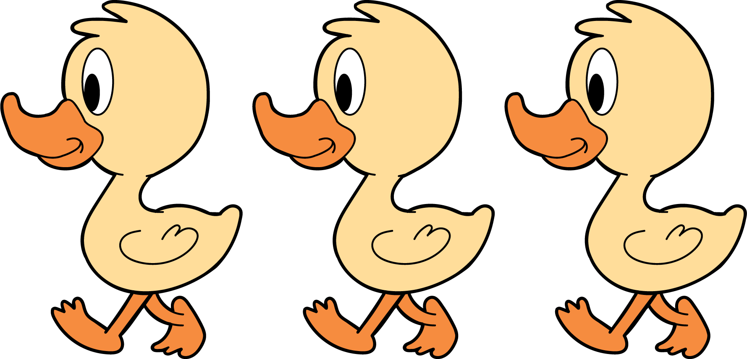
3 little ducks went out one day,
over the hill and far away.
Mother duck said, “Quack, quack, quack.”
Then 3 little ducks came back.

8.1: How Many Do You See: 1, 2, 3
How many do you see?
How do you see them?
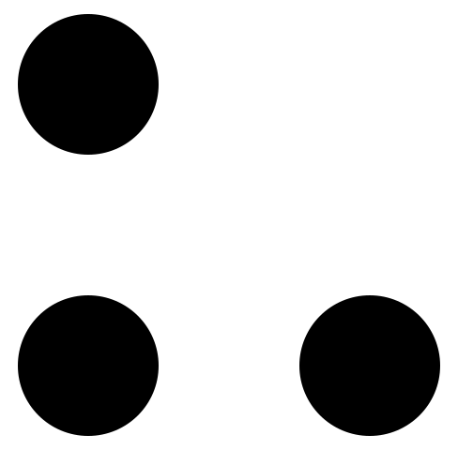

8.2: Different Groups, Same Quantity
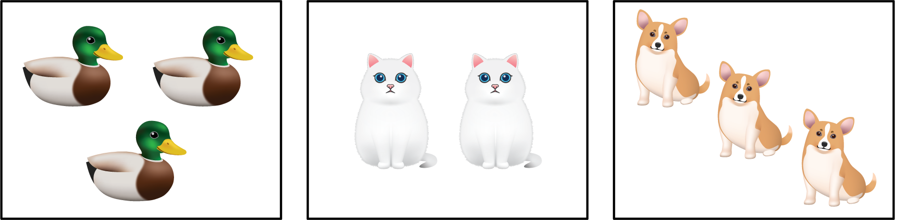

8.3: Centers: Choice Time
Choose a center.
Geoblocks
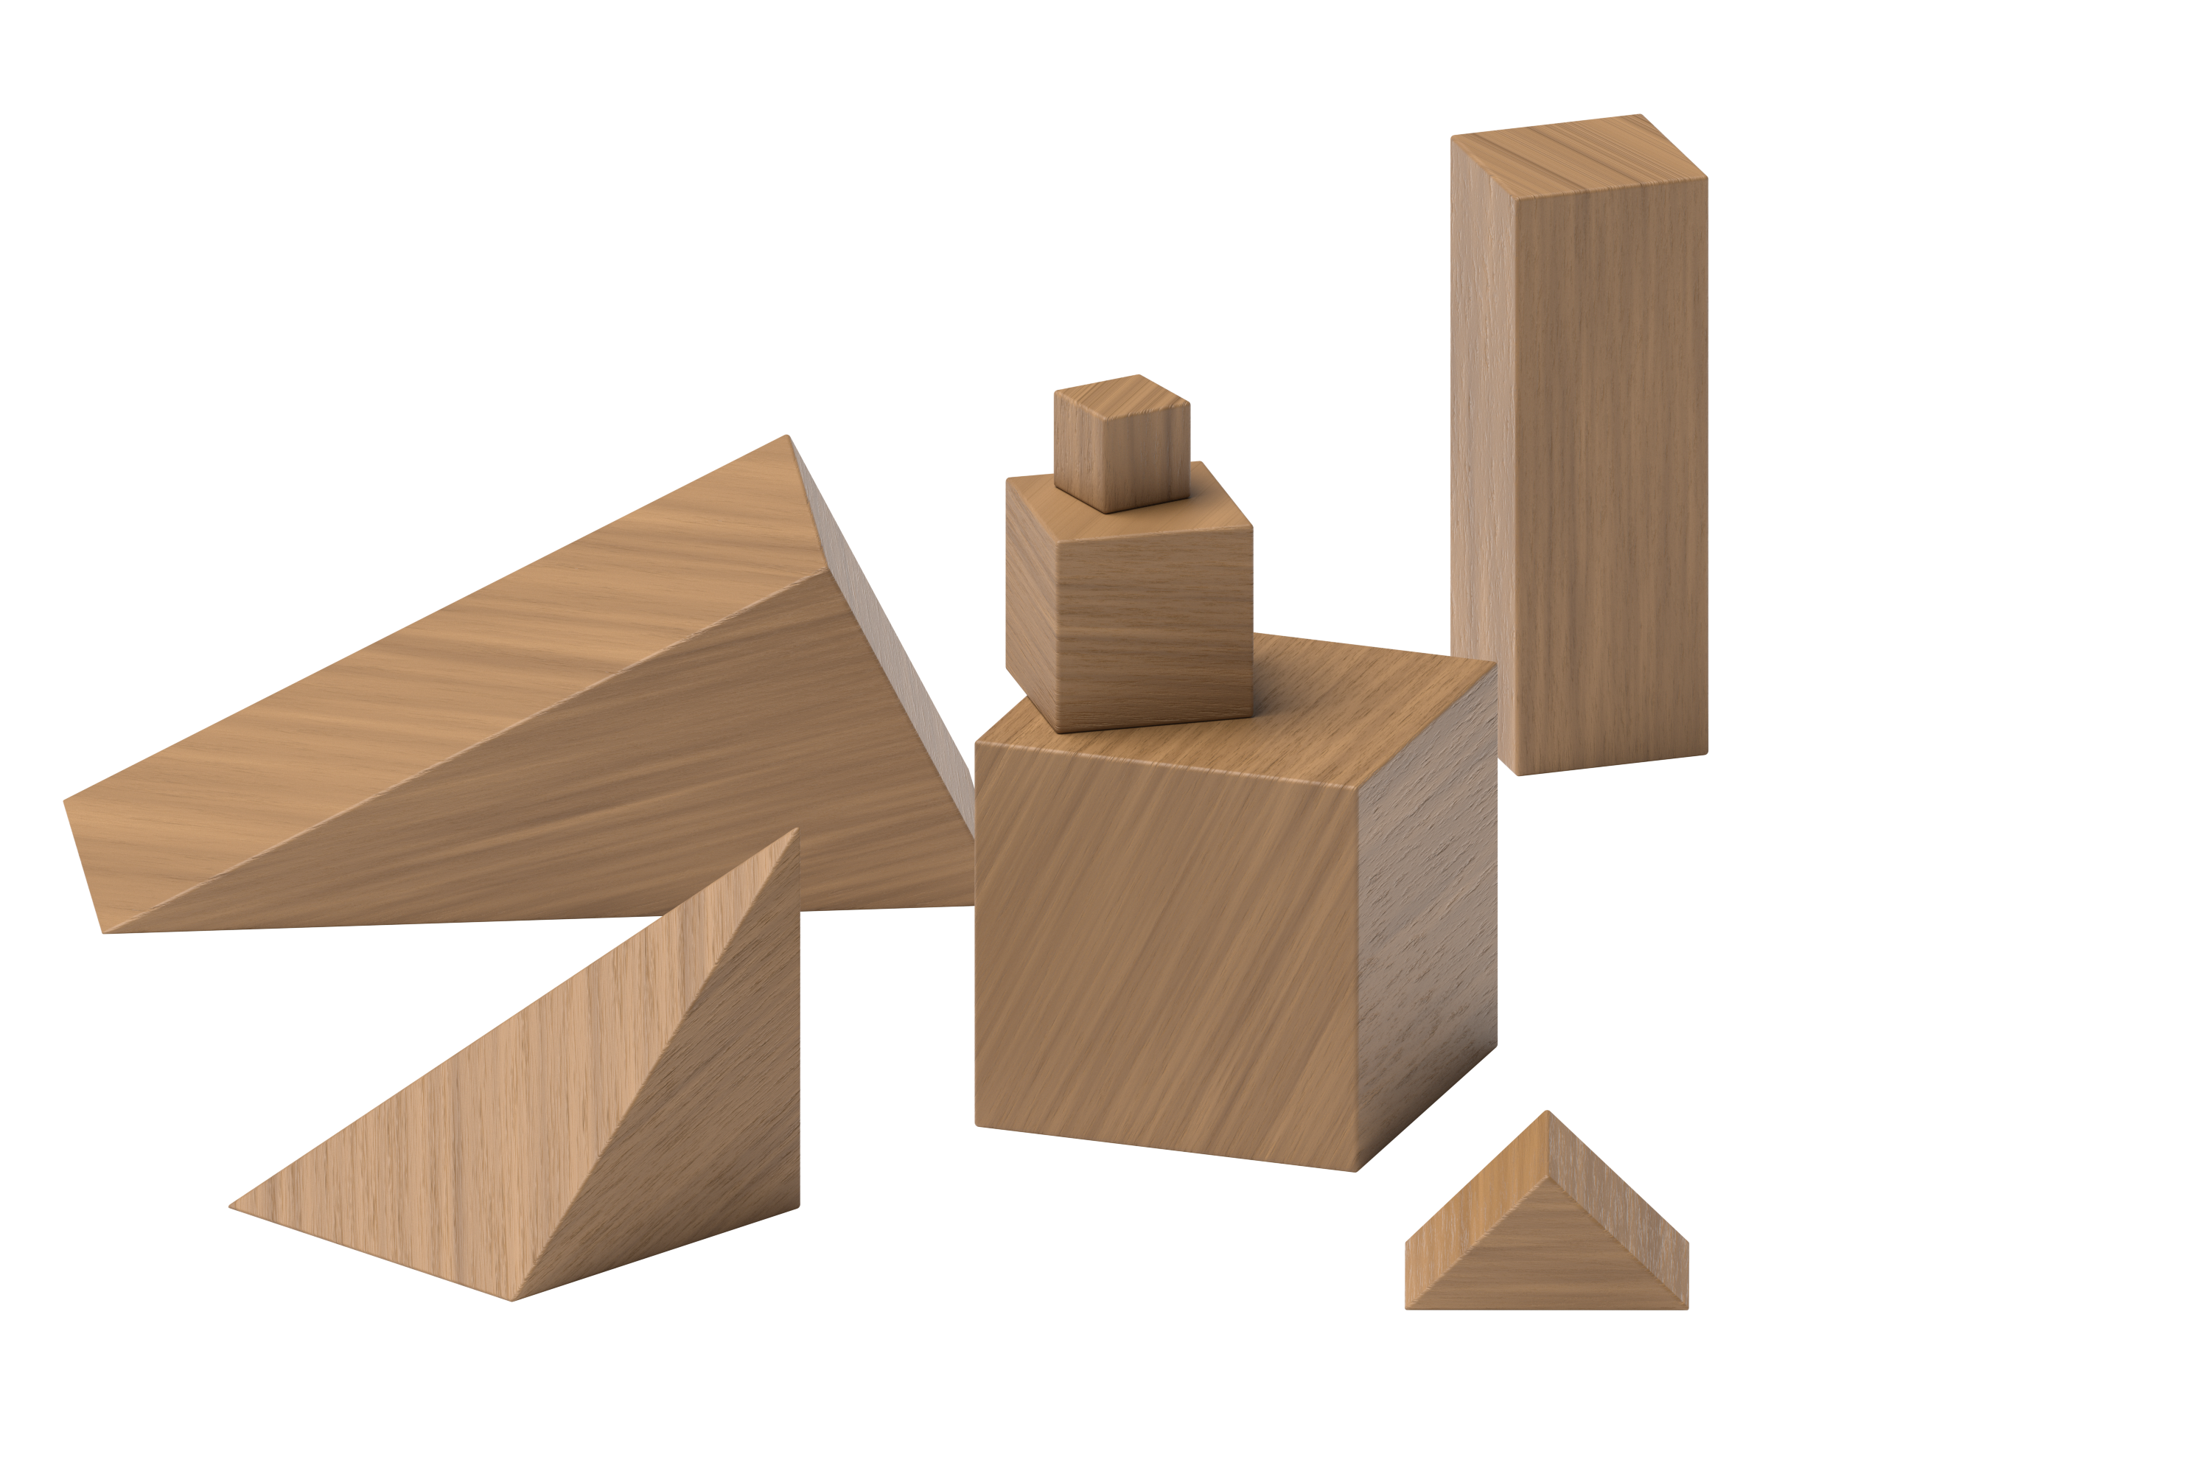
Connecting Cubes
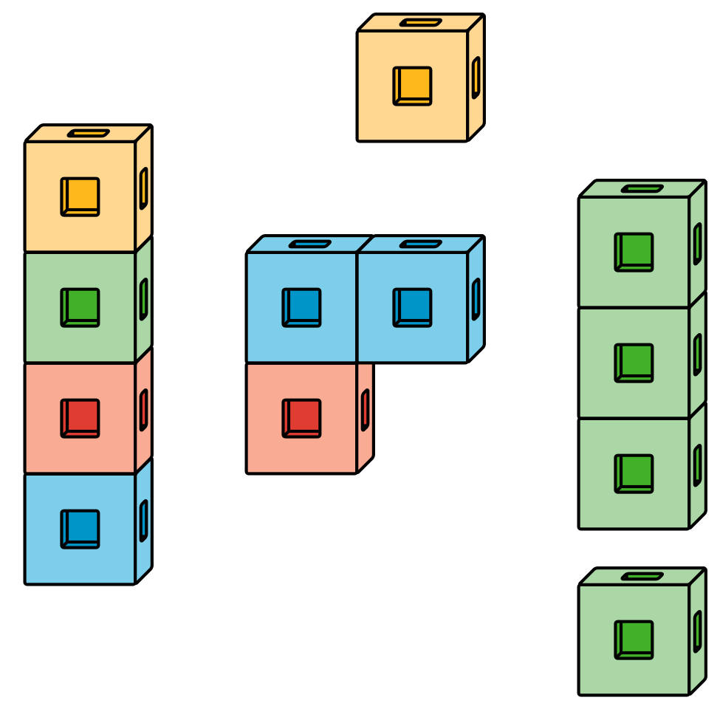
Pattern Blocks
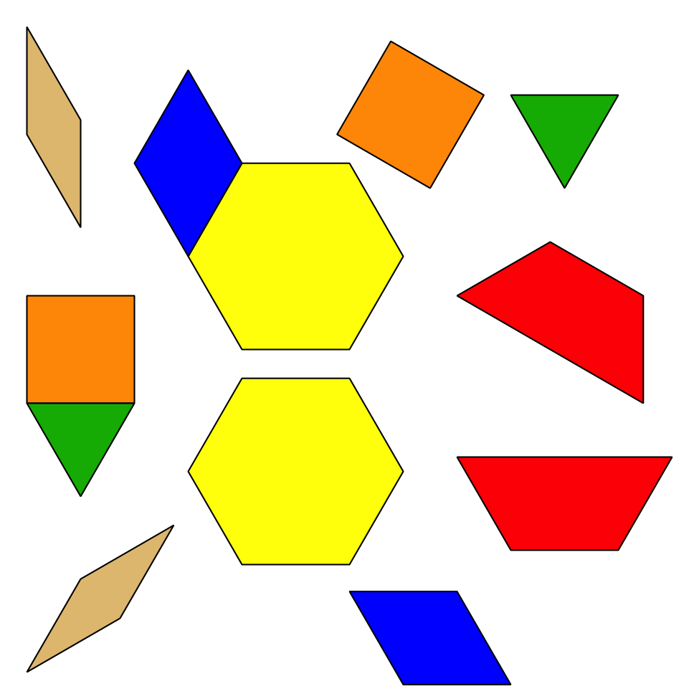
Picture Books
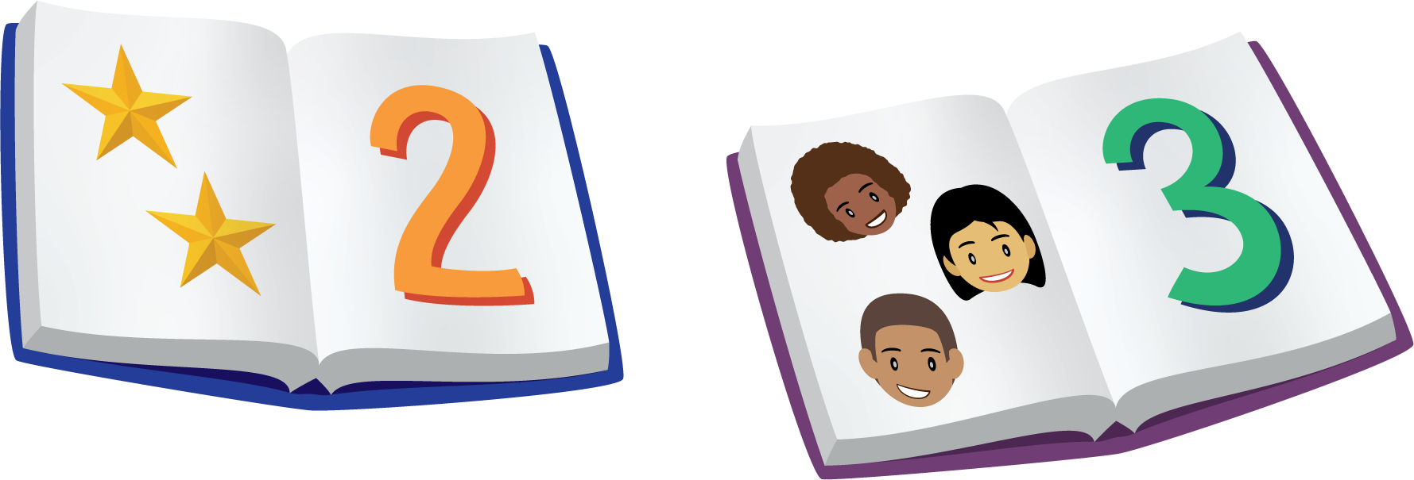
© CC BY 2021 Illustrative Mathematics®

