Lesson 15 Practice Problems
- In 2011, the population of deer in a forest was 650.
  - In 2012, the population increases by 15%. Write an expression, using only multiplication, that represents the deer population in 2012.
  - In 2013, the population increases again by 15%. Write an expression that represents the deer population in 2013.
  - If the deer population continues to increase by 15% each year, write an expression that represents the deer population $t$ years after 2011.
- Mai and Elena are shopping for back-to-school clothes. They found a skirt that originally cost $30 on a 15% off sale rack. Today, the store is offering an additional 15% off. To find the new price of the skirt, in dollars, Mai says they need to calculate $30⋅0.85⋅0.85$. Elena says they can just multiply $30⋅0.70$.
  - How much will the skirt cost using Mai’s method?
  - How much will the skirt cost using Elena’s method?
  - Explain why the expressions used by Mai and Elena give different prices for the skirt. Which method is correct?
- Technology required. One $1,000 loan charges 5% interest at the end of each year, while a second loan charges 8% interest at the end of each year.
- t, number of years | - b, loan balance with 5% interest | - c, loan balance with 8% interest
- 1
- 2
- 3
- $t$
  - Complete the table with the balances for each loan. Assume that no payments are made and that the interest applies to the entire loan balance, including any previous interest charges.
  - Which loan balance grows more quickly? How will this be visible in the graphs of the two loan balances $b$ and $c$ as functions of the number of years $t$?
  - Use technology to create graphs representing $b$ and $c$ over time. The graph should show the starting balance of each loan as well as the amount of the loan after 15 years. Write down the graphing window needed to show these points.
- Lin opened a savings account that pays $5\frac{1}{4}\%$ interest annually and deposited $5,000.
- If she makes no deposits and no withdrawals for 3 years, how much money will be in her account?
- A person loans his friend $500. They agree to an annual interest rate of 5%.
- Write an expression for computing the amount owed on the loan, in dollars, after $t$ years if no payments are made.
- Select all situations that are accurately described by the expression $15⋅3^{5}$.
  - A population of bacteria begins at 15,000. The population triples each hour. How many bacteria are there after 5 hours?
  - A population of bacteria begins at 15,000. The population triples each hour. How many thousand bacteria are there after 5 hours?
  - A population of bacteria begin at 15,000. The population quintuples each hour. How many thousand bacteria are there after 3 hours?
  - A bank account balance is $15. The account balance triples each year. What is the bank account balance, in dollars, after 5 years?
  - A bank account balance is $15,000. It grows by $3,000 each year. What is the bank account balance, in thousands of dollars, after 5 years?
- (From Unit 5, Lesson 3.)
- Here are graphs of two exponential functions, $f$ and $g$.
- If $f(x)=100⋅{\left(\frac{2}{3}\right)}^{x}$ and $g(x)=100⋅b^{x}$, what could be the value of $b$?
- 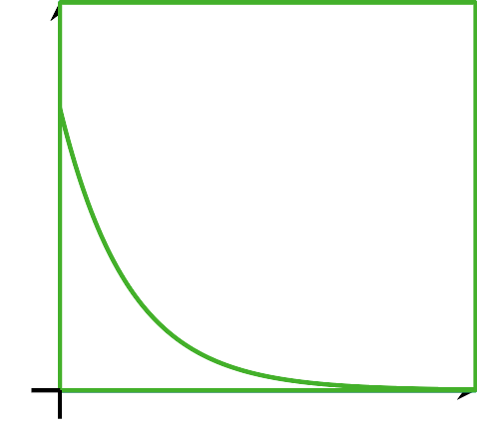
  - $\frac{1}{3}$
  - $\frac{3}{4}$
  - 1
  - $\frac{3}{2}$
- (From Unit 5, Lesson 13.)
- The real estate tax rate in 2018 in a small rural county is increasing by $\frac{1}{4}\%$. Last year, a family paid $1,200.
- Which expression represents the real estate tax, in dollars, that the family will pay this year?
  - $1,​200+1,​200⋅\left(\frac{1}{4}\right)$
  - $1,​200⋅(1.25)$
  - $1,​200⋅(1.025)$
  - $1,​200⋅(1.0025)$
- (From Unit 5, Lesson 14.)
- Two inequalities are graphed on the same coordinate plane.
- Select all of the points that are solutions to the system of the two inequalities.
- 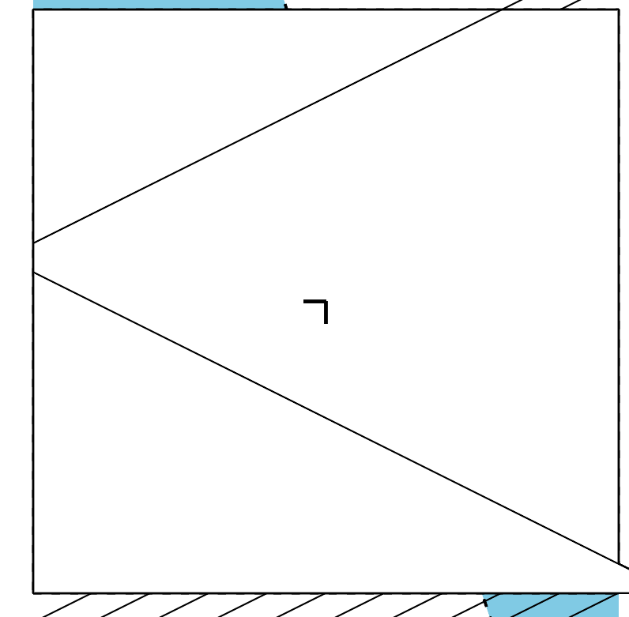
  - $(4,\text{-}6)$
  - $(4,6)$
  - $(\text{-}4,\text{-}6)$
  - $(\text{-}4,6)$
  - $(6,\text{-}8)$
  - $(7,\text{-}9)$
  - $(\text{-}8,6)$
- (From Unit 2, Lesson 24.)
© CC BY 2019 by Illustrative Mathematics®

