Lesson 12 Practice Problems
- Lin is using the diagram to prove the statement, “If a parallelogram has one right angle, it is a rectangle.” Given that $EFGH$ is a parallelogram and angle $HEF$ is right, which reasoning about angles will help her prove that angle $FGH$ is also a right angle?
- 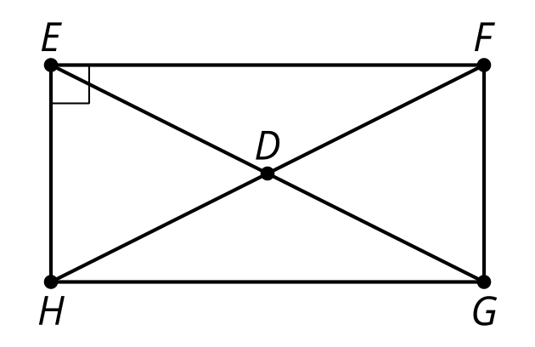
  - Corresponding angles are congruent when parallel lines are cut by a transversal.
  - Opposite angles in a parallelogram are congruent.
  - Vertical angles are congruent.
  - The base angles of an isosceles triangle are congruent.
- $ABDE$ is an isosceles trapezoid. Select all pairs of congruent triangles.
- 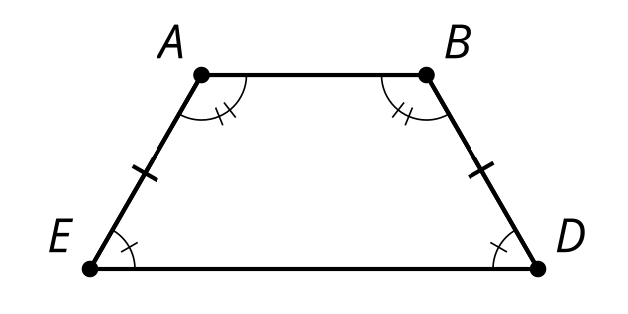
- ​​​​​​
  - Triangle $ABE$ and triangle $DBE$
  - Triangle $ABD$ and triangle $DAE$
  - Triangle $ABE$ and triangle $BAD$
  - Triangle $AED$ and triangle $BDE$
  - Triangle $EAB$ and triangle $EDB$
- Match each conjecture with the rephrased statement of proof connected to the diagram.
- 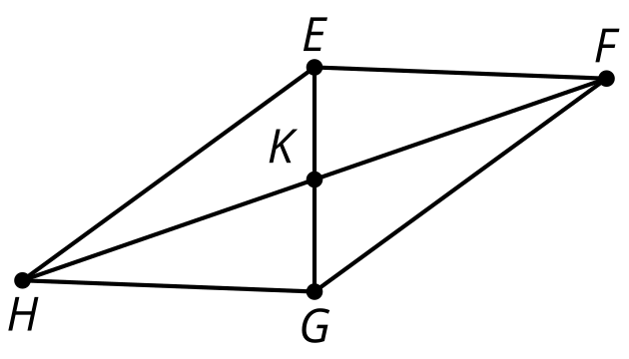
  - The diagonals of a parallelogram bisect each other.
  - In a parallelogram, opposite sides are congruent.
  - A quadrilateral with opposite sides congruent is a parallelogram.
  - If the diagonals of a quadrilateral bisect each other, then it is a parallelogram.
  - In quadrilateral $EFGH$ with $GH$ congruent to $FE$ and $EH$ congruent to $FG$, show $EFGH$ is a parallelogram.
  - In parallelogram $EFGH$, show $GH$ is congruent to $FE$ and $EH$ congruent to $FG$.
  - In quadrilateral $EFGH$ with $EK$ congruent to $KG$ and $FK$ congruent to $KH$, show $EFGH$ is a parallelogram.
  - In parallelogram $EFGH$, show $EK$ is congruent to $KG$ and $FK$ congruent to $KH$.
- Which of the following criteria always proves triangles congruent? Select all that apply.
  - Corresponding congruent Angle-Side-Angle
  - Corresponding congruent Side-Angle-Side
  - Corresponding congruent Side-Side-Angle
  - 3 congruent sides
  - 2 congruent sides
  - 3 congruent angles
- (From Unit 2, Lesson 11.)
- Select all true statements based on the diagram.
- 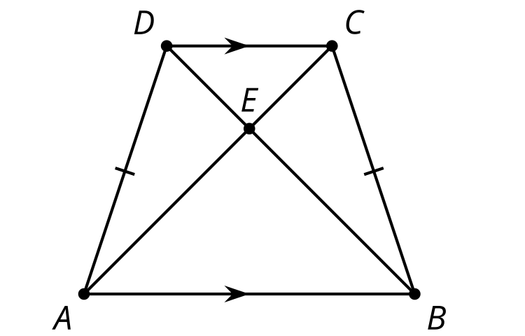
  - Segment $EB$ is congruent to segment $AD$.
  - Segment $DC$ is congruent to segment $AB$.
  - Segment $DA$ is congruent to segment $CB$.
  - Angle $CBE$ is congruent to angle $ABE$.
  - Angle $CEB$ is congruent to angle $DEA$.
  - Line $DA$ is parallel to line $CB$.
  - Line $DC$ is parallel to line $AB$.
- (From Unit 2, Lesson 10.)
- Diego states that diagonal $WY$ bisects angles $ZWX$ and $ZYX$. Is he correct? Explain your reasoning.
- 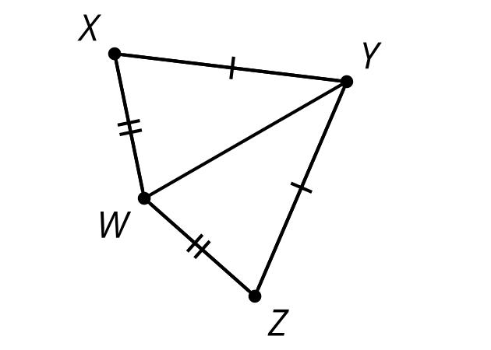
- (From Unit 2, Lesson 9.)
- Sketch the unique triangles that can be made with angle measures ${80}^{∘}$ and ${20}^{∘}$ and side length 5. How do you know you have sketched all possibilities?
- (From Unit 2, Lesson 4.)
© CC BY 2019 by Illustrative Mathematics®

