Unit 6 Lesson 3: Lots of Rectangles

1 Math Talk: Many Ways to Area (Warm up)

Student Task Statement
A rectangle is partitioned into smaller rectangles. Explain why each of these expressions represents the area of the entire rectangle.
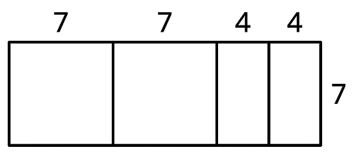
$7(7+7+4+4)$
$7(2⋅7+2⋅4)$
$7^{2}+7^{2}+4⋅7+4⋅7$
$2(7^{2})+2(4⋅7)$

2 Representing Areas

Student Task Statement
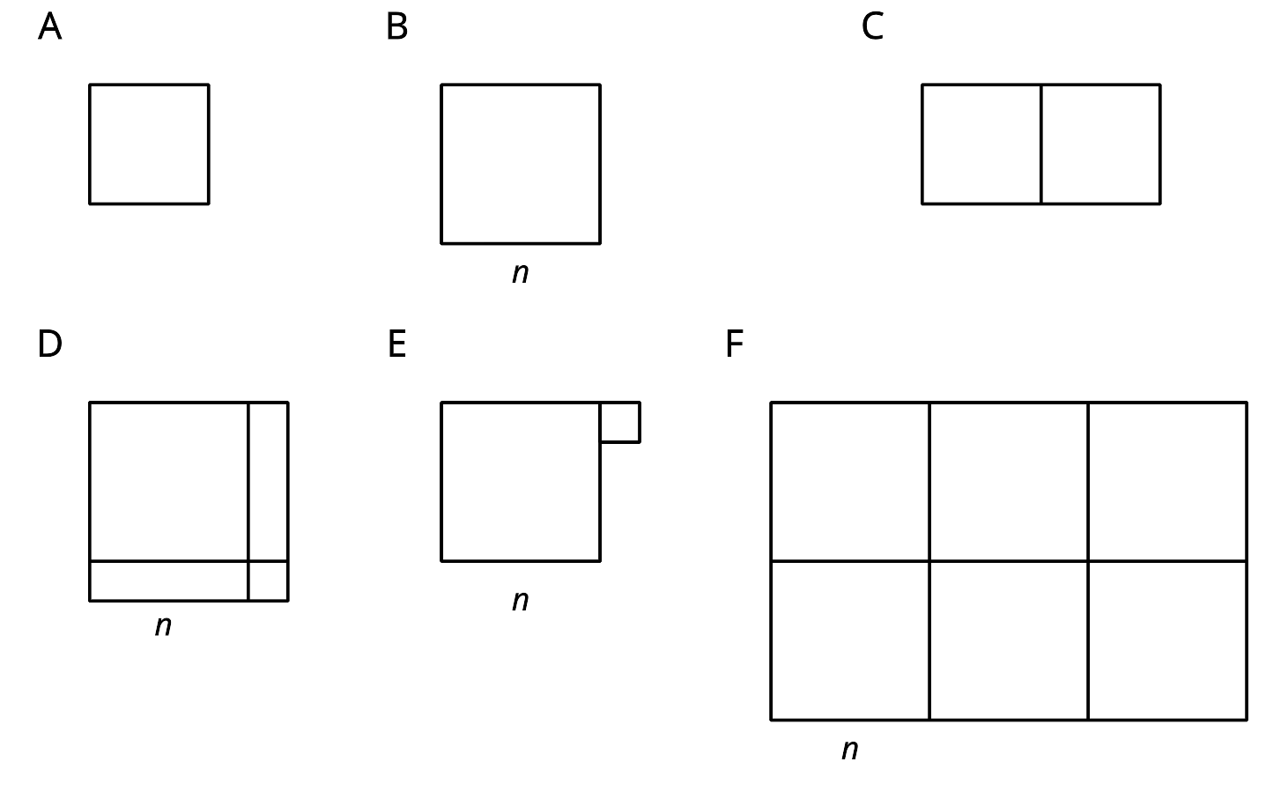
Match each figure with one or more expressions for its area. Every shape that looks like a square is a square.
- $2⋅3^{2}$
- $6n^{2}$
- $n^{2}+1^{2}$
- $3^{2}$
- $(n+1)(n+1)$
- $(2n)(3n)$
- $(n+1)^{2}$
- $3(3+3)$
- $n^{2}$
- $(n+n)(n+n+n)$
- $3^{2}+3^{2}$

3 Areas of Rectangles

Student Task Statement
Complete the table with the length, width, and area of each rectangle.
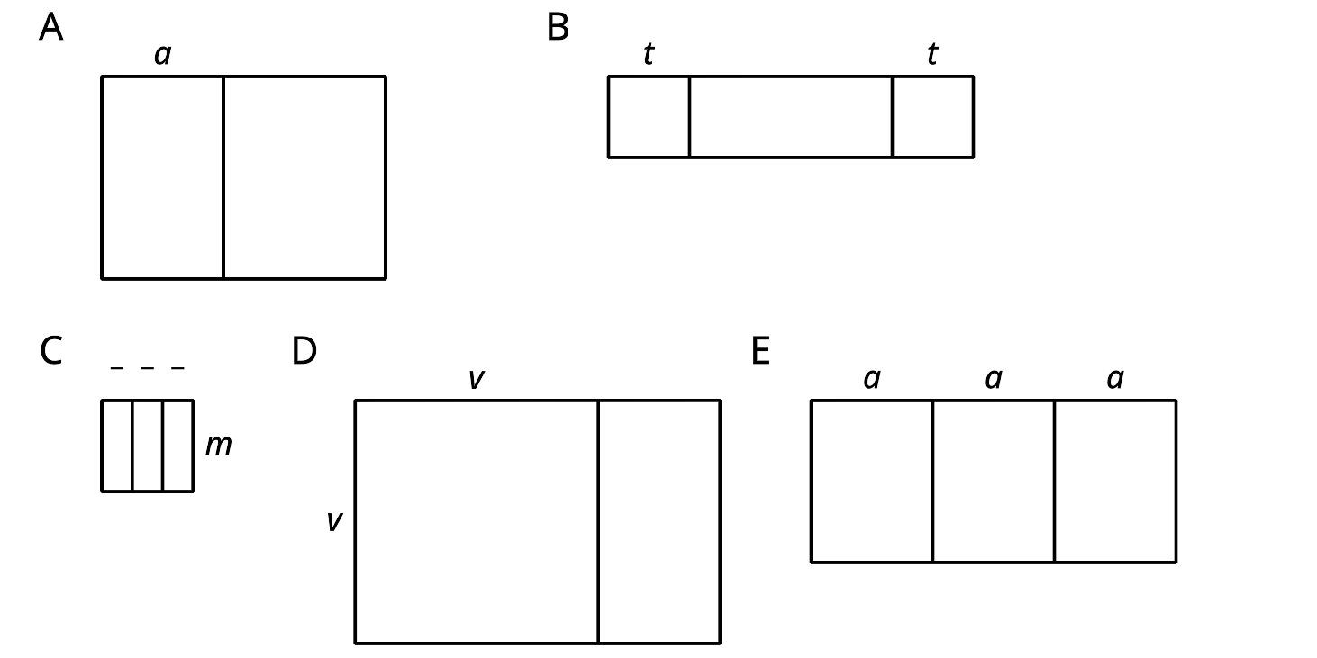
rectangle (units) | length (units) | width (units) | area (square units)
A | $a+4$
B |  | 2
C
D
E
© CC BY 2019 by Illustrative Mathematics

