Lesson 13: Perimeter and Area of Rectangles

Standards Alignments
Addressing | 5.G.A.2, 5.NBT.B.7, 5.OA.B.3
Building Towards | 5.G.A.2

Teacher-facing Learning Goals
- Use the coordinate grid to understand the length and width of rectangles with fixed area.
- Use the coordinate grid to understand the length and width of rectangles with fixed perimeter.

Student-facing Learning Goals
- Let’s explore the perimeter and area of rectangles on the coordinate grid.

Lesson Purpose
The purpose of this lesson is for students to examine rectangles with given perimeter or area, plotting their length and width on the coordinate grid.
The purpose of this lesson is to plot the lengths and widths of different rectangles with a given perimeter or with a given area. In a previous course, students found rectangles with the same area and different perimeter and rectangles with the same perimeter and different area. Graphing the possible lengths and widths helps to visualize and quantify these relationships. Specifically, when the perimeter is given, the relationship between the length and width is that each unit taken away from the length is added to the width. When the area is given, the relationship is more complicated and the graphs of the two situations reveal this. As students calculate side lengths they also have opportunities to perform arithmetic with fractions and decimals.
This lesson has a Student Section Summary.

Access for:

Students with Disabilities
- Representation (Activity 1)

English Learners
- MLR8 (Activity 1)

Instructional Routines
Estimation Exploration (Warm-up)

Lesson Timeline
Warm-up | 10 min
Activity 1 | 15 min
Activity 2 | 20 min
Lesson Synthesis | 10 min
Cool-down | 5 min

Teacher Reflection Question
As you finish up this unit, reflect on the norms and routines that have supported each student in learning math. How have you seen each student grow as a young mathematician throughout this work? How have you seen yourself grow as a teacher?

Cool-down
(to be completed at the end of the lesson) 5min
Area and Perimeter of a Rectangle

Standards Alignments
Addressing | 5.OA.B.3

Student-facing Task Statement
The point represents the length and width of a rectangle.
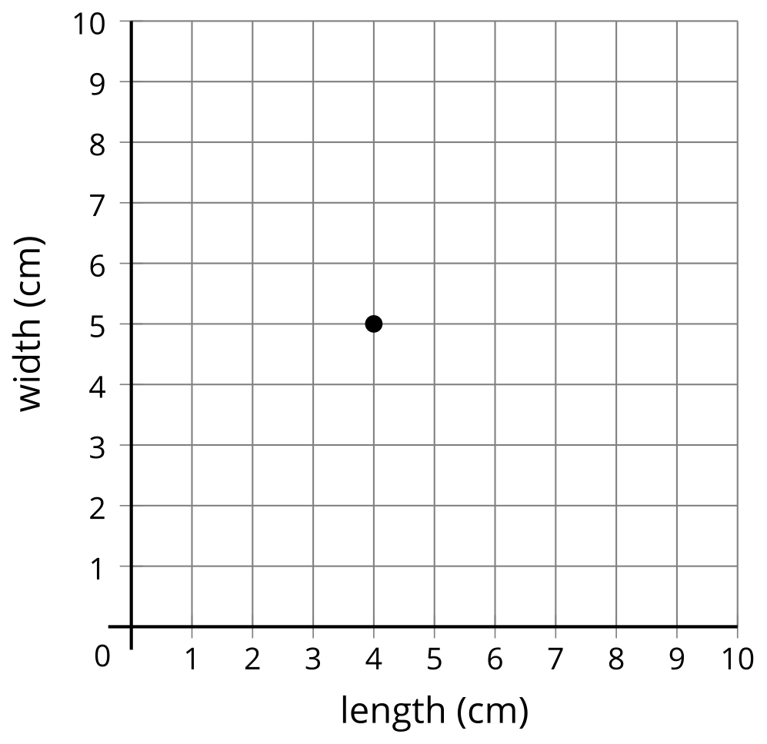
- What are the area and perimeter of the rectangle? Explain or show your reasoning.
- What is a point that represents a different rectangle with the same area? Explain or show your reasoning.

Student Responses
- Sample response:
- Area: 20 square centimeters since $4×5=20$
- Perimeter: 18 centimeters since $\left(2×4\right)+\left(2×5\right)=18$
- Sample responses: $\left(2,10\right)$, $\left(10,2\right)$, $\left(2.5,8\right)$, $\left(8,2.5\right)$

