Lesson 13: Questions About Data
- Let’s ask and answer questions about data.

Warm-up: Number Talk: Plus or Minus 1 or 2
Find the value of each expression mentally.
- $7+1$
- $7+2$
- $9−1$
- $9−2$

13.1: Can You Answer It?
Elena asked her classmates, “What is your favorite subject in school?”
She showed their responses below.
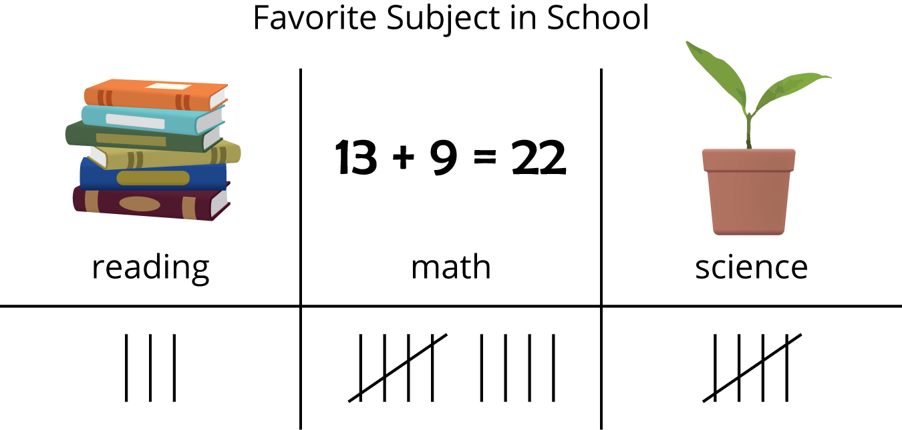
Han wrote questions about Elena's data.
Decide whether each question can be answered using the data representation.
Be ready to explain why.
- How many students said math is their favorite subject?
- 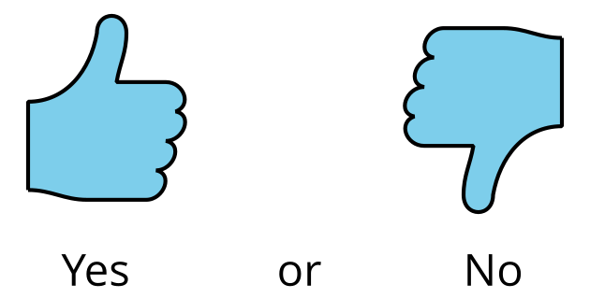
- How many students said writing is their favorite subject?
- Who said they like reading best?
- How many students chose reading or science?

13.2: Ask Questions
Our favorite __________________________________________________
category 1 | category 2 | category 3

Section Summary
Section Summary
We looked at different ways to show data.
You can show data using tally marks.
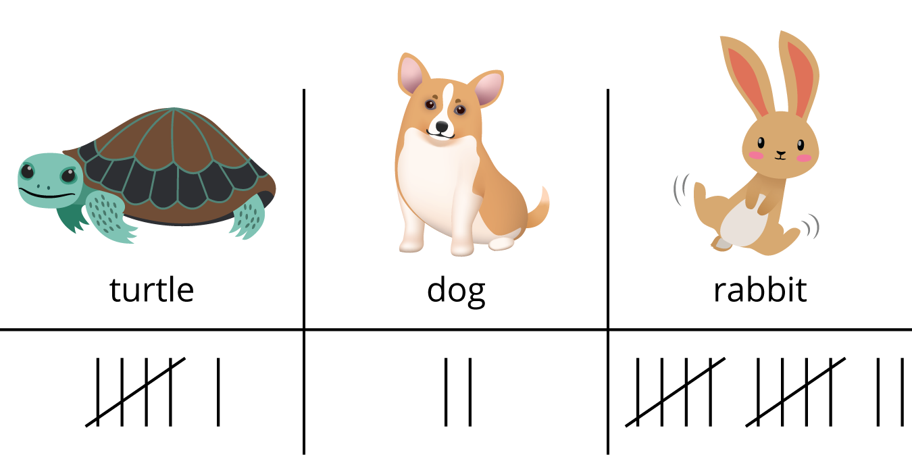
You can show data using numbers.
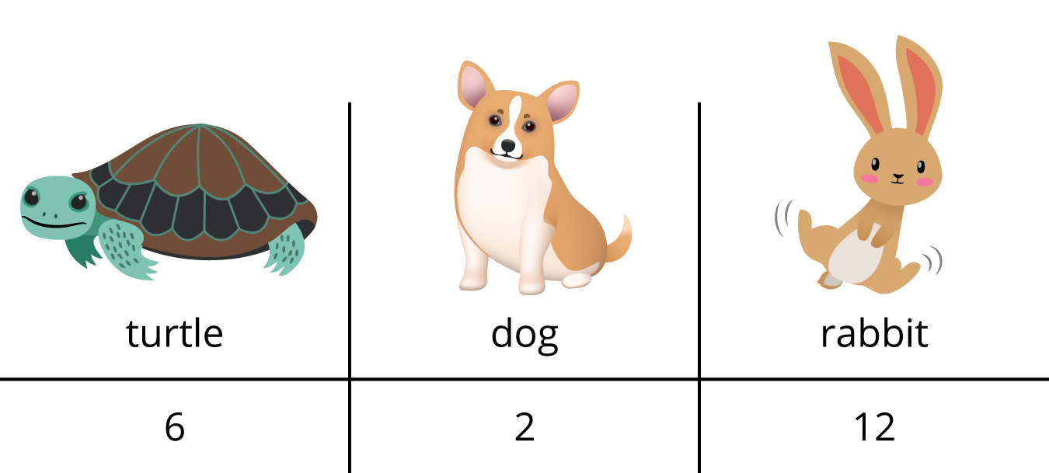
We asked and answered questions about data.
- How many students want a turtle as a class pet? (6)
- How many students want a dog or a rabbit as a class pet? (14)
- How many students took the survey? (20)
Think of some questions you can ask your family at home and make a representation to show the data.
© CC BY 2021 Illustrative Mathematics®

