Lesson 2: Measure in Centimeters
- Let’s measure in centimeters.

Warm-up: Notice and Wonder: Centimeters
What do you notice? What do you wonder?
A
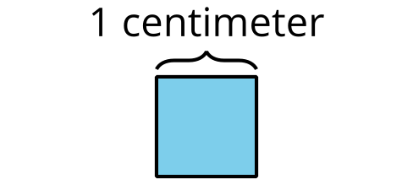
B
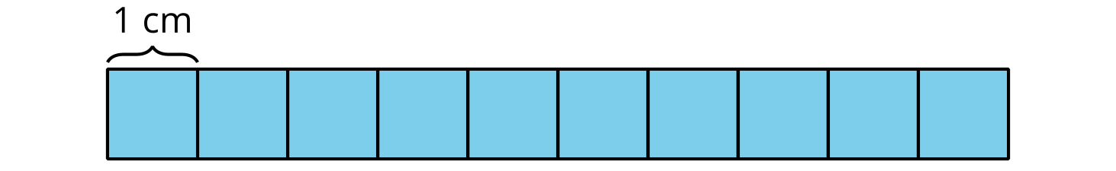

2.1: Length in Centimeters
- Measure the length of the bearded dragon using the single centimeter cubes.
- The bearded dragon is ____________ centimeter cubes long.
- Measure the bearded dragon using the 10-centimeter tool.
- The bearded dragon is ____________ 10-centimeter tools long.
- How many centimeters long is the bearded dragon?
- The bearded dragon is ____________ centimeters long.

2.2: Measure with 10-centimeter Tools
- Measure the length of each reptile in centimeters.
  - ____________ cm
  - ____________ cm
  - ____________ cm
  - ____________ cm
- Compare your measurements with your partner’s measurements.
- How much longer is the day gecko than the threadsnake?
© CC BY 2021 Illustrative Mathematics®

