Unit 5 Lesson 10: Equivalent Fractions

WU Choral Count: One-halves (Warm up)

Student Task Statement

1 Equivalent to $\frac{1}{2}$

Student Task Statement
- For which shapes is the shaded portion $\frac{1}{2}$ of the shape? Be prepared to share your reasoning.
- A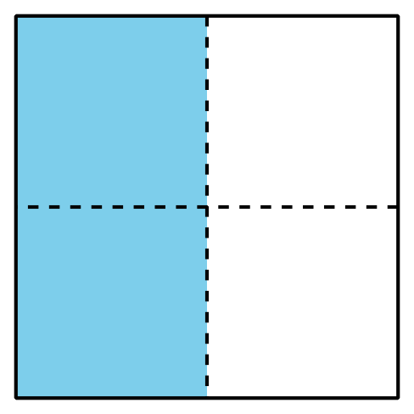
- B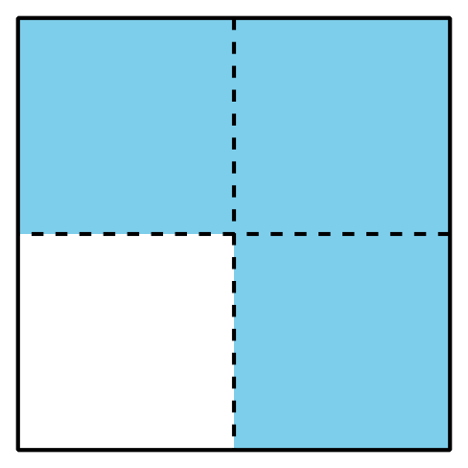
- C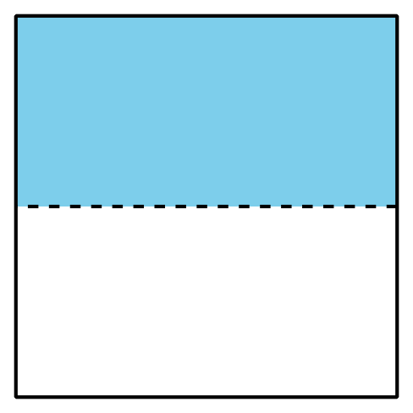
- D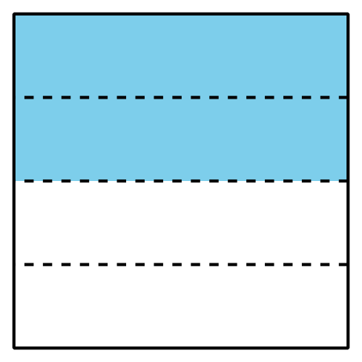
- E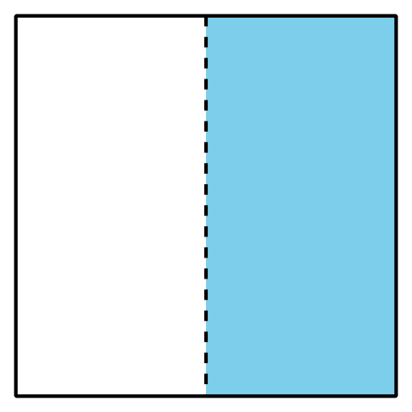
- F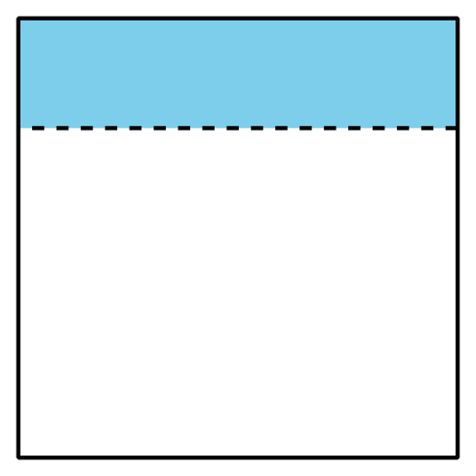
- How can there be more than one way of shading a shape to show $\frac{1}{2}$?

2 Find Equivalent Fractions

Student Task Statement
Use your fraction strips from an earlier lesson to find as many equivalent fractions as you can that are equivalent to:
- $\frac{1}{2}$
- $\frac{2}{3}$
- $\frac{6}{6}$
- $\frac{3}{4}$
Be prepared to show how you know the fractions are equivalent.
© CC BY 2021 Illustrative Mathematics®

