Unit 3 Lesson 1: Sums I Know

WU Notice and Wonder: Addition Table (Warm up)

Student Task Statement
What do you notice?
What do you wonder?
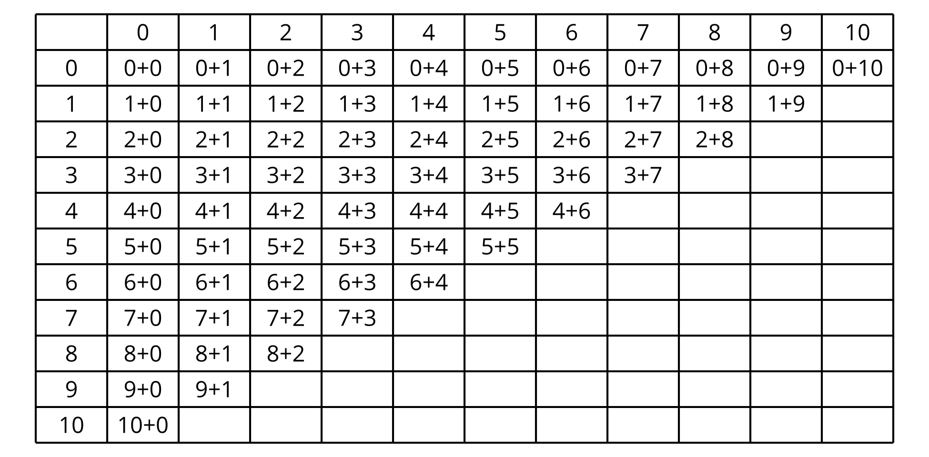

1 My Favorite Sum

Student Task Statement
Pick your favorite sum.
Write the equation: ________________________________
Show why it is your favorite using drawings, numbers, or words.

2 Sums I’ve Got

Student Task Statement
- Place your cards in a pile face down.
- Flip the card and say the expression.
- If you can say the value of the sum quickly, place it under “got it.”
- If it takes you some time to find the value, place it under “not yet.”
- got it | - not yet
© CC BY 2021 Illustrative Mathematics®

