Lesson 9 Practice Problems
- 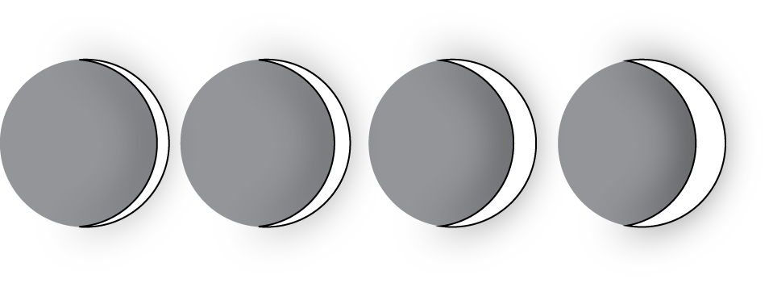
- On the first day after the new moon, 2% of the Moon's surface is illuminated. On the second day, 6% is illuminated.
  - Based on this information, predict the day on which the Moon’s surface is 50% illuminated and 100% illuminated.
  - The Moon’s surface is 100% illuminated on day 14. Does this agree with the prediction you made?
  - Is the percentage illumination of the Moon’s surface a linear function of the day?
- In science class, Jada uses a graduated cylinder with water in it to measure the volume of some marbles. After dropping in 4 marbles so they are all under water, the water in the cylinder is at a height of 10 milliliters. After dropping in 6 marbles so they are all under water, the water in the cylinder is at a height of 11 milliliters.
  - What is the volume of 1 marble?
  - How much water was in the cylinder before any marbles were dropped in?
  - What should be the height of the water after 13 marbles are dropped in?
  - Is the relationship between volume of water and number of marbles a linear relationship? If so, what does the slope of a line representing this relationship mean? If not, explain your reasoning.
- Solve each of these equations. Explain or show your reasoning.
- $2\left(3x+2\right)=2x+28$
- $5y+13=\text{-}43−3y$
- $4\left(2a+2\right)=8\left(2−3a\right)$

- (From Unit 4, Lesson 5.)
- For a certain city, the high temperatures (in degrees Celsius) are plotted against the number of days after the new year.
- Based on this information, is the high temperature in this city a linear function of the number of days after the new year?
- 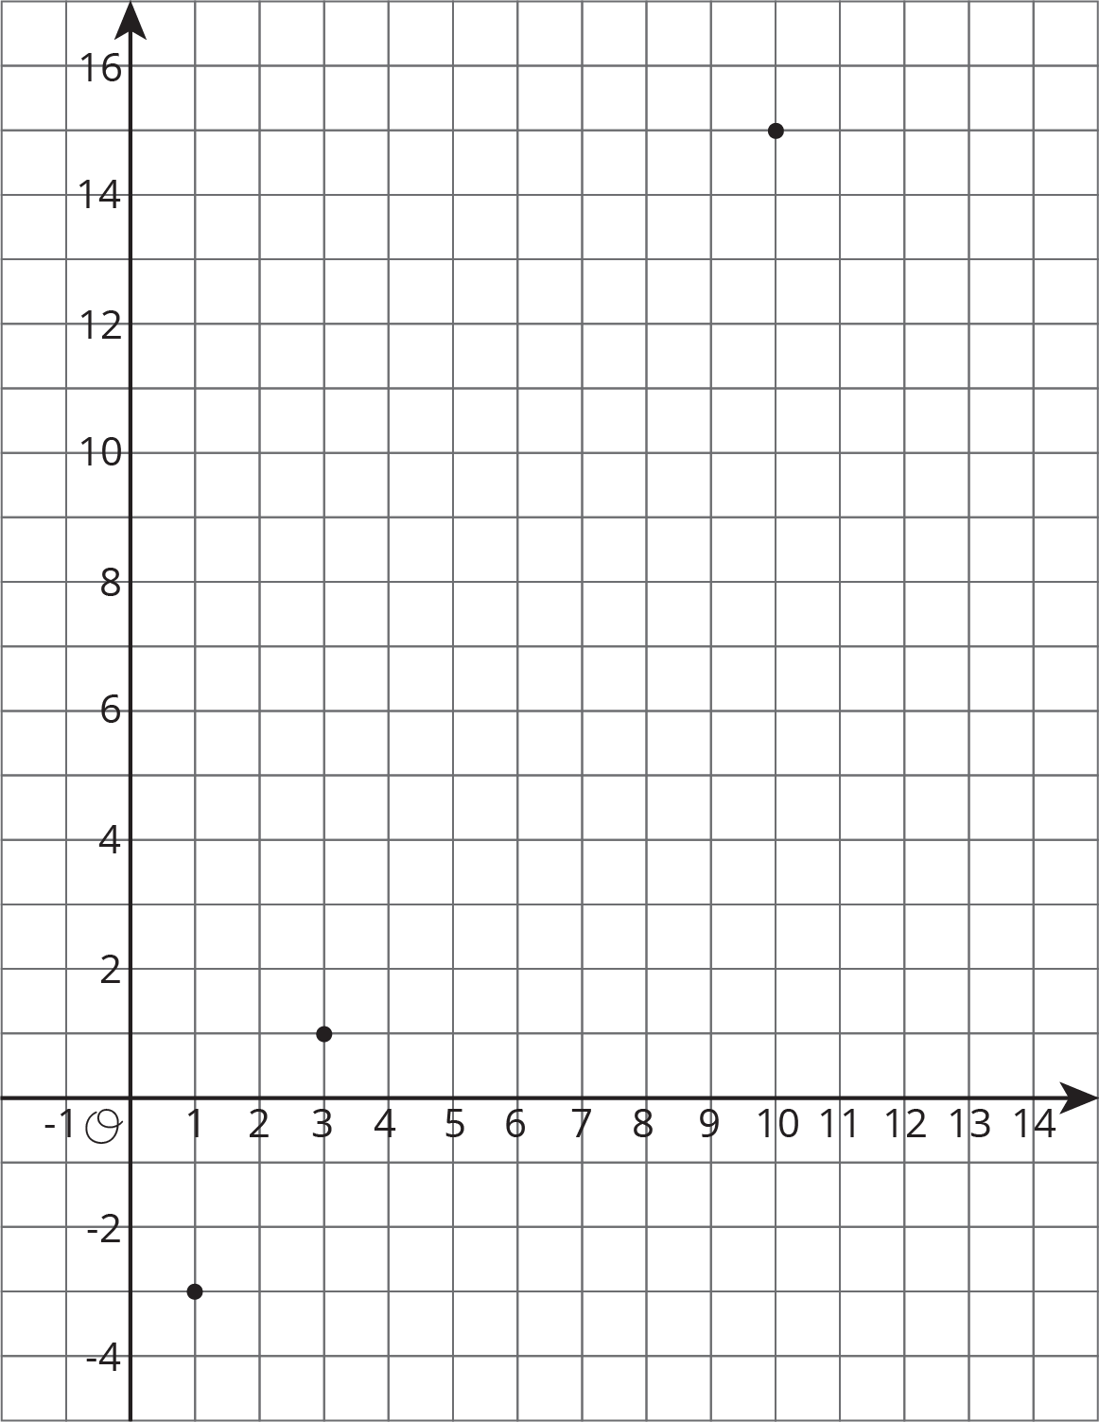
- The school designed their vegetable garden to have a perimeter of 32 feet with the length measuring two feet more than twice the width.
  - Using $ℓ$ to represent the length of the garden and $w$ to represent its width, write and solve a system of equations that describes this situation.
  - What are the dimensions of the garden?
- (From Unit 4, Lesson 15.)
© CC BY Open Up Resources. Adaptations CC BY IM.

