Lesson 13: Using Radians
- Let’s see how radians can help us calculate sector areas and arc lengths.

13.1: What Fraction?
A circle with radius 24 inches has a sector with central angle $\frac{π}{3}$ radians.
- What fraction of the whole circle is represented by this sector?
- Find the area of the sector.

13.2: A Sector Area Shortcut
Lin and Elena are trying to find the area of the shaded sector in the image. Lin says, “We’ve found sector areas when the central angle is given in degrees, but here it’s in radians. Should I start by finding the area of the full circle?”
Elena says, “I saw someone using the formula $\frac{1}{2}r^{2}θ$ where $θ$ is the measure of the angle in radians, and $r$ is the radius. But I don’t know where that came from.”
- Compare and contrast finding sector areas for central angles measured in degrees and those measured in radians.
- Explain why the formula that Elena saw works.
- Find the area of the sector.

13.3: An Arc Length Shortcut
The city of Riverside has 2 straight highways extending out from its town hall (located at $T$ in the image). Several roads shaped like circular arcs connect the two highways. Exits from 1 of the highways are shown at points $A,B,C,$ and $D$.
- Create a table that shows the arc length, $ℓ$, of the connector roads as a function of the radius, $r$, of the highway.
- Plot the points from your table on the coordinate grid and connect them.
- 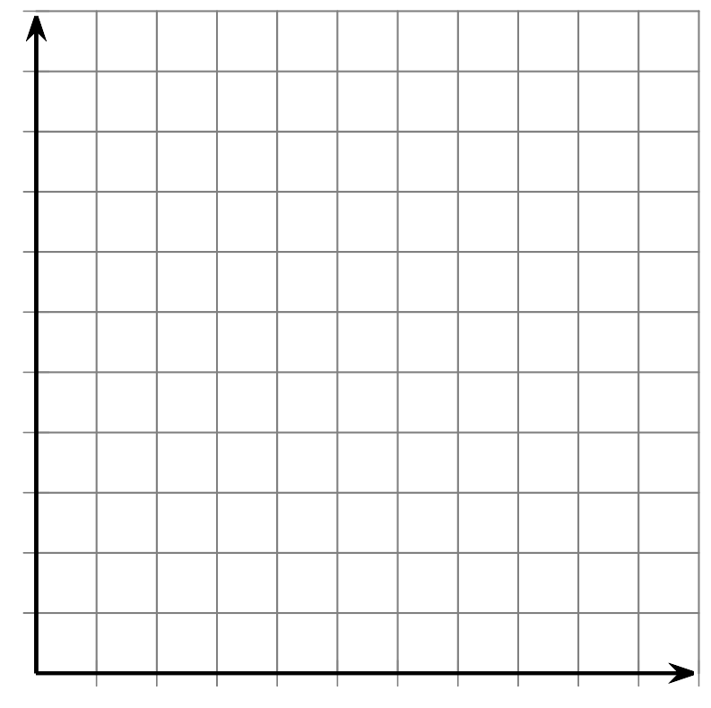
- The points should form a line. Write an equation for this line, using the variables $ℓ$ and $r$.
- What does the slope of the line mean in context of the highways and connector roads?
- The city wants to build a new arc-shaped connector road starting at point $E$ which will be an additional 6 miles past exit $D$. How long will this road be?

Are you ready for more?
Suppose a Ferris wheel with a 50 foot radius takes 2 minutes to complete 1 rotation.
- After 20 seconds, through how many radians would a rider on the Ferris wheel have traveled?
- How long would it take to travel through 3 radians?
- What is the rotational speed of the rider on the ferris wheel in radians per second?
- A decorative light is attached to the Ferris wheel 25 feet from the center of the wheel. What is the rotational speed of the light in radians per second?

Lesson 13 Summary
Suppose we want to find the area of a sector of a circle whose central angle is $θ$ radians and whose radius is $r$ units. First we find the area of the whole circle, or $πr^{2}$ square units. Then we find the fraction of the circle represented by the sector. The complete circle measures $2π$ radians. So the fraction is $\frac{θ}{2π}$. Multiply the fraction by the area to get $\frac{θ}{2π}⋅πr^{2}$. This can be rewritten as $\frac{1}{2}r^{2}θ$.
For example, let the radius be 25 units and the radian measure of the sector’s central angle be $\frac{3π}{5}$ radians. Substitute these values into the formula we just created to get $\frac{1}{2}(25)^{2}⋅\frac{3π}{5}$. This can be rewritten as $\frac{375π}{2}$, which is about 589 square units. Using the formula was a bit quicker than going through the process of finding the specific fraction of the circle represented by this sector and multiplying by the circle’s area.
Additionally, we can write a formula for arc length based on the definition of radian measure as $θ=\frac{ℓ}{r}$ where $θ$ is the central angle measure in radians, $ℓ$ is the arc length, and $r$ is the radius. Rewrite the definition to solve for arc length. We get $ℓ=rθ$.
© CC BY 2019 by Illustrative Mathematics®

