Lesson 9: Create Picture Books
- Let’s make picture books about our classroom.

Warm-up: Act It Out: The Story Changes
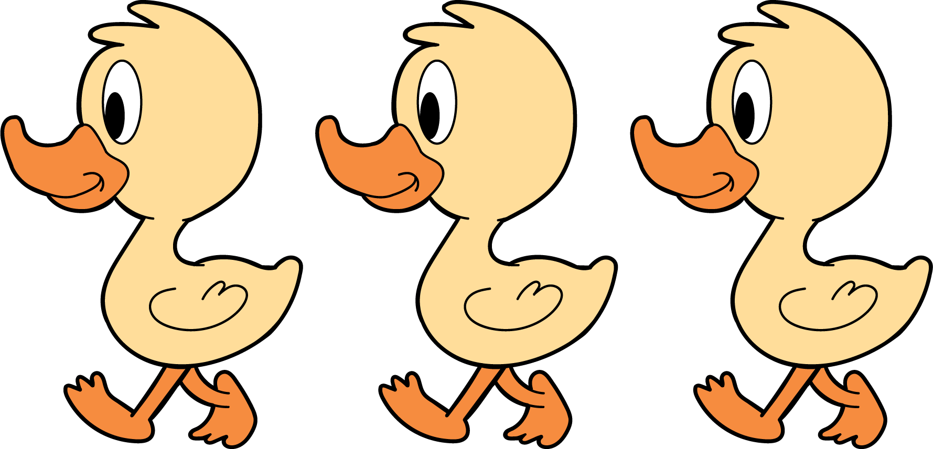
3 little ducks went out one day,
over the hill and far away.
Mother duck said, “Quack, quack, quack.”
Then 3 little ducks came back.
3 little ducks went out one day,
over the hill and far away.
Mother duck said, “Quack, quack, quack.”
Then 2 little ducks came back.

9.1: How Many Do You See: What Do You Notice?
How many do you see?
How do you see them?
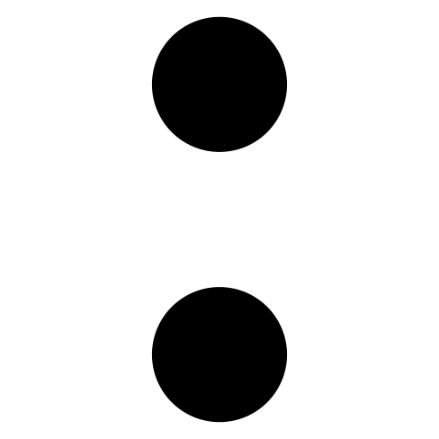

9.2: Introduce Picture Books, Create
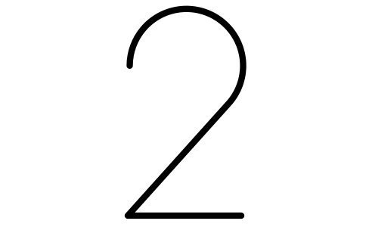

9.3: Centers: Choice Time
Choose a center.
Geoblocks
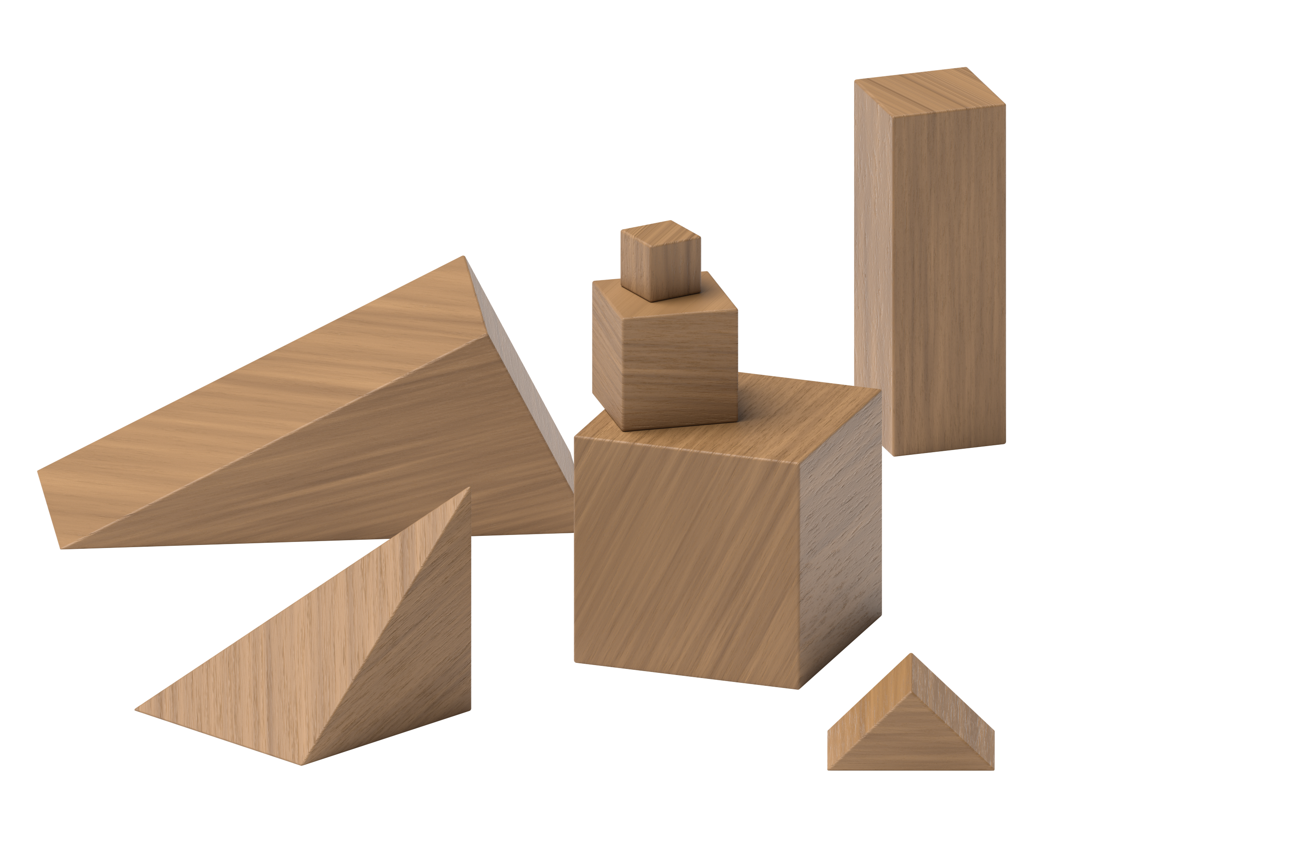
Connecting Cubes
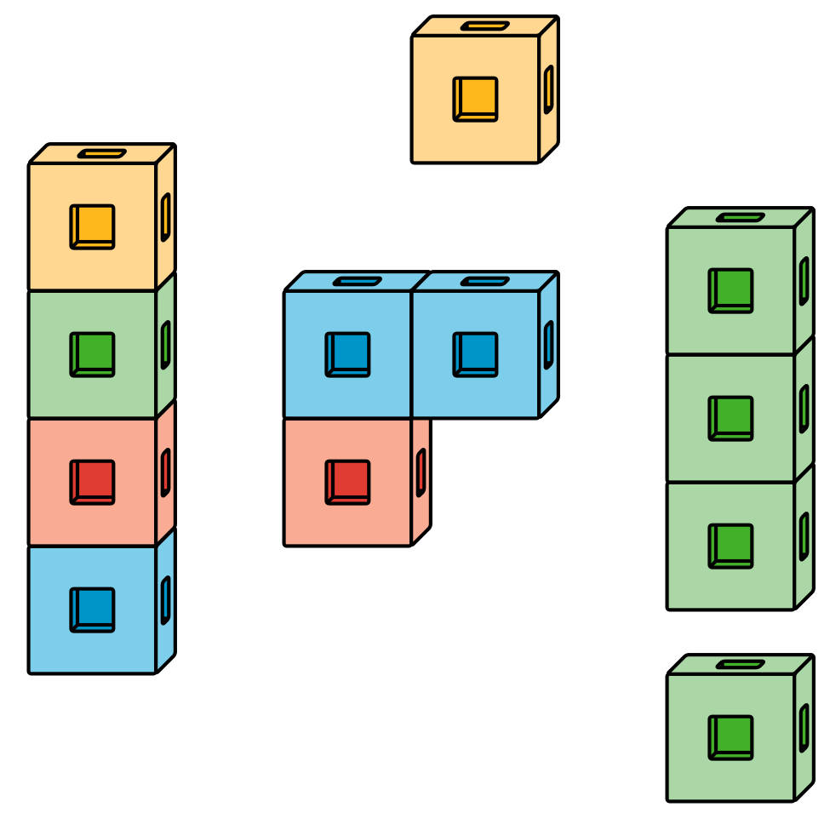
Pattern Blocks
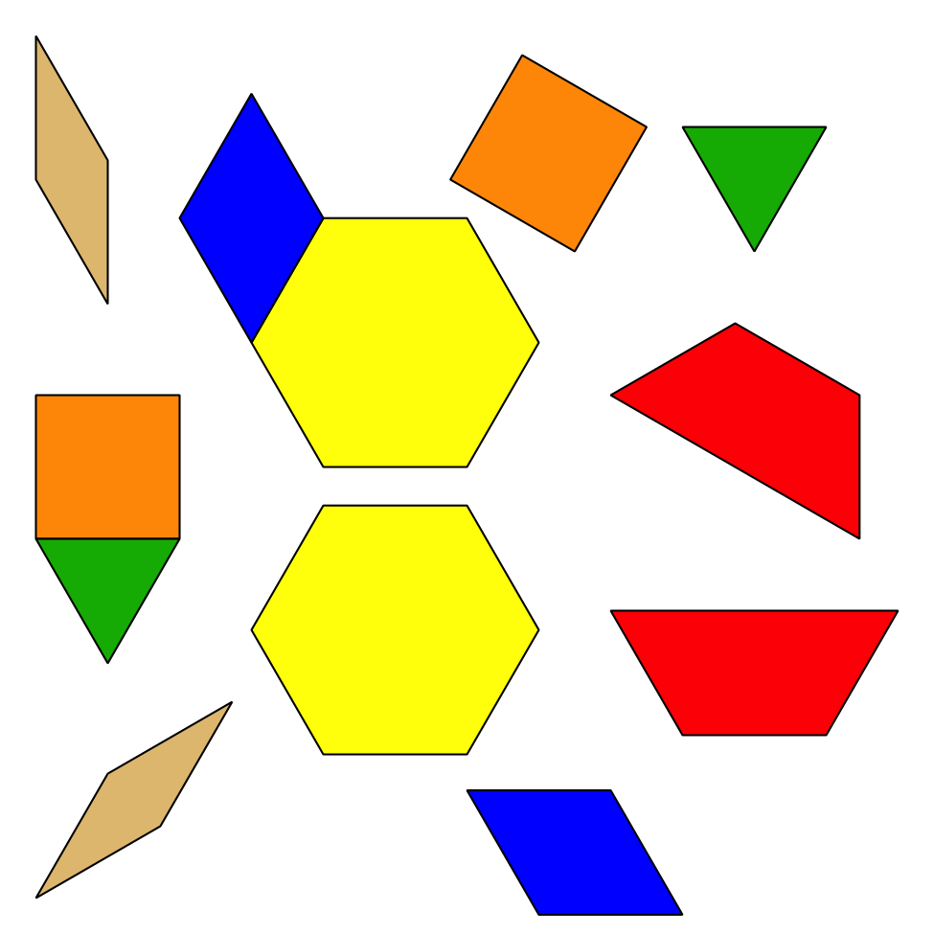
Picture Books
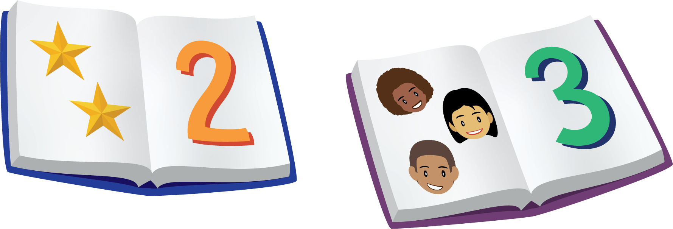

Section Summary
Section Summary
In this section, we noticed math in our world.
We found groups of things in our classroom and in books.
We used our fingers and said numbers to tell how many things there are.
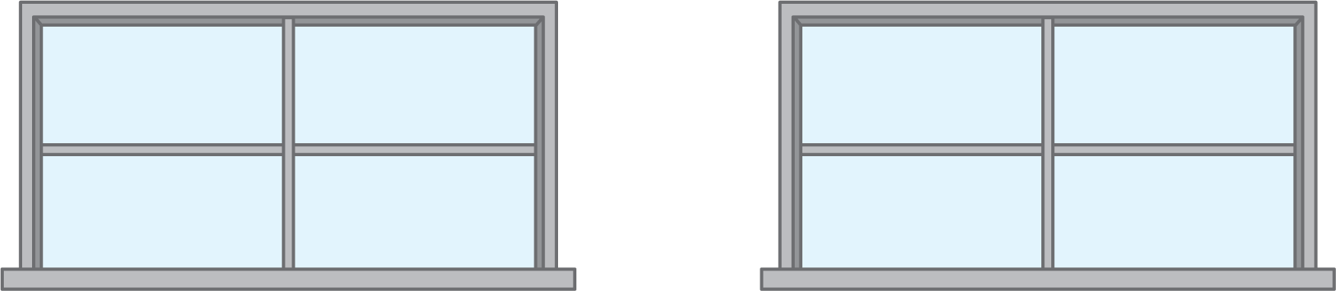
We found groups that have the same number of things.
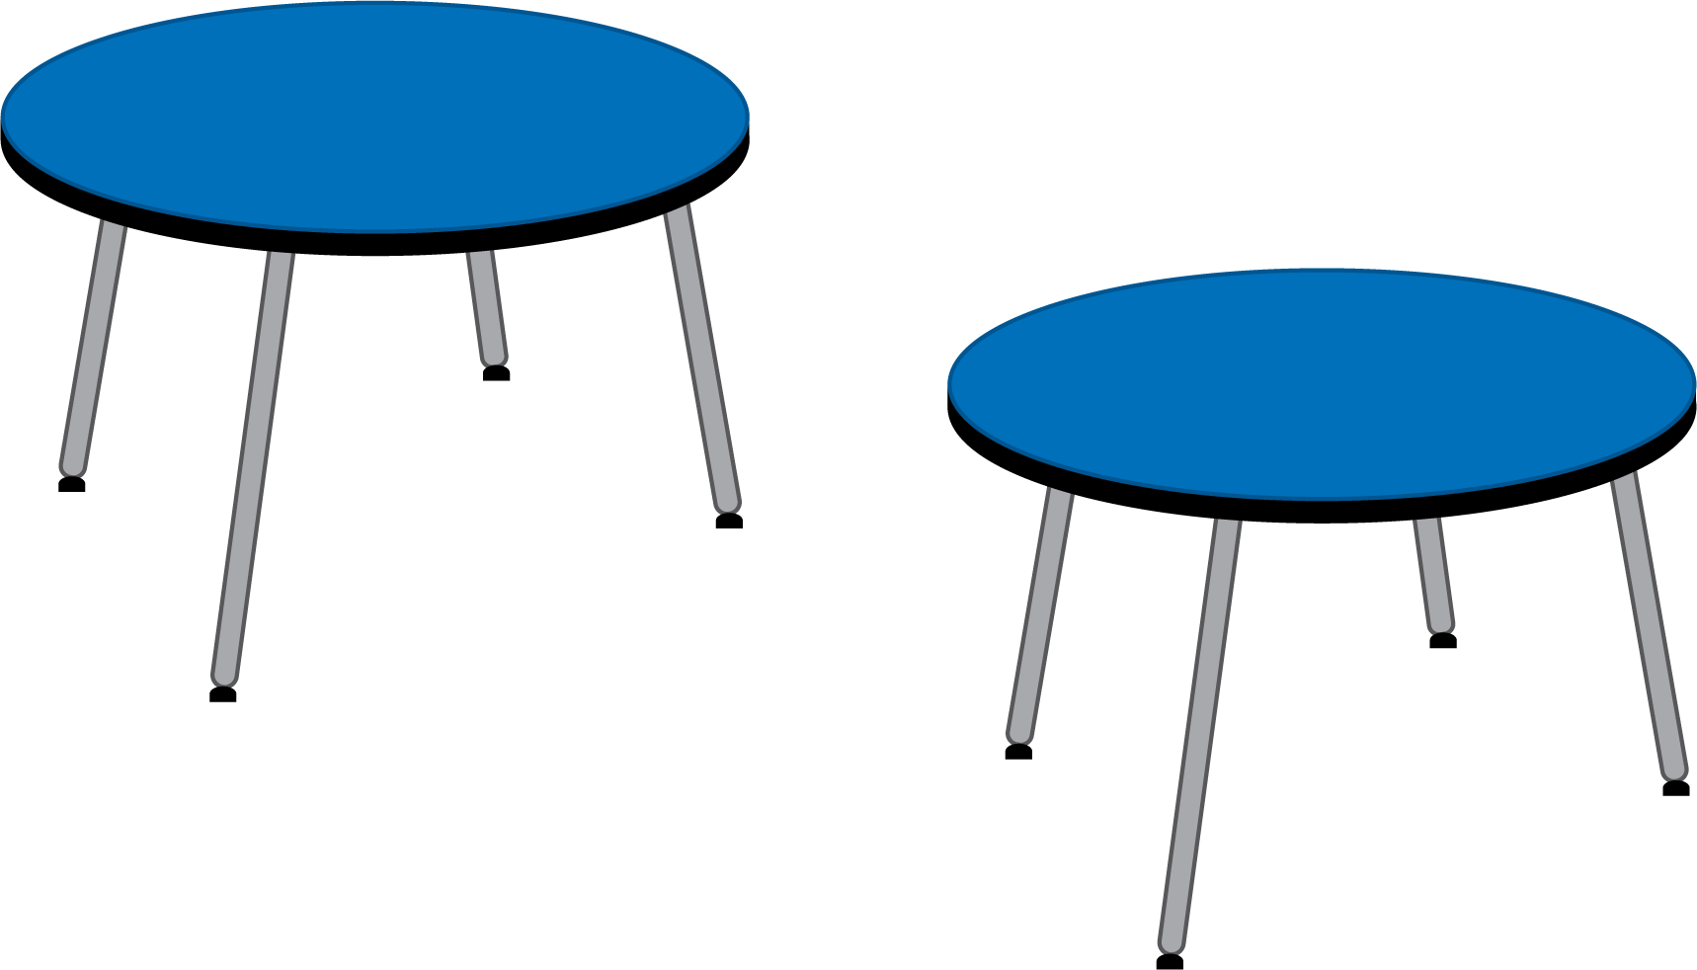
There are 2 windows and 2 tables.
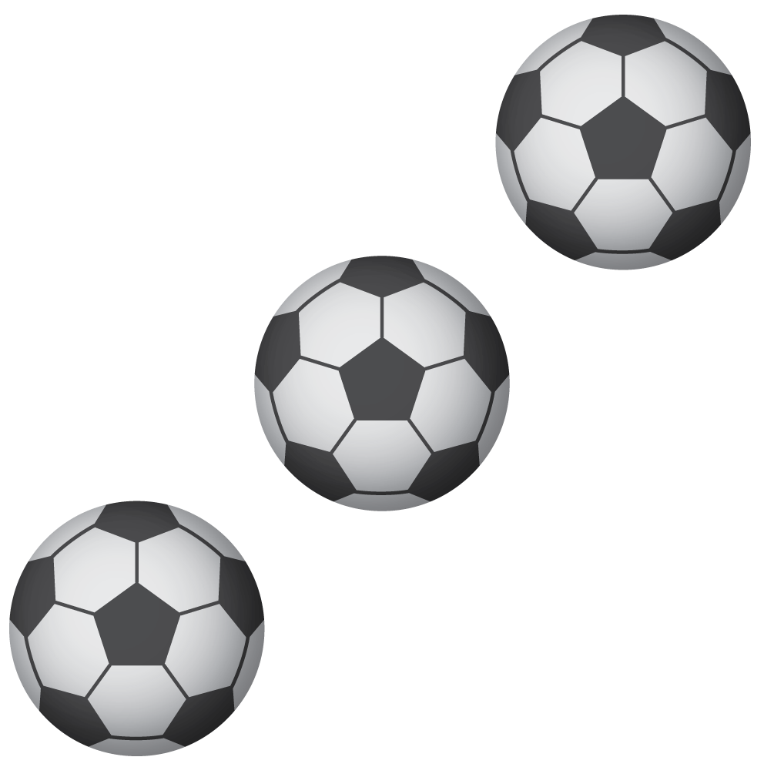
There are 3 stars and 3 soccer balls.
They look different but they are both 3.
We created our own books to show groups that have the same number of things in our classroom.
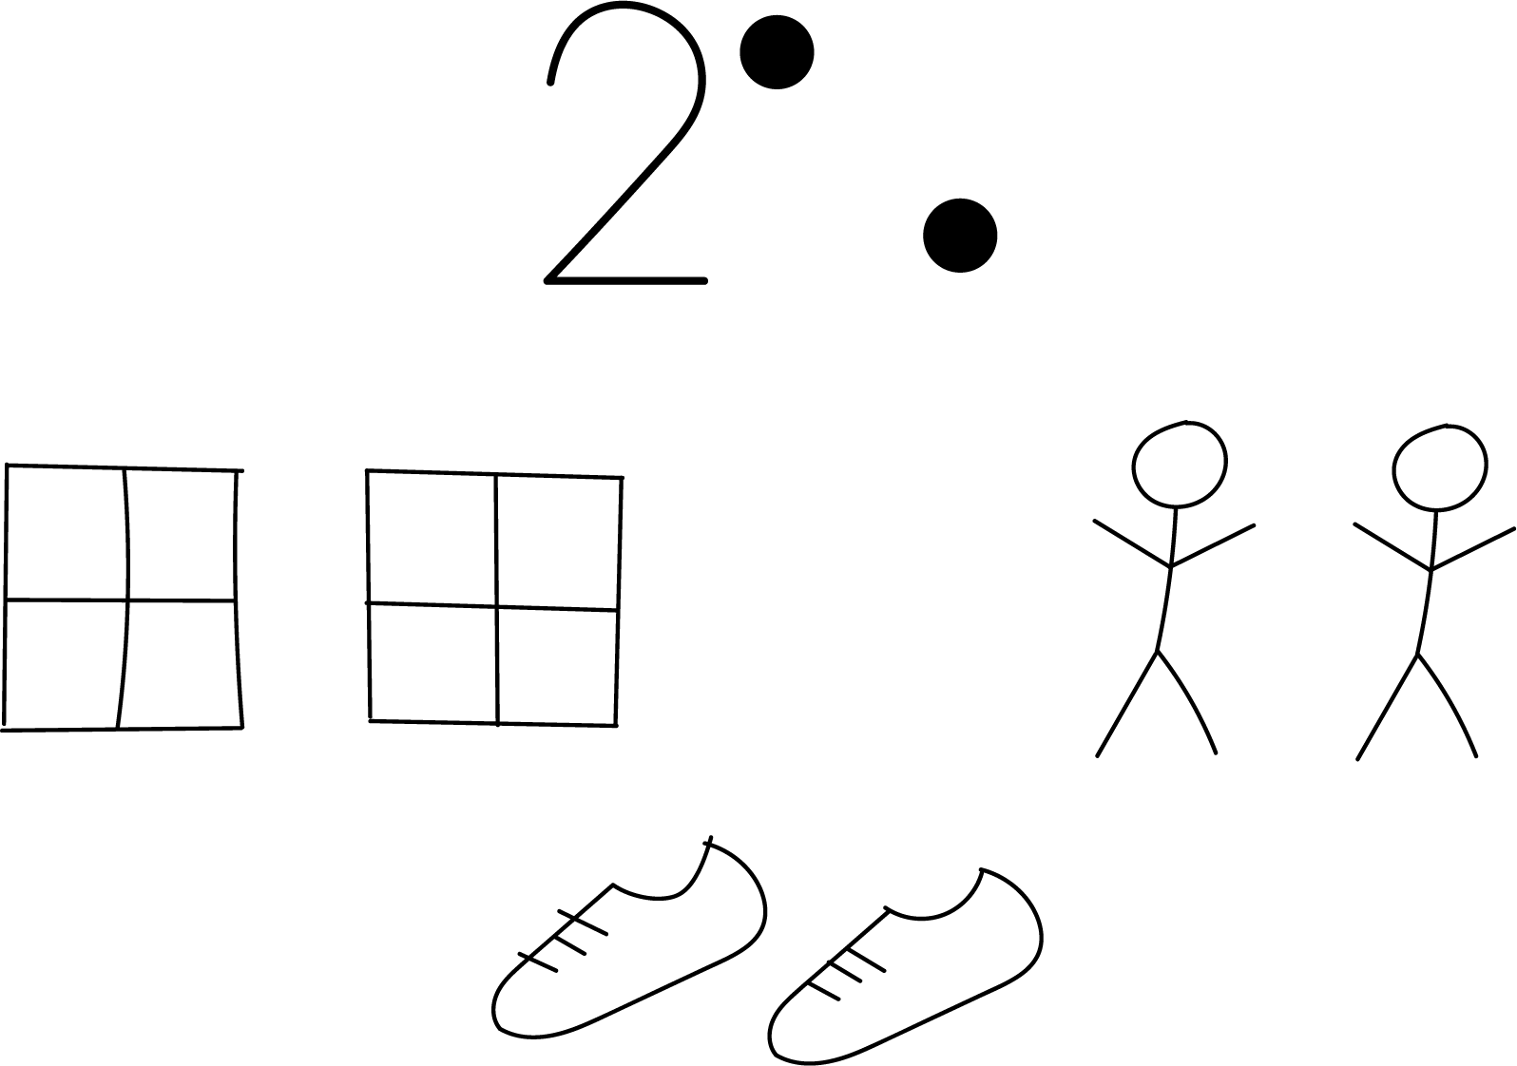
© CC BY 2021 Illustrative Mathematics®

