Curated Practice Problem Set

Unit 5 Lesson 4 Cumulative Practice Problems
- The dashed function is the graph of $f$ and the solid function is the graph of $g$. Express $g$ in terms of $f$.
- 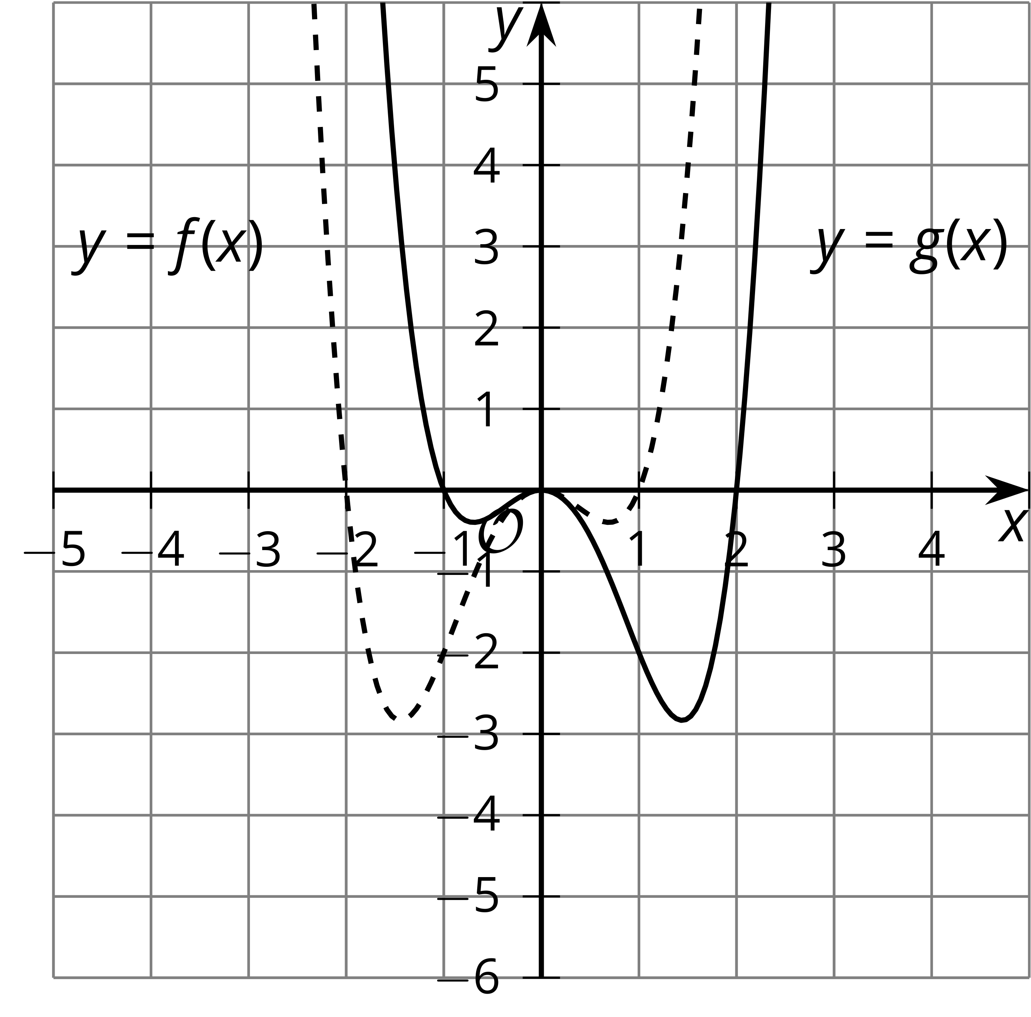
- The table gives some values of functions $f$ and $g$.
- Which of these equations could be true for all values of $x$?
- $x$ | - $f(x)$ | - $g(x)$
- -2 | - 4 | - $\frac{1}{4}$
- -1 | - 2 | - $\frac{1}{2}$
- 0 | - 1 | - 1
- 1 | - $\frac{1}{2}$ | - 2
- 2 | - $\frac{1}{4}$ | - 4
  - $f(x)=\text{-}g(x)$
  - $f(x)=g(−x)$
  - $f(x)=\text{-}g(−x)$
  - $f(x)=g(x)$
- Here is the graph of a function $f$.
- 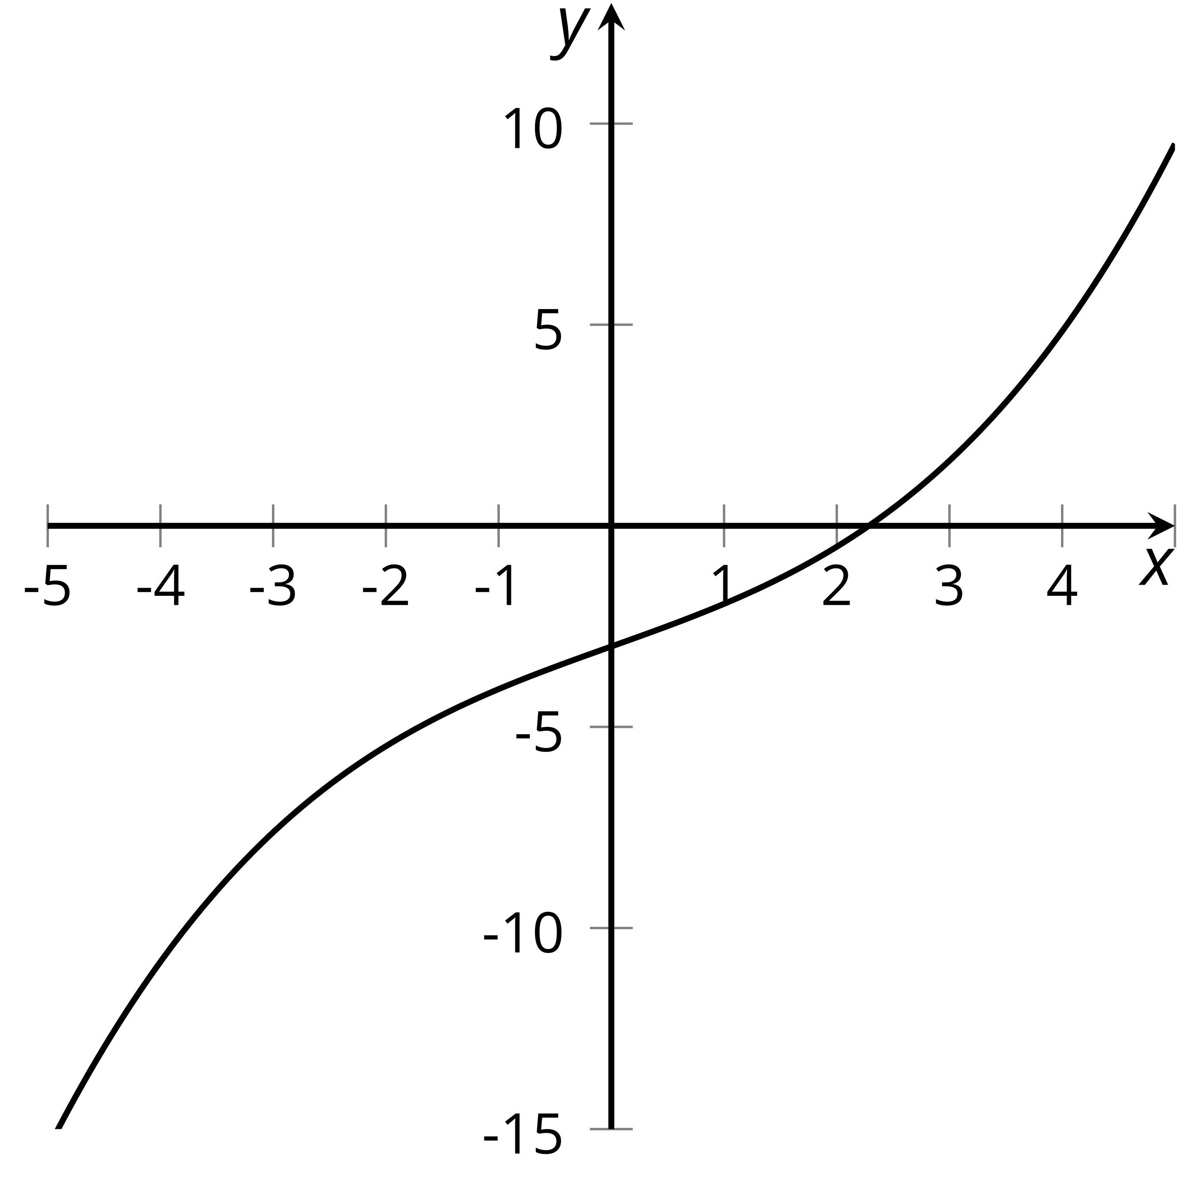
  - On the same axis, sketch a graph of $f$ reflected over the $y$-axis and then translate it 3 units up.
  - Write an equation (in terms of $f$) for a function $g$ that has the graph that you drew.
- Describe a transformation of the line that contains the two labelled points.
- 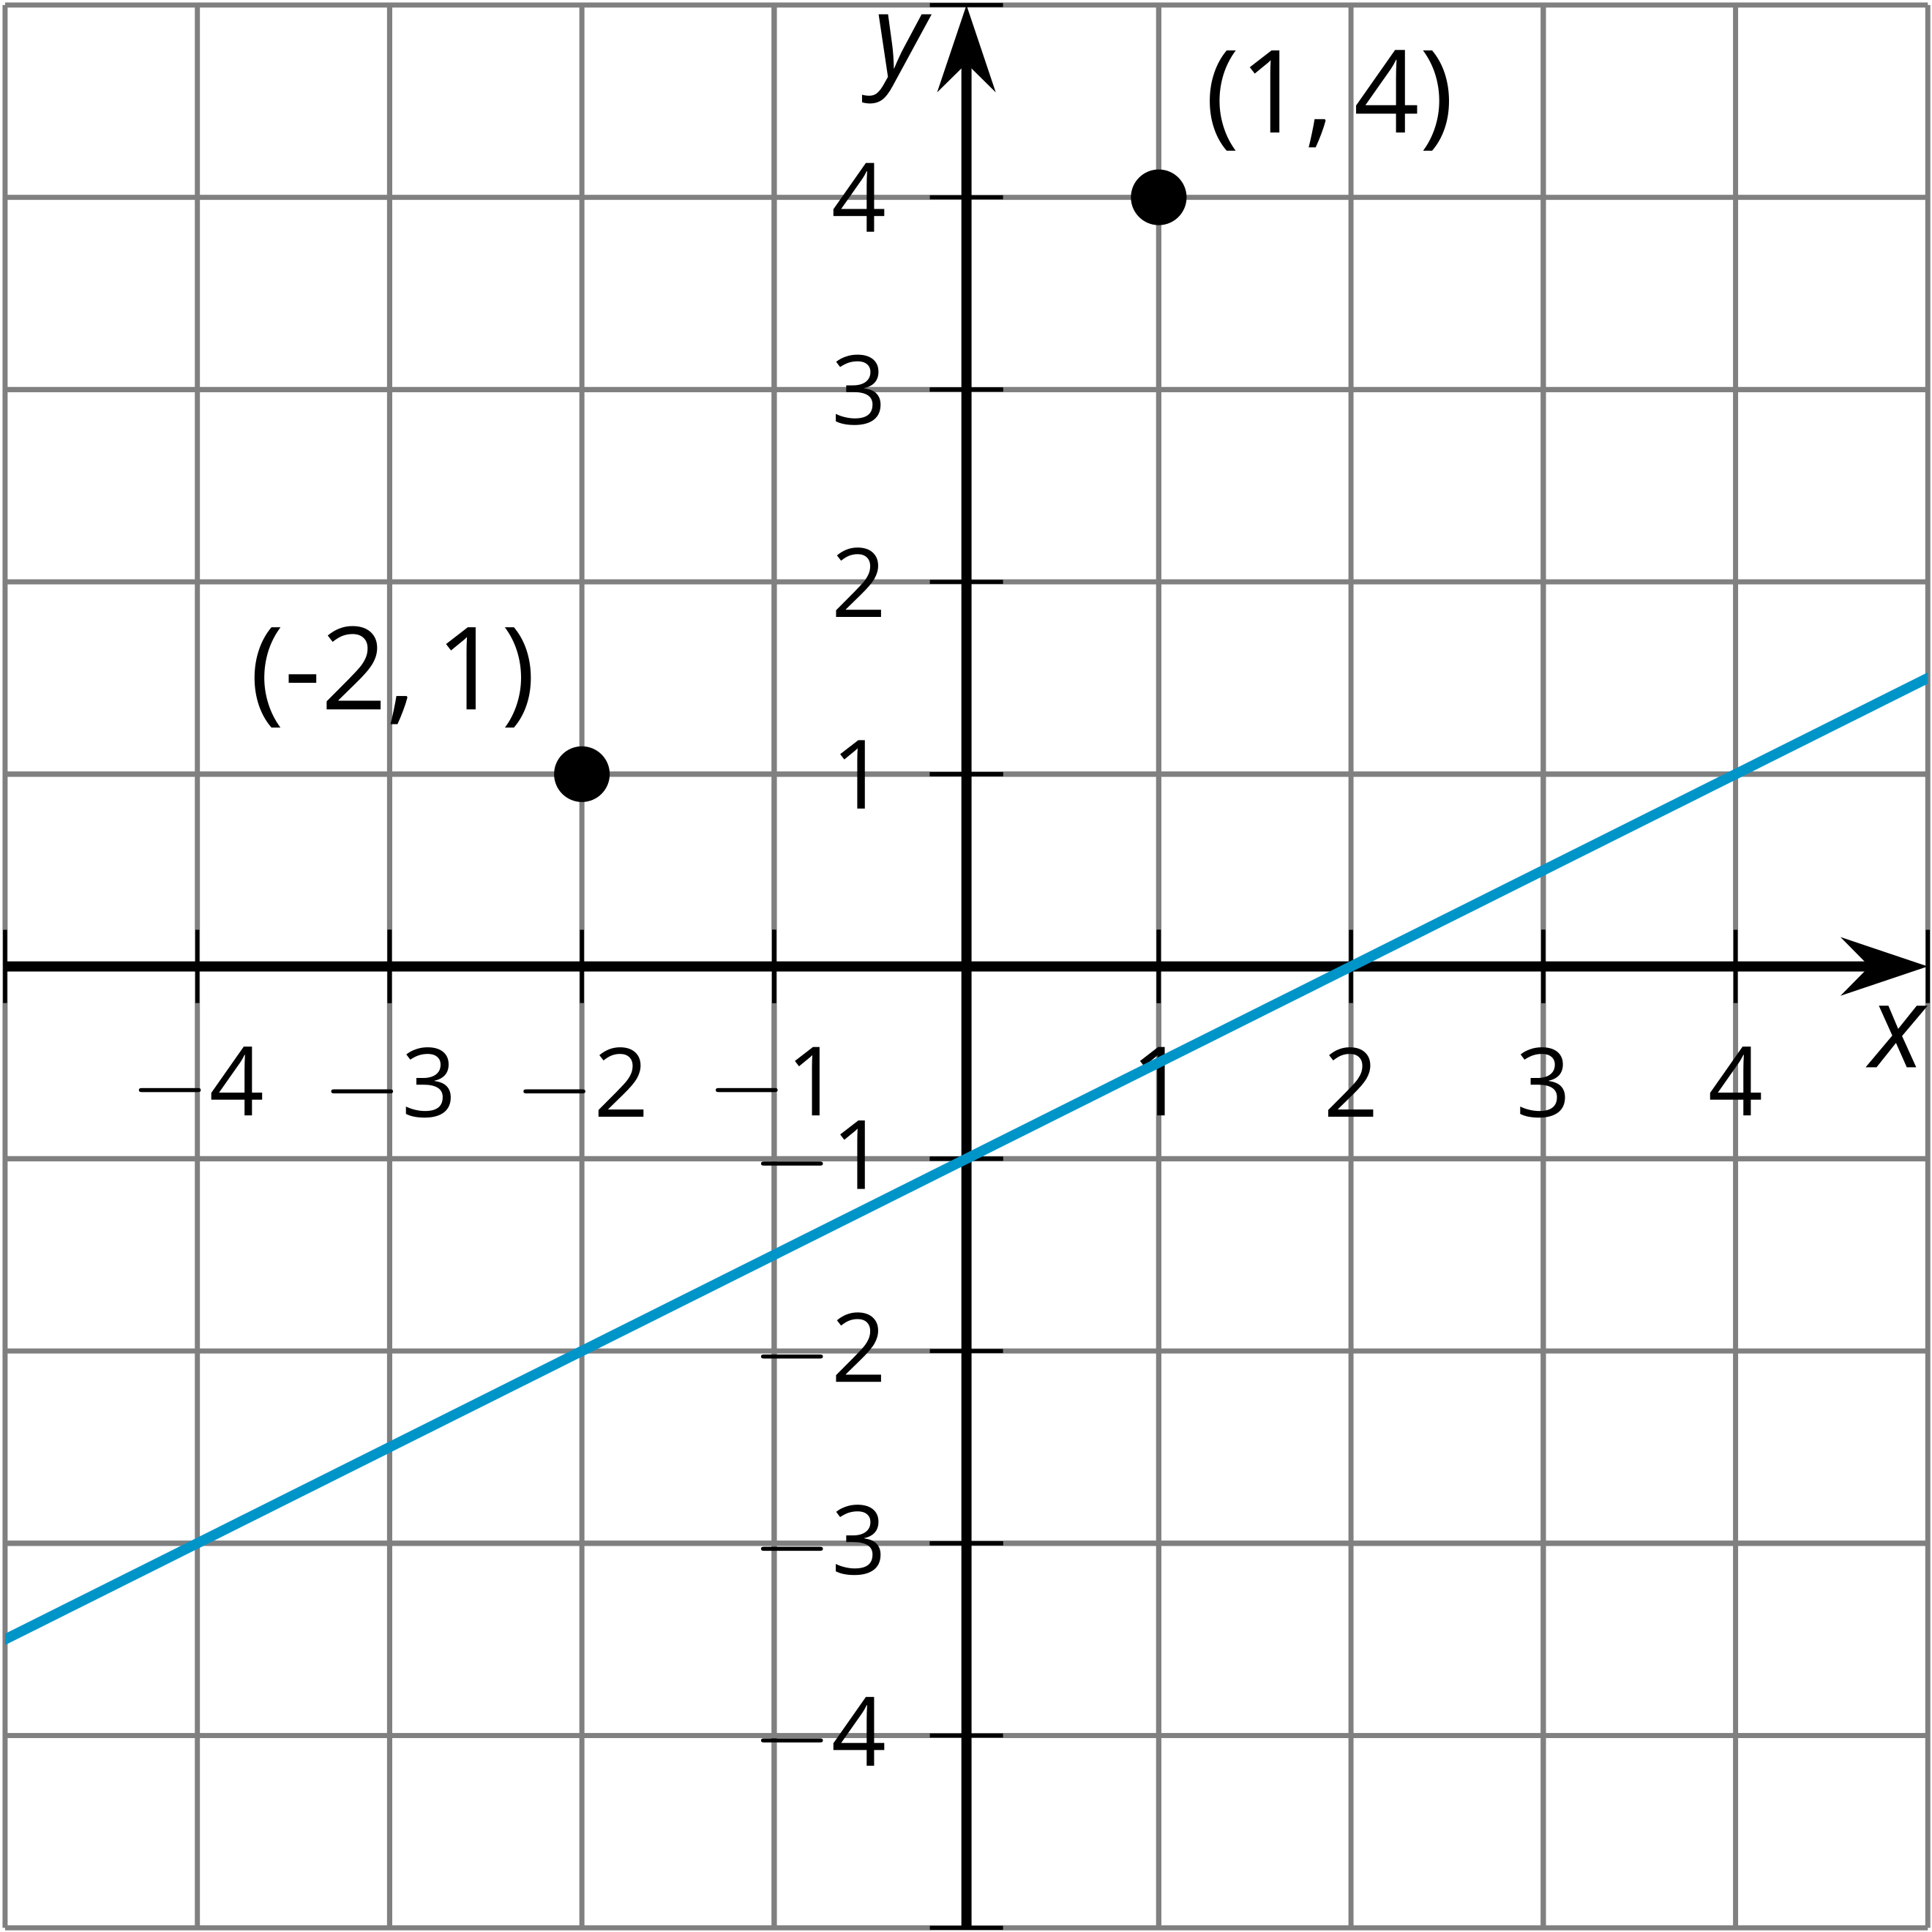
- (From Unit 5, Lesson 1.)
- The thermostat in an apartment is set to ${75}^{∘}\text{F}$ while the owner is awake and to ${60}^{∘}\text{F}$ while the owner is sleeping. The function $W$ gives the temperature $W(x)$, in degrees Fahrenheit, in the apartment $x$ hours after midnight. When it is hot outside, the owner changes the settings to be exactly 10 degrees warmer than $W$ to save energy. The function $H$ gives the temperature $H(x)$, in degrees Fahrenheit, $x$ hours after midnight when it is hot outside.
  - If $W(6.5)=75$, then what is the corresponding point on $H$? Use function notation to describe the point on $H$.
  - If $W(2)=60$, then what is the corresponding point on $H$? Use function notation to describe the point on $H$.
  - Write an expression for $H$ in terms of $W$.
- (From Unit 5, Lesson 2.)
- A ball is hit in the air. Its height $h$, in feet, $t$ seconds after it is hit is modeled by the equation $h=4+50t−32t^{2}$. Which equation models the height of a ball following the same path but is hit 2 seconds after the first ball?
  - $h=6+50t−32t^{2}$
  - $h=2+50t−32t^{2}$
  - $h=4+50(t+2)−32(t+2)^{2}$
  - $h=4+50(t−2)−32(t−2)^{2}$
- (From Unit 5, Lesson 3.)
© CC BY 2019 by Illustrative Mathematics

