Lesson 16: More Symmetry
Let’s describe more symmetries of shapes.

16.1: Which One Doesn't Belong: Symmetry
Which one doesn’t belong?

A
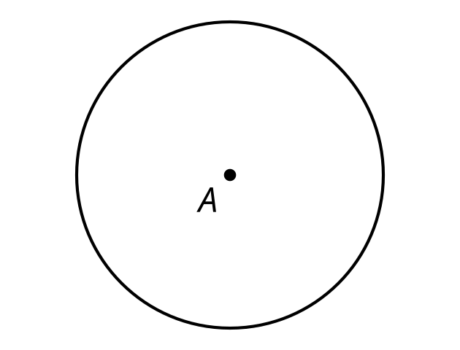

B
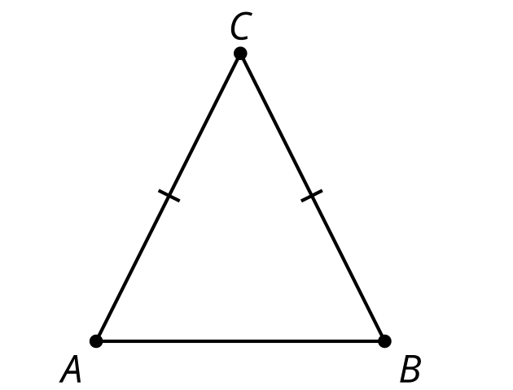

C
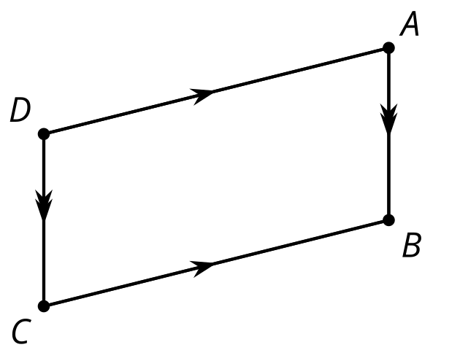

D
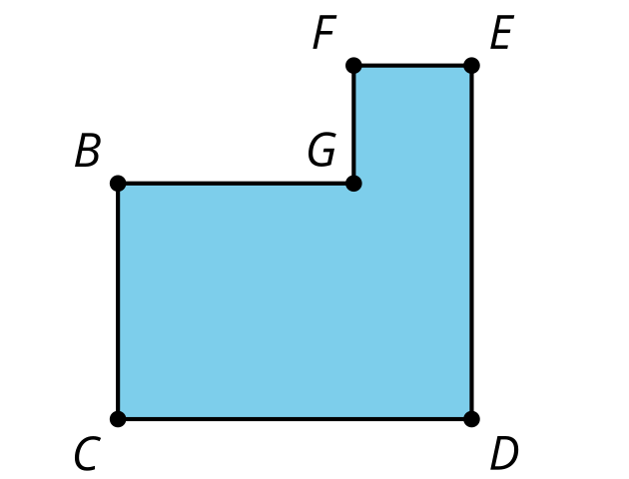

16.2: Self Rotation
Determine all the angles of rotation that create symmetry for the shape your teacher assigns you. Create a visual display about your shape. Include these parts in your display:
- the name of your shape
- the definition of your shape
- drawings of each rotation that creates symmetry
- a description in words of each rotation that creates symmetry, including the center, angle, and direction of rotation
- one non-example (a description and drawing of a rotation that does not result in symmetry)

Are you ready for more?
Finite figures, like the shapes we have looked at in class, cannot have translation symmetry. But with a pattern that continues on forever, it is possible. Patterns like this one that have translation symmetry in only one direction are called frieze patterns.

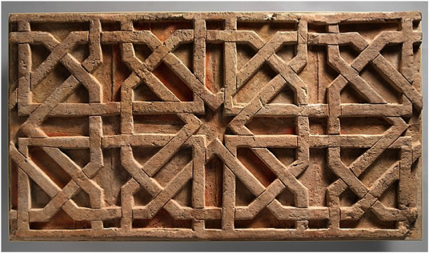
- What are the lines of symmetry for this pattern?
- What angles of rotation produce symmetry for this pattern?
- What translations produce symmetry for this pattern if we imagine it extending horizontally forever?

16.3: Parallelogram Symmetry
Clare says, "Last class I thought the parallelogram would have reflection symmetry. I tried using a diagonal as the line of symmetry but it didn’t work. So now I’m doubting that it has rotation symmetry."
Lin says, "I thought that too at first, but now I think that a parallelogram does have rotation symmetry. Here, look at this."
How could Lin describe to Clare the symmetry she sees?

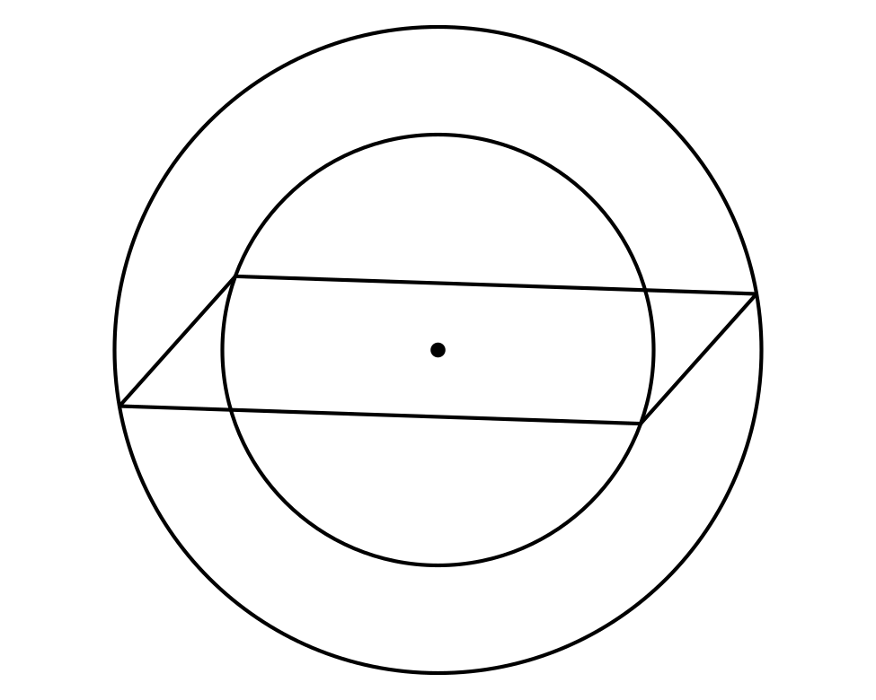

Lesson 16 Summary
A shape has rotation symmetry if there is a rotation between 0 and 360 degrees that takes the shape to itself. A regular hexagon has many angles that work to create rotation symmetry. Here is one of them. What other angles would create a rotation where the image is the same as the original figure?
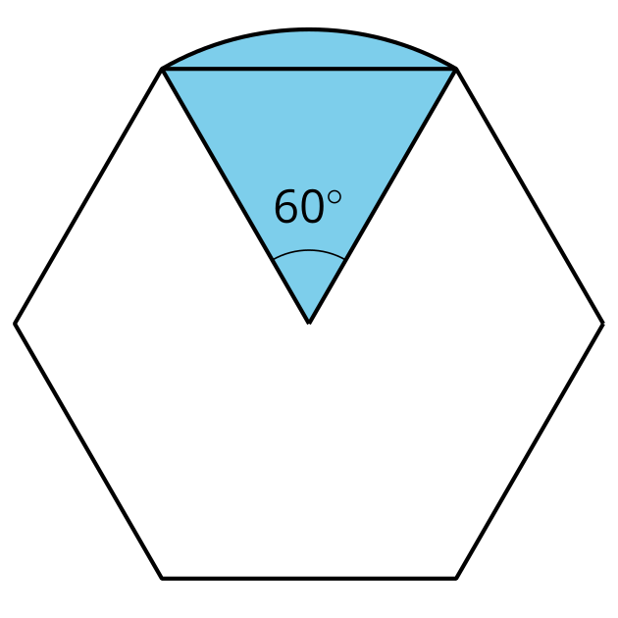
Can you think of a shape that has translation symmetry?
There aren’t any polygons with translation symmetry, but an infinite shape like a line can be translated such that the translation takes the line to itself.
© CC BY 2019 by Illustrative Mathematics®

