Lesson 13 Practice Problems
- Conjecture: A quadrilateral with one pair of sides both congruent and parallel is a parallelogram.
  - Draw a diagram of the situation.
  - Mark the given information.
  - Restate the conjecture as a specific statement using the diagram.
- In quadrilateral $ABCD$, $AD$ is congruent to $BC$, and $AD$ is parallel to $BC$. Show that $ABCD$ is a parallelogram.
- 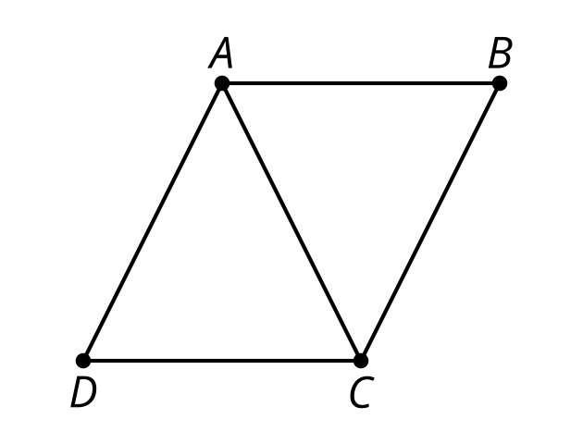
- $ABDE$ is an isosceles trapezoid. Name one pair of congruent triangles that could be used to show that the diagonals of an isosceles trapezoid are congruent.
- 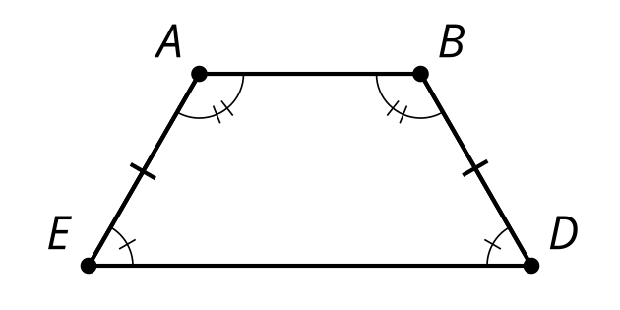
- ​​​​​​

- (From Unit 2, Lesson 12.)
- Select the conjecture with the rephrased statement of proof to show the diagonals of a parallelogram bisect each other.
- 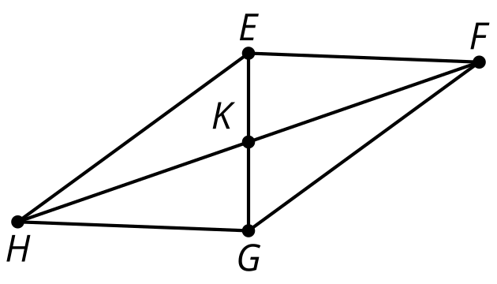
  - In parallelogram $EFGH$, show triangle $HEF$ is congruent to triangle $FGH$.
  - In parallelogram $EFGH$, show triangle $EKH$ is congruent to triangle $GKF$.
  - In parallelogram $EFGH$, show $EK$ is congruent to $KG$ and $FK$ is congruent to $KH$.
  - In quadrilateral $EFGH$ with $GH$ congruent to $FE$ and $EH$ congruent to $FG$, show $EFGH$ is a parallelogram.
- (From Unit 2, Lesson 12.)
- Is triangle $EJH$ congruent to triangle $EIH$?
Explain your reasoning.

- $\overset{¯}{HJ}⊥\overset{¯}{JE},\overset{¯}{HI}⊥\overset{¯}{IE},\overset{¯}{HJ}≅\overset{¯}{HI}$
- 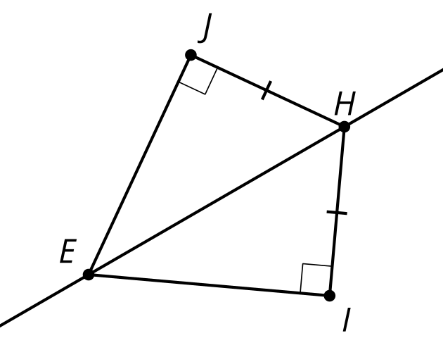

- (From Unit 2, Lesson 11.)
- Select all true statements based on the diagram.
- 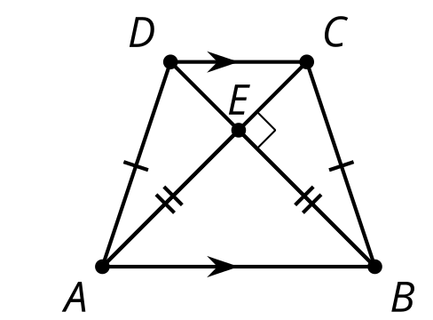
  - Segment $DC$ is congruent to segment $AB$.
  - Segment $DA$ is congruent to segment $CB$.
  - Line $DC$ is parallel to line $AB$.
  - Line $DA$ is parallel to line $CB$.
  - Angle $CBE$ is congruent to angle $DEA$.
  - Angle $CEB$ is congruent to angle $DEA$.
- (From Unit 2, Lesson 10.)
- Which conjecture is possible to prove?
  - If the four angles in a quadrilateral are congruent to the four angles in another quadrilateral, then the two quadrilaterals are congruent.
  - If the four sides in a quadrilateral are congruent to the four sides in another quadrilateral, then the two quadrilaterals are congruent.
  - If the three angles in a triangle are congruent to the three angles in another triangle, then the two triangles are congruent.
  - If the three sides in a triangle are congruent to the three sides in another triangle, then the two triangles are congruent.
- (From Unit 2, Lesson 5.)
© CC BY 2019 by Illustrative Mathematics®

