Lesson 14: Center Day 3
- Let’s work with data and practice adding and subtracting.

Warm-up: Number Talk: Plus or Minus 2
Find the value of each expression mentally.
- $4+2$
- $7−2$
- $9−2$
- $8+2$

14.2: Centers: Choice Time
Choose a center.
Five in a Row: Addition and Subtraction
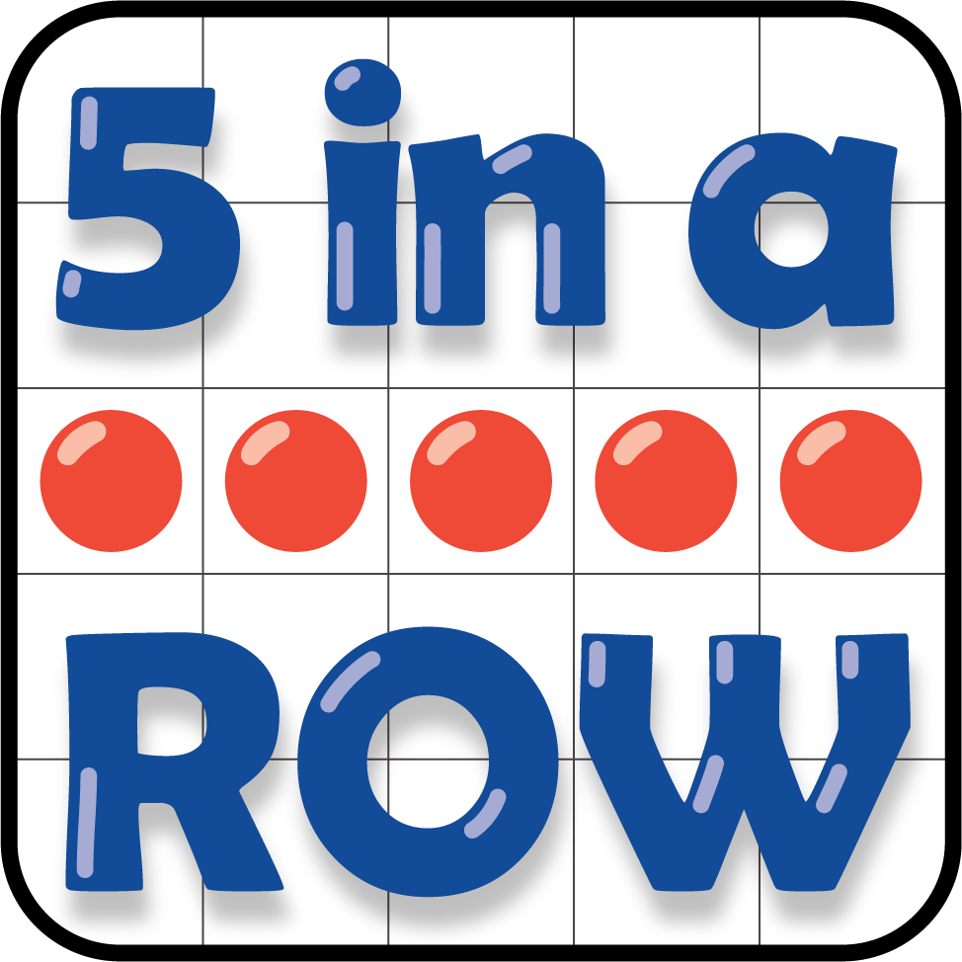
Check it Off
Find the Pair
What's Behind My Back
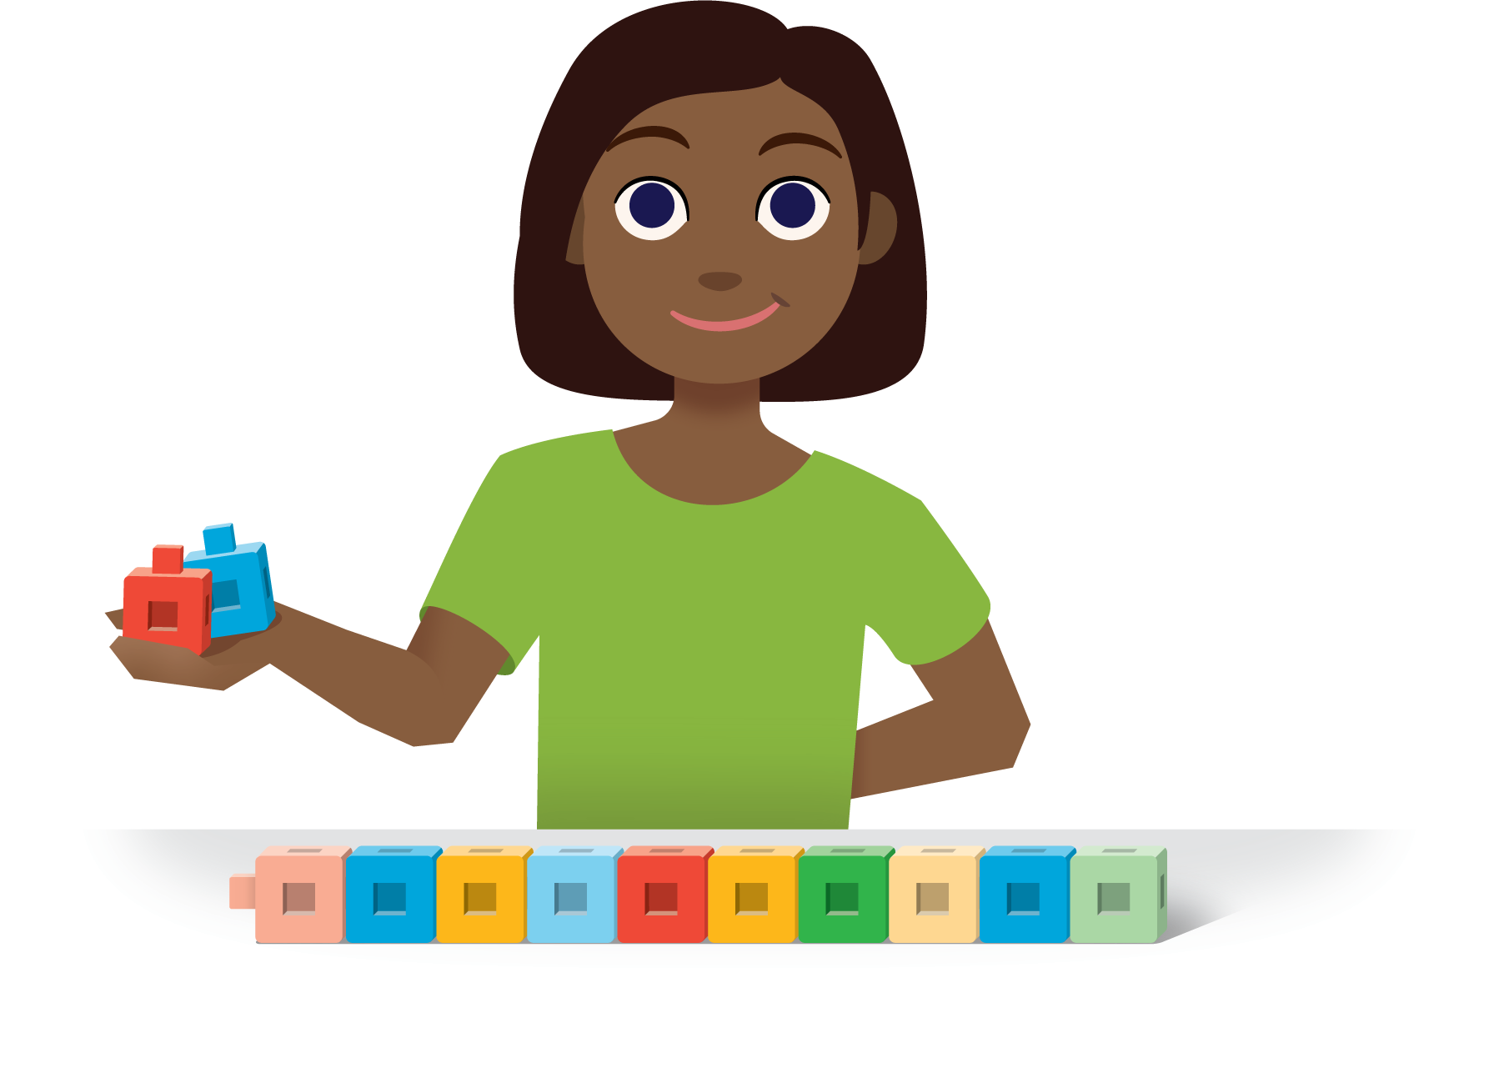
Number Race
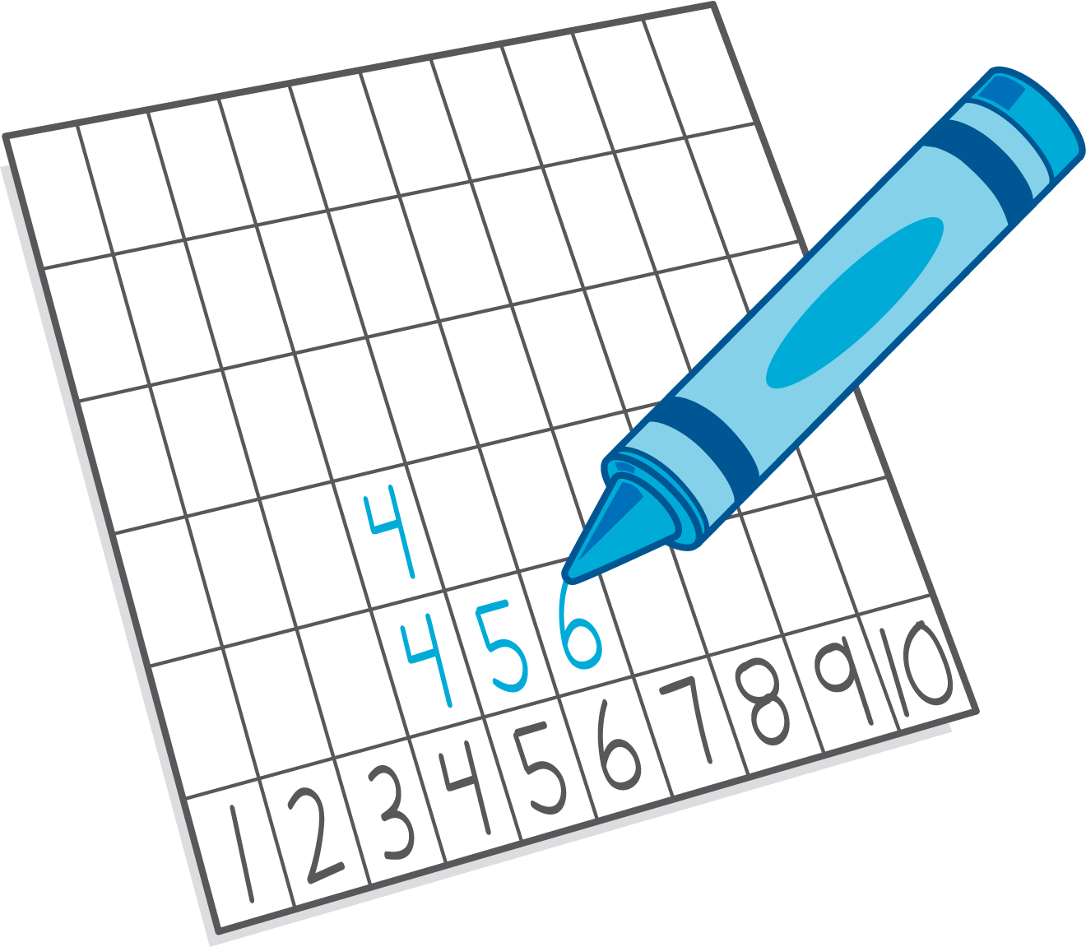
© CC BY 2021 Illustrative Mathematics®

